Programmed solution to a Problem

A2 Unit 5

Car Rental Service

Jacob Cheah



Contents

Page

* Discussion 5
  + Nature of the problem to be investigated
  + Description of End User/Business
  + Aims of the project
  + Possible limitations of the solution
  + Details of the area of development
  + Origin and form of relevant data
  + Feedback from others
* Investigation 13
  + Methods to investigate the problem
  + Sample documents
  + Data flow diagrams to analyse the data
  + Problems and inefficiencies
  + End user requirements specification
  + Hardware and software specifications
  + Research into existing solutions to similar problems
  + Justification of solutions
  + Stakeholders in the current system
  + Current methods used by the existing system
  + Current system outputs
  + Limitations of the current system
  + Requirements specification for the project
  + Methods to be used in the solution
  + Objectives
  + Performance indicators and success criteria
* Design 61
  + Abstraction
  + How do the sub programs and the project objectives link
  + Inputs to and outputs from the system
  + Files, data structures and methods of access
  + Validation routines to be carried out
  + Processes for the new system
  + Relationships between the data and the processes that manipulate and transform the data
  + Interconnection between the programs and the files
  + Processing routines
* Prototype 71
  + Justification on the choice of areas to be included in the prototype system and reasons for omitting the remaining areas
  + Proposed interface design/screen layouts
  + Testing using realistic data for output and storage
  + Evaluation of the functioning of the prototype
  + Shortcomings of the prototype
  + Good features of the prototype solution
  + Suggestions for improvement
* Post-Prototype Refinement of Design 102
  + Feedback on the prototype system from a competent third party
  + Implications of the feedback for the re-design of the system
  + Re-considered and re-structured input and output facilities
  + Required files and/or data structures in light the need to include additional data
  + Additional processes needed and new relationships between the data and the processes of the revised design
  + Processing routines for implementation
  + Fully refined and detailed design of the final system
* Software Development 110
  + Original objectives stated in requirements specification matched to the achievements
  + ER model
  + Data model normalised to third normal form
  + User-defined routines
  + Recursive algorithms
  + Evidence of validation for all key components
  + Exception handling
  + Variables and actual data structures used to create the solution
  + Evidence of the completed user interface
  + Full description of the features that make the solution fit for audience and purpose
* Development Testing 173
  + Modular testing
  + Alpha Testing
  + Actions taken to overcome problems in alpha testing
* Testing 193
  + Test strategy and plan for all areas of the system
  + Applying the test plan and data
  + Test data
* Evaluation 283
  + The effectiveness of the programming language
  + Justification of the tools and techniques used
  + The completed system compared with similar commercially available systems
  + Good features of the completed solution
  + Shortcomings of the completed solution
  + Potential improvements that could be made to improve the solutions effectiveness
  + Self-reflection review of strengths and weaknesses in the design and development of the system
  + Specific changes of approach that would be adopted in future to avoid problems experienced during the project

Discussion

Section 1



Nature of the problem to be investigated

The car rental service at Belfast City Airport, called ‘City Car Rentals’ is owned and managed by Malcolm Watts. This Business allows people to rent cars whether they are tourists flying in from all over the world or locals that wish to rent a car.

Since the opening of City Car Rentals, a paper-based system has been implemented to control the rentals, staff, payments, customer details and vehicle status. This has been carried out through using forms that would be filled out by staff or occasionally customers that were renting vehicles from the business.

The paper-based forms of current rentals, payments, and vehicles that were being currently processed were kept in folders under the front desk and then after the booking was over, or the payments had been made, the forms were archived in filing cabinets in the storage room of City Car Rental. This has resulted in the efficiency and effectiveness of the business to slowly decline as the number of rentals and customers increases.

There is an extensive amount of duplication and inefficiency currently in the business, if any customer details need to be changed, this needs to be amended for all their previous bookings and payments and clutters the forms, this takes a huge amount of time to process and raises increases the risk of mistakes being made and/or illegible writing on the forms to come about.

If a booking is needed to be searched for, the staff member involved is required to go through each of the archived bookings one by one until the desired form is found. This paper based system is also very susceptible to damage from fires, flood, degrading over time and extremely vulnerable to theft as booking details and customer’s personal details are being kept under the front desk and could easily be stolen and misused.

This has resulted in a large amount of wasted time, space and money as customer’s previous records become harder to search through, more and more files are misplaced or destroyed and customer satisfaction is at an all-time low, a new system must be implemented.

Description of End User/Business

The business owner and staff members of the business are the end users as they will be the only people using the new system, as customers will never be able to use it.

There are three members of staff which take shifts working at the front desk their duties are to make the rentals for the customers. This will involve them filling in the customer's personal details, their payment details, and the booking details. They will also be required to search for and possibly amend a customer's details or a customer’s booking details.

The manager/business owner will also have access to the staff and can add new staff, amend staff details, and remove staff, have the ability to review the statistics of the business and all current forms that are in use and add new vehicles to the rental company and remove others if they become decommissioned

All staff members, including the manager, will need to have basic technical skills to operate the new system and understand its function, however, I plan to keep the operations and processes of the new system relatively simple. This includes having the design of the new system be natural and intuitive to ensure that there will be no difficulties with the staff learning how the new system will work.

Therefore, the staff should not be required to take part in technical training as any advanced technical skills should not be needed to simply operate the new system.

Aims of the project

Main Goal

The main goal of the project is to create an easy to use, efficient computerized program that is capable of inserting, editing, updating, and deleting records in a smooth and straightforward way.

Completion of the project

The project should be completed within six months of the discussion submission, it should have usernames and passwords for staff members. It should eradicate the existing problems with the paper-based system and make the process of car rental much more easy and efficient.

Specific Aims

The new system must be able to provide the following components to the car hire system:

Insert data to hold customer, booking, vehicle, payment and staff information.

Update data to save changes to the customer, booking, vehicle, payment and staff information.

Edit data to change the customer, booking, vehicle, payment and staff information.

Delete data to remove the customer, booking, vehicle, payment and staff information.

The design should:

Be convenient.

Be easy to use and understand.

Have multiple access levels.

Have verification for the login.

Have a way to search the data.

Have a way to view the data.

Be aesthetically pleasing

Be very pleasant to view for extended periods of time.

The manager of City Car Rental added:

The new system should be easy to use as not all staff have been professionally trained in IT and using computers but all staff have a general knowledge of operating a computer and using technology. Therefore, my current plan should be to create a system that is appropriate based on the skill levels of the staff members and to ensure it is not overly complex to achieve the desired task.

Adding in new bookings should not contain excessive information as some are slow to type and don't want to spend too much time simply entering in details. Forms and menus should be easy to navigate as they do not want to waste time trying to find the form they are looking for.

Possible limitations of the project

Due to restrictions on time, budget and staff, there will be certain limitations of the project, the function of the program will not be affected by these restrictions, however, the graphical interface of the program, will not be as sleek and user-friendly as an interface designed by a professional graphic designer but it will be more than adequate for the operation.

The program will not be optimised as much as it could possibly be and will not run as quickly on a low-performance computer as it could have if the program had been professionally optimised to run as smoothly and quickly as possible. However, I will use what tools I have at my disposal to optimise the programming of the new system.

The security of the application will also be minimal as I will be unable to take advantage of current encryption or hashing algorithms to secure data like passwords or customer details as using these would require purchasing third-party security software, which will be impossible due to budget and time restrictions. However, this is something that I would like to rectify given a larger budget or more time.

I will also be unable to add networking features to the new system, this would make the same data available on multiple computers on and off the premises of City Car Rental. However, unfortunately, due I do not have the necessary skills to create this program and I lack the budget to hire an expert to accomplish this. Which means the new system will be a local only program.

Feedback from others

The Company Manager has read through the project aims and limitations. He has accepted that the program will be sufficient for the needed purpose but has emphasised that multiple access levels is necessary for him to be able to edit staff booking database but that other staff will not be able to access it as they could cause trouble in the company

The Project Manager has read through the discussion and has raised concerns that the project should be completed by the 6-month deadline. However, the different forms for entering data will be very similar. This will cut down greatly on time for designing the program.

Origin and form of relevant data

The data will be sourced from the current paper-based system in the storage room in ‘City car rental’ I will be required to redesign the forms for creating bookings, customers, and payments as the customer details do not need to be copied into the booking and payment forms.

|  |  |
| --- | --- |
| Origin of data | Format |
| Filing cabinet “Booking” in office | Booking data capture form |
| Filing cabinet “Customer” in office  Processing “Customer” folder under front desk | Customer data capture form |
| Filing cabinet “Staff” in managers’ office | Staff data capture form |
| Processing “Payments” form under front desk  Filing cabinet “Payments archive” in office | Payments data capture form |
| “Vehicles” forms under front desk | Vehicle display data form |

Investigation

Section 2



Investigation of current problem

I will use 3 methods of Fact Finding to investigate the current problem, this will help me in understanding the problems with the system in use currently and give me an in-depth knowledge in to how the new system should be developed.

Methods of investigation

Questionnaires

1. Questionnaires will be distributed to staff and then the completed forms will be returned to me. I will then conduct both a statistical analysis and analysis of the written answers from the questionnaire. this will help me gain a good understanding of the problems with the current system, their effects, and importance to rectify. It will also give me an idea of what the staff would like to see in the new system.

Interviews

1. I will conduct an interview with the employees that work at the front desk as they handle the majority of bookings and solely work with the customers that rent from City Car Rental. I feel they will have the greatest input of how the current system affects them and the customers. Also, they should have good insight into how the new system should work as they will be the primary users of the new system.

Observation

1. I will spend some time in the business, observing the various documents used in the day to day work, speaking to the employees and customers about how they feel about how things are operating and what they would change.

Questionnaire

I have taken advantage of a service called ‘Smart Survey’ to conduct my questionnaire, its free, easy to use and quickly and easily distributes the survey to the employees of ‘City Car Rental’ for them to complete digitally then it will be automatically sent back to me to review.

Page – 1: Introduction

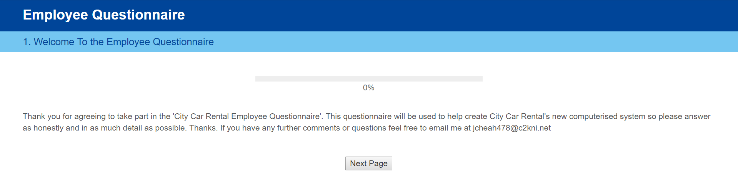

Page – 2: Questions

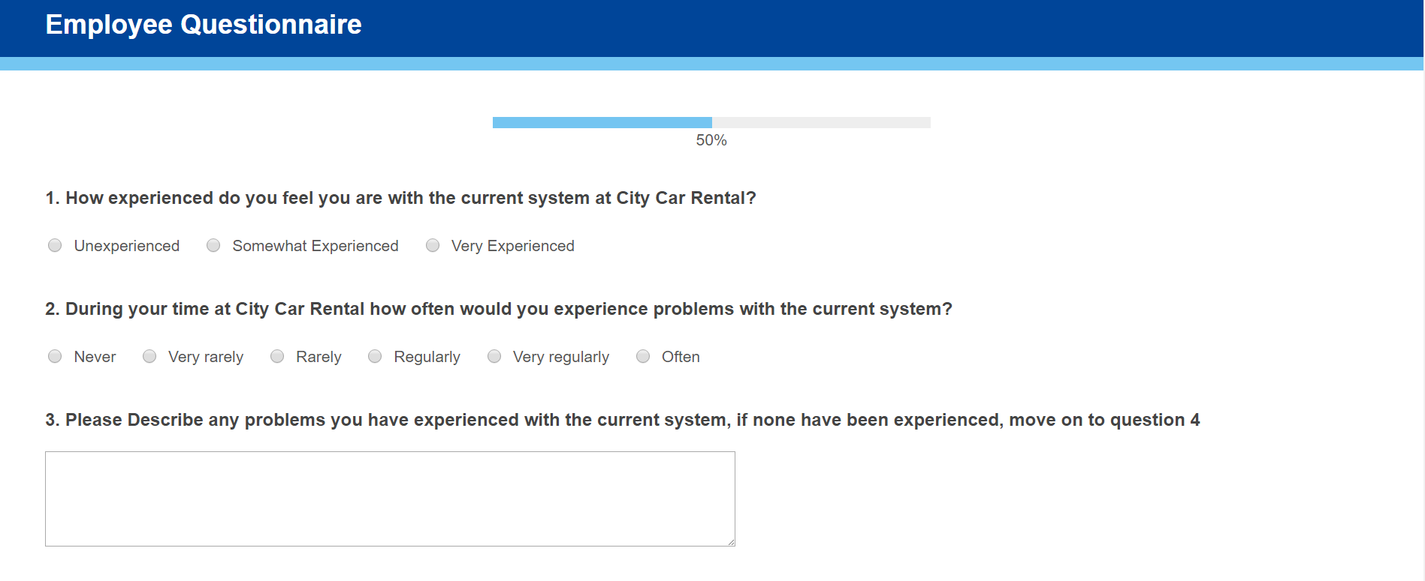

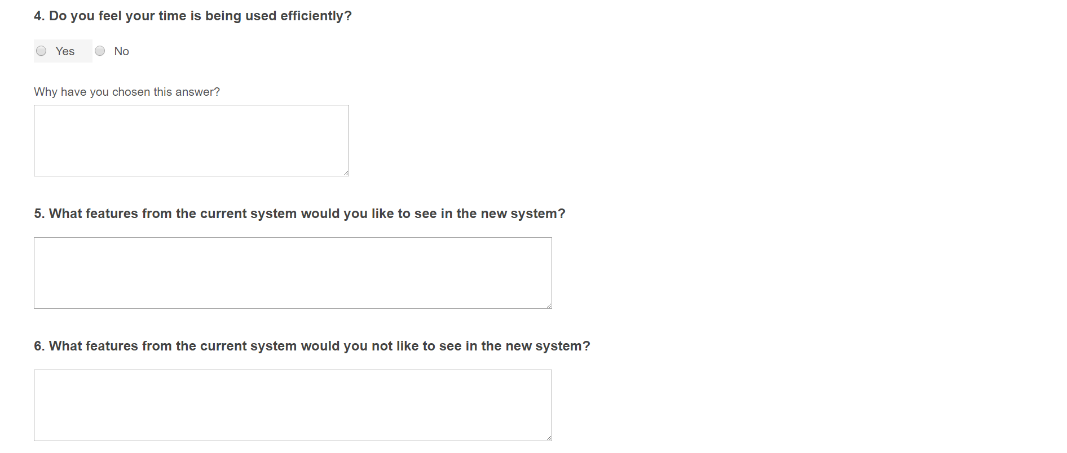

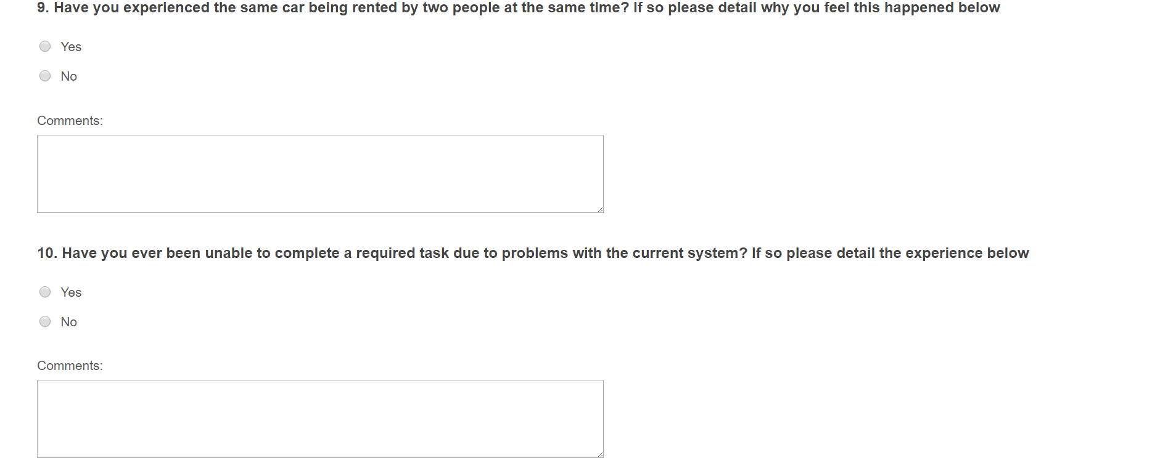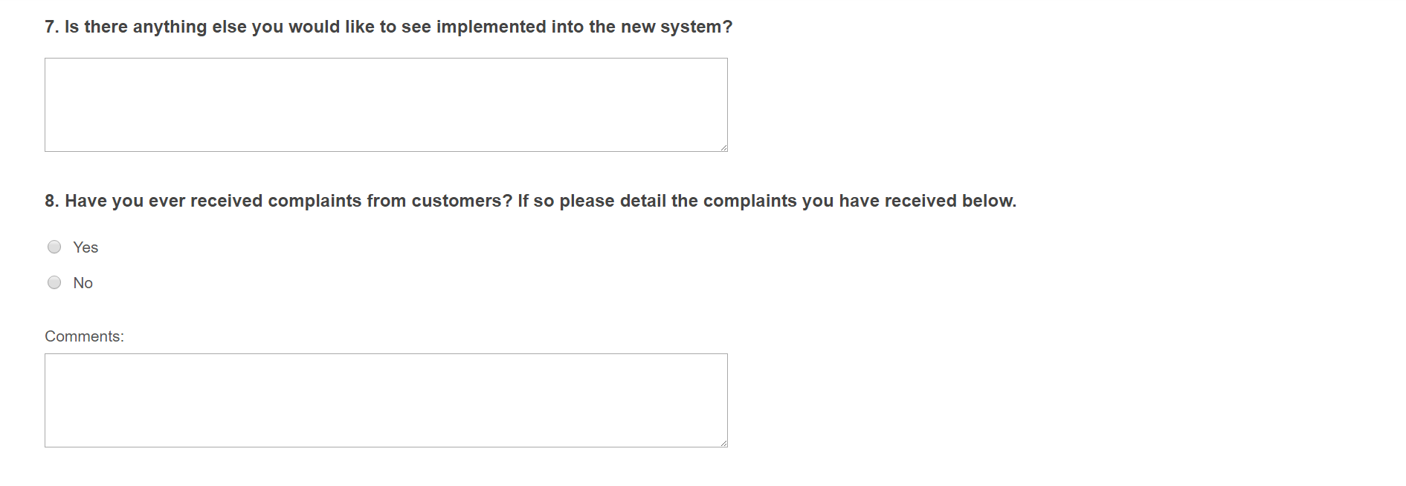

Questionnaire Analysis

**Q1. How experienced do you feel you are with the current system at City Car Rental?**

|  | | | **Response Percent** |
| --- | --- | --- | --- |
| 1 | Unexperienced | |  | | --- | |  | | 17.65% |
| 2 | Somewhat Experienced | |  | | --- | |  | | 47.06% |
| 3 | Very Experienced | |  | | --- | |  | | 35.29% |

The above chart shows that most of the employees of City Car Rental have been there for multiple years and therefore will be very well acquainted with the problems of the system

**Q2. During your time at City Car Rental, how often would you experience problems with the current system?**

|  | | | **Response Percent** |
| --- | --- | --- | --- |
| 1 | Never | |  | | --- | |  | | 5.56% |
| 2 | Very rarely |  | 0.00% |
| 3 | Rarely | |  | | --- | |  | | 11.11% |
| 4 | Regularly | |  | | --- | |  | | 22.22% |
| 5 | Very regularly | |  | | --- | |  | | 22.22% |
| 6 | Often | |  | | --- | |  | | 38.89% |

As shown by the results above employees clearly agree that there are regular and reoccurring problems with the system as 81% have experienced regular or more often problems with the current system.

**Q3. Please describe any problems you have experienced with the current system. If none have been experienced, move on to question 4**

Most employees described problems with searching for a customer's records as the would be required to go through multiple filing cabinets to find a customer and then their payments and their bookings.

Other employees described problems with updating a customer's information as they needed to not only update this information on the customer details form but also on their payments and bookings forms if they had any.

Some employees also mentioned that when customers had filled in forms that on occasion they would be illegible due to the person's handwriting or that some of the forms could be hard to follow if mistakes had been made on it.

Some employees also called attention to the fact that some of the older records in the business that have been archived, have degraded over time and are no longer legible as the writing on them has faded or the paper has become damaged.

**Q4. Do you feel your time is being used efficiently?**

|  | | | **Response Percent** |
| --- | --- | --- | --- |
| 1 | Yes | |  | | --- | |  | | 11.11% |
| 2 | No | |  | | --- | |  | | 88.89% |

As can be seen, by the diagram above, 88% of employee’s agree that their time isn't being used effectively. As the employees are paid by the hour, if the employee’s time is being wasted, the owner's money is being wasted and I think it's clear that all employee’s and stakeholders within the business are very unhappy with the current system and are looking forward to the new system.

**Q5. What features from the current system would you like to see in the new system?**

Multiple employees commented that they would like the form contents to be the same for the new system as they feel that the current contents are concise and accurate without being excessive. I have already planned on keeping the form contents the same, just with a new layout for faster entry.

They also answered that they would like the simplicity and elegance to the current system to be kept for the new system with it still being comprehensive and not lacking compared to the current system. I think the staff members are concerned that as the new system involves a lot of technology that it will be very complex and difficult to use, however, I hope to keep the new system as simple and easy to use as the previous with still being fit for use.

**Q6. What features from the current system would you not like to see in the new system?**

Almost every employee wrote here that they do not want to have to re-enter data that is the same in multiple places. This issue can be solved by using a relational database to store the data for the business as there is very minimal data redundancy and the data will be entered once and then stored, ready to be called upon if necessary.

Some employee’s also said that they would like all information to be word-processed and not handwritten, to prevent any problems with illegible handwriting as mentioned earlier. This will mean the documents for customers will not be scanned in but manually input which makes the program easier to develop and will cut down on time and cost.

**Q7. Is there anything else you would like to see implemented into the new system?**

Most employee’s asked to see a search function implemented in the new system as the current paper-based system is very frustrating and time-consuming to search through existing records.

Some employees have raised concerns about storage of records, in the current system once they have completed a form they have to find the appropriate filing cabinet/folder file it away in the correct order. This sometimes causes problems as people make mistakes putting files in the incorrect storage space. The current methods of storage also take up a large amount of storage space and they hope to see a more space efficient way of storing all the data. As everything is digital, they will be stored and sorted automatically. Another benefit of everything being computerised is that the data being stored takes up no physical space, unlike the current system.

Some other employees have said they would like to see data validation used the new system as the current system allows for a lot of human error to occur, as employees and customers often enter details incorrectly.

**Q8. Have you ever received complaints from customers? If so please detail the complaints you have received below.**

|  | | | **Response Percent** |
| --- | --- | --- | --- |
| 1 | Yes | |  | | --- | |  | | 66.67% |
| 2 | No | |  | | --- | |  | | 33.33% |

As can be seen, by the diagram above, the majority of employees have experienced complaints from employees, this shows that customer satisfaction must not be very favourable.

The employees that included the complaints they have received all mentioned that multiple customers have made comments on the time that is taken for rentals to be made and some have even canceled their rental due to the extended wait, this must be rectified in the new system.

**Q9. Have you experienced the same car being rented by two people at the same time? If so please detail why you feel this happened below.**

|  | | | **Response Percent** |
| --- | --- | --- | --- |
| 1 | Yes | |  | | --- | |  | | 33.33% |
| 2 | No | |  | | --- | |  | | 66.67% |

As can be seen above, this has been experienced by some staff, fortunately, the majority of staff have not come in contact with this problem. However, this should never happen while renting cars as it can result in a customer losing their rental if no other car is available.

The employees have mentioned they feel this happens as it can be very difficult to check whether a vehicle is available or not available, and also that the handwritten dates can become cluttered or illegible if the dates have been amended. This has resulted in two vehicles being under two rentals at the one time, meaning a customer must be given a different vehicle which may cause issues and frustrations for the customer. This will not be a problem with the new system as it will require you to check the avaailability before making a booking and availability will be validated so it will be extremely unlikely for this to happen again.

**Q10. Have you ever been unable to complete a required task due to problems with the current system? If so please detail the experience below**

|  | | | **Response Percent** |
| --- | --- | --- | --- |
| 1 | Yes | |  | | --- | |  | | 44.44% |
| 2 | No | |  | | --- | |  | | 55.56% |

As can be seen above about half of the employees have been unable to complete a task due to a problem with the current system.

Some of the employees have said that due to all forms being on paper. They have been unable to retrieve older archived documents as they have been misplaced or destroyed; they have been unable to give information to customers of previous bookings or give the manager previous statistics of older bookings. This problem will be solved as digital data cannot be misplaced and a backup is easily created so if the computer is destroyed all data will still be present.

Interview

I prepared some questions to ask the members of staff working at the front desk of City Car Rental.

I have chosen to use an interview approach as I believe this will let me tailor questions to specific problems and let them elaborate on their points. It will also let me discuss the current system with the person that has the greatest involvement within it.

This interview will enable me to get first-hand accounts on which parts of the system causes the employees most problems, or frustrations and help me to correct those problems in the new system.

Interview Questions

1. Do you feel a lot of your time is wasted in operating the current system?
2. Has a customer ever been unsatisfied with the service due to problems with the current system?
3. What problem is of the greatest importance to be solved by the new system in your opinion?
4. What other problems exist in the current system that should be solved?
5. Is there anything from the current system that you feel need to be retained in the new system?
6. Is there anything else you would like to be implemented in the new system?
7. How long does it approximately take to make a rental for a new customer?
8. How many customers would you approximately serve each day in City Car Rental?
9. Would there usually be long queues to take out new rentals?

Interview Analysis

1. The employees believe that using the current system is causing a lot of unnecessary work that is taking much longer than is needed to complete, e.g. manually calculating prices for rentals, searching for records (with greater emphasis on archived records) and completing forms. They believe they could be using their time much more efficiently attending to other customers that need rentals.
2. A lot of customers said they do not feel they get seen soon enough by the employee’s due to the current process of processing rentals, also some customers are left waiting for a long time due to illegible/lost/archived documents.
3. The issue that seemed the most prevalent for the employee is that so many of the details need to be amended in many different forms, this large amount of repetition and data redundancy is wasting a lot of time and money and also makes the risk of errors in the system much higher
4. The employees pointed out that there is a lack of organisation within the system making it very difficult to amend data as it can be very confusing and time-consuming to search for particular forms. Furthermore making sure that all details are correct can be quite difficult and reading what people have written can be very difficult or if they have incorrectly answered part of the form, correcting it can be very difficult.
5. The employees stressed that the simplicity of the forms to be filled in should be kept, as sometimes the forms need to be filled in quite quickly and if they are confusing or designed poorly it could cause problems with customers.
6. A search function is vital to the efficiency of the system, the forms should be indexed by surname for ease of sorting and searching and it should have a gentle design as the employee sometimes must look at the screen for hours at a time.
7. They said that on average, a rental for a new customer can take from 15 to 30 minutes, one employee stated that one customer took almost an hour to process as there were so many faults and inefficiencies with the system.
8. The average value that the employees gave me was around 35 customers per day, but if large flights are coming into Belfast City Airport with many tourists aboard this can rise to over 60 people in a day. This can put a large amount of stress on the employees if it is difficult to make a rental for a customer and there are large amounts of customers coming in at once.
9. Normally, the queue in the premises is small and controlled, however, on days described above where large groups are coming into the premises at once, there can be very large queues that can stretch out of the front door, causing a lot of stress for the staff members and a lot of frustration for customers.

Problems and limitations with the current system

All the data entered into forms is hand written, this includes all their data capture forms, invoices, receipts, customer details, booking details, vehicle details, and payments. One of the main problems with this is that sometimes the handwriting of the employee or of the customer can be illegible to others. This causes problems within the company as each customer's data has to be processed which involves passing documents between employees. This can lead to lots of incorrect data being stored or sent to customers.

Each paper document is stored systematically in filing cabinets, this can lead to problems if the documents are not stored correctly as customer data could be misplaced or lost completely, this can cost a lot of time and money

Time

One of the biggest problems with the current system is the time taken to complete tasks. If City Car Rental expands and deals with an increasing number of customers they need to use each employees time more efficiently as currently a lot of time is wasted unnecessarily.

Updating existing files

When employees need to update existing files they first need search through filing cabinets for the handwritten file and then rewrite the file copying the data and making the necessary changes, these changes need to be made across multiple forms to ensure data consistency. This wastes a lot of time and therefore money in doing this

Physical Space taken

as all of the data is stored on paper in filing cabinets, if the company wishes to expand then the current system would be extremely impractical as the amount of space needed would be greatly excessive.

Security

The current storage of data within City Car Rental has very minimal security as it consists of filing cabinets in offices that only have a small lock on each. This could lead to customer’s personal details and payment details being accessed by an unauthorized person

Poor Staff Attitude

It is clear that some employees are frustrated with the amount of unnecessary work and repetition they have to carry out. This leads to employees taking long amounts of time to create receipts and invoice or to process customers details which in turn leads to dissatisfied customers as they have to wait a long time and sometimes get incorrect documentation.

Communication

Whilst reviewing the current process I noticed quite a few employees having trouble sending documents throughout the company as they get lost or forgotten about.

Checking overall managing statistics

When the owner wants statistics to review the progress of the company, the managers have to search and read through a lot of documents, this is a very long and tedious process.

End User Requirements specification, stakeholders in the current system and their envolvement.

**Employees**

They will be the using the new system almost entirely as they will have to use it in everyday work, filling out forms, adding, deleting, editing rentals, taking in payments and dealing with customers. This is why the new system has been specifically designed for them to enable them to use their time more efficiently as filling out forms will involve filling in text boxes and almost all calculations that were done manually before will be done automatically if there is enough time to implement them. These enable employees to enter valid information quickly and safely.

The new system will also use a database which will enable employees to search for existing files from a customer's name or id within a matter of seconds instead of the old process of manually searching for paper copies.

The new system must be designed in such a way, using it for extended periods of time will not cause eye strain or problems while entering data must be systematic as this will allow faster data entering and prevent confusion.

**Managers**

It is important that the managers are able to review each customer transaction, be able to view staff details and vehicle details, including the vehicle's status as this information, is essential for the business to grow and stay efficient. Previously if a manager wished to review some files searching for handwritten documents or from asking multiple employees and reviewing data was extremely time consuming and took away time from other essential tasks and could possibly be very unreliable. The managers require their own login to enable them to keep on top of rentals and keep track of all staff members, some of these features will not be available to staff members.

**Customers**

The customers will not be using the new system but will see the differences in the new system through the time savings in employees entering their details and giving back payment information of their rentals. Which in turn will result in more satisfied customers which are essential as the company wishes to expand as there will be more customer retention if they have a pleasant experience with the business.

Stakeholders in the current system

The manager and the staff members of City Car Rental are all stakeholders in the current system as they each have their own use for the system and their own needs for the new system, which have been made very apparent to me through my various paths of investigation.

The manager, all members of staffs and I all are stakeholders in the new system as it will have an effect on all staff and their quality of work continuing forward

Hardware and Software Specification

Recommended hardware and software for the developing team

* Intel i5-4210 CPU
* 8.00GB of RAM
* 64-Bit operating system
* 50GB free hard drive space on a 500GB 7200 RPM hard drive
* Nvidia 860 graphics card
* 1080p screen with DirectX 9 installed
* 64-Bit Windows 7 Enterprise SP1

These specifications are required to run the program and develop and build the program efficiently without running into any performance problems also being able to compile and create anything quickly.

* SQL server express installed
* Visual Studio Community installed
* Apache OpenOffice installed
* .NET Framework 4.6 installed

SQL server is needed as I wish to use this to create the database and the express version should be adequate for making this depth of database

Visual studio is vital for creating the program in c# as it has a very powerful graphical interface IDE, the community version should be adequate as I will not have a development team that needs constant modification from the cloud.

Apache open office is a budget platform to create this write-up on the program as it is free and efficient to use and is not lacking any necessary features required to create this write-up

.Net framework and class libraries are required to run both SQL Server Express and Visual Studio Community version

Minimum hardware and software for the developing team

* 1.6 GHz Processor
* 2GB of RAM
* 25GB of free space on 250GB 5400 RPM hard drive
* DirectX 9 capable graphics card
* 720p Monitor
* 64-Bit Windows 7 Home Premium

These specifications are the minimum required to run the program and develop and build the program without running many performance problems also being able to compile and create anything.

* SQL server express installed
* Visual Studio Community installed
* Apache OpenOffice installed
* .NET Framework 4.6 installed

SQL server is needed as I wish to use this to create the database and the express version should be adequate for making this depth of database

Visual studio is vital for creating the program in c# as it has a very powerful graphical interface IDE, the community version should be adequate as I will not have a development team that needs constant modification from the cloud.

Apache open office is a budget platform to create this write-up on the program as it is free and efficient to use and is not lacking any necessary features required to create this write-up

.Net framework and class libraries are required to run both SQL Server Express and Visual Studio Community version

Recommended Hardware and software Specifications for running the program

* 1 GHz Processor or higher
* 1 GB of RAM
* 64-Bit operating system (Windows vista Home Premium)
* 2GB Free space on Hard Disk Drive
* SQL server express installed
* the program installed
* .NET framework 4.0 installed

Minimum Hardware and software Specifications for running the program

* .NET Framework 2.0
* 512 MB of RAM
* 1 GB of free space on hard drive
* 600 MHz Processor (Pentium III or higher)
* 32-Bit operating system Windows XP Home Edition SP2
* SQL server express installed
* the program installed
* .NET framework 4.0 installed

Above I have shown the minimum and recommended hardware requirements to run the new system. A 250GB Total hard drive space is sufficient to run the new system and hold all database information as this will create a lot of free space to store the increasing number of files as the company expands.

A monitor will be needed in order to display the GUI from the computer to enable the employees to see the new system. A keyboard and mouse will also be required to enable the employees to interact with the new system.

Existing solutions to similar problems

Existing Database Management Systems (DBMS)

There are other programs that would be suitable for problems similar to this one.

Oracle

Oracle is an example of a Database Management System, this would be suitable if the bookings database did not need to be so powerful and the staff of the business was trained in ICT usage professionally as oracle can be very complex for those untrained in the area and has some limitations within it.

Oracle is also a very unpopular DBMS and therefore there is not very much support for training staff or if any problems are found, due to these Problems I feel Oracle won't be a viable solution.

Microsoft Access

Microsoft Access is another example of a database management system. This is a more user-friendly solution to creating a database system. This would save some time and money on training staff to use the DBMS, it is also the most popular DBMS in the world and large amounts of support are available to anyone who uses it. Although can still be challenging to people who are not very technically savvy.

Microsoft Access is also very limited in many ways;

Microsoft Access is useful for individual departments or small-to-medium business sectors, as City Car Rental plan to expand to multiple locations, they do not want to have to upgrade to a new system once they reach the limits of the current one as they will waste both money and time that way, they would rather have a future proof system. SQL for MS Access is not as robust as MS SQL Server or Oracle

All the information from your database is saved into one file. This limits options and how you choose utilize data; slowing down reports, queries, and forms. Its performance becomes slow as the user scales data size, this will also require City Car Rental to upgrade their computers once their customer (and consequently booking and payment) base grows larger as the computers will struggle to launch the file as everything is saved into one file instead of being separated into multiple files. Multimedia data can use up MS Access limited space quickly, including pictures of vehicles available to rent into the database will quickly reach the limit of MS access.

Existing programming language solutions

There are multiple languages that could offer possible solutions to this problem, I will be looking into C#, Visual Basic, and Java.

* C#

C# is a relatively modern language that takes advantage of a C++ foundation with added new features. It is a very powerful language for developing programs as it takes advantage of large class libraries and the ‘Common Language Runtime’ for adding components from many places, it can also be used for web applications on Microsoft computers and works well with the all Microsoft product line and is very easy to develop for windows devices.

However, C# almost completely locks you into the Microsoft Platform so not able to develop for any other platforms using it.

* Visual Basic (VB)

VB is extremely easy to use, especially for people who are not computer programmers and therefore relatively easy to learn. Allows the user to modify Microsoft Office applications to suit their needs, this means that using VB with Microsoft Access could be very advantageous. Works well on an intranet to complement the network shares and permissions, meaning the program could possibly have network features.

However, VB almost completely locks you into the Microsoft Platform so not able to develop for any other platforms using it. VB is unsuitable to use on larger programs such as this one as VB becomes overly complex and difficult to manage on very large programs.

* Java

Java is a large and very scalable for web applications. It mixes with XML very well and is platform independent, meaning it is not locked to Microsoft or windows devices. As it is very popular as a language, a large amount of the code needed to create the new system is usually already published and free on the Internet.

However, Java may not be suited for low-level programming and uses large amounts of computer resources, meaning it may not perform well on older computers or slower machines in general.

Existing car rental digital systems

I have done some research into other computed car rental database management systems and have been unable to find anything that would be sufficient to be used in city car rental

However, in order to gather more information about other car rental systems and what features would be useful for City Car Rental, I have investigated a few other car rental systems

Hertz Rent a Car

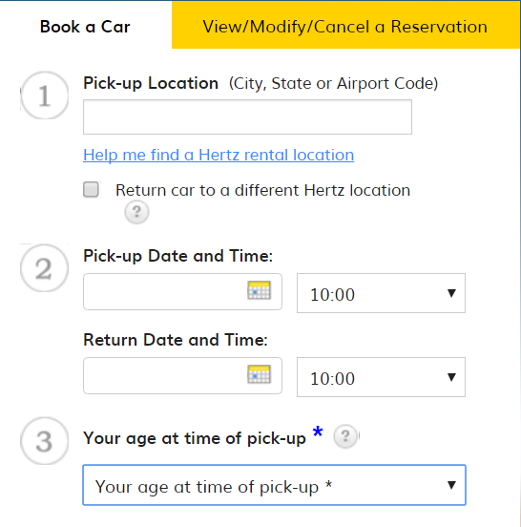

As can be seen to begin the rental process Hertz has a very simple input menu to get the basic quote for a rental, the only details needed are Start Date, End Date, Pickup location (not necessary for City Car Rental as they only have one pickup location) and age.

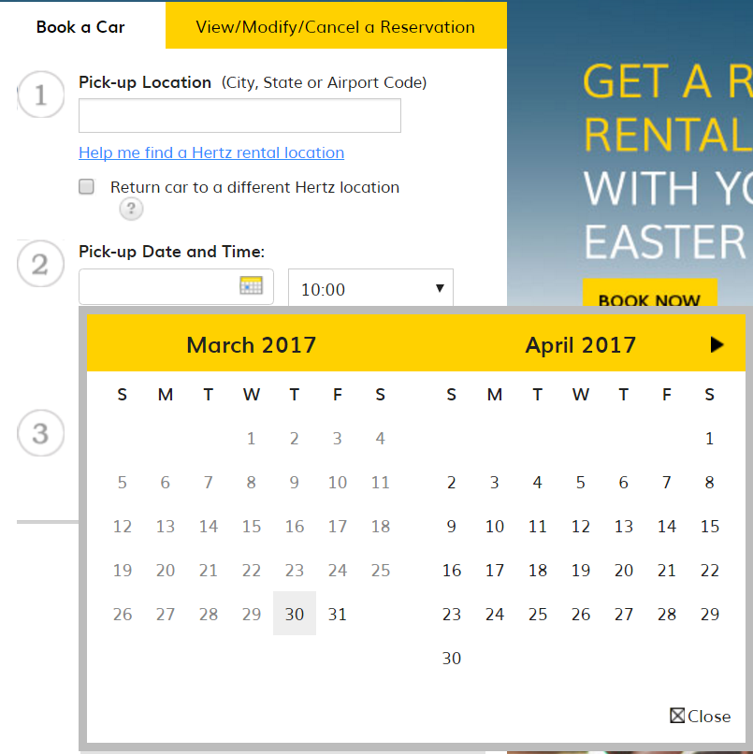

Hertz also make use of date-time pickers in order to set the Start Date and End Date, this would be a useful feature to add into my new system as it adds validation and reduces human error.

Avis Car Rental

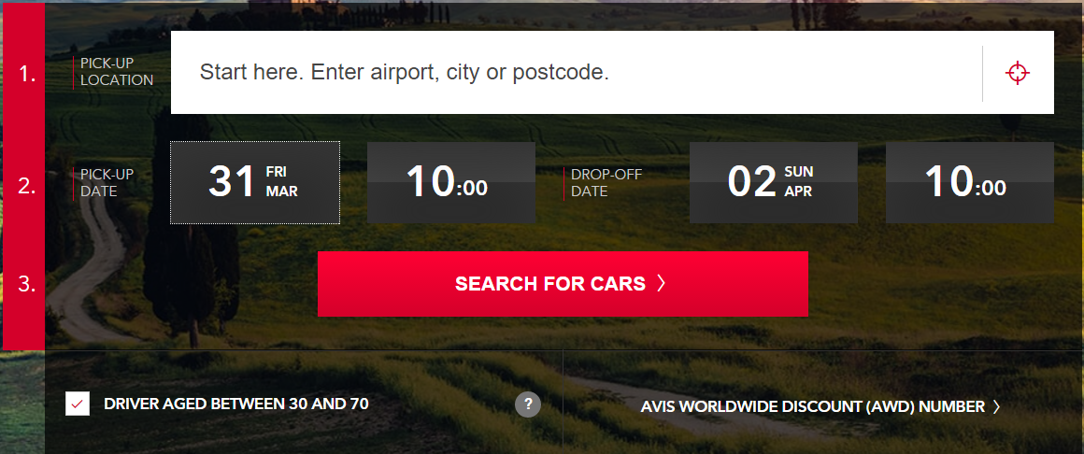

As shown above Avis has an even simpler design, showing that the rental system does not have to be complex, I shall take this on board and make my system as intuitive and easy to use as possible, this will make the system appropriate for the technical skills of the members of staff.

Avis have also made use of clear buttons and natural formatting of everything, this makes their form very pleasing to view especially with the partially opaque background. I will incorporate this into my program as much as possible, however, due to time and budget restrictions, I will not be able to refine my design to this level.

Best facilities and features of these systems

From what I have observed from these other system, I have found that the design and layout of the system does not need to be overly complex or cluttered and can be very clean and simple while still retaining all functionality.

This will help with system implementation, staff training and when hiring inexperienced staff.

Date-time pickers are also essential for the new system as it will save time and reduce errors in formatting or orientation of typing the date as different programs and different countries can write their dates in separate ways. All date-time pickers are easy to use, fast and efficient and would be an excellent addition to the new system.

Justification of language

I have decided I will be developing the new system using C# with a SQL Server Express database after considering the advantages and disadvantages of other programming languages including Visual Basic, C#, and Java

Justification for C#

The main requirements for the new system which persuaded me when choosing the solutions include speed, efficiency, storage and ease of use for employees.

The development of the new system will be quick and easy as I am already well versed in C# so there won't be much of a learning process and it is not error-prone during development. C# is also a very easy language to learn so if there is anything that I need to learn it will not be very difficult or time-consuming. C# is a compiled language meaning it will undergo optimisation when compiled, this will ensure that the new system is efficient and runs as quickly and smoothly as possible.

There is support for internationalization, meaning that when designing a system in C# it can be adapted to various other languages without many changes. This may be useful if City Car Rental wishes to expand their system.

Justification of Database Management System

I have chosen to use SQL server express, I have made this decision by taking into account, City Car rentals goals for the new system and goals for the future and also the time and budget restrictions.

As the main business goal for City Car Rental is to expand and gain a larger customer base. Using MS SQL Allows for the size of the database to grow immensely and still be very efficient to search through, sort and view records in the database.

Due to budget restrictions, SQL Server Express is the best option as it is free to install on all computers and free to develop on.

Efficiency and saving time are the primary goals of the new system for City Car Rental, SQL Server is perfect for this as it allows for what are called SQL commands; which can be implemented into a C# program to make it fast and easy to add, update, delete, search, and select records from a database for use by the staff.

Using SQL Server Express will allow the database to be customised to perfectly suit the purpose that it is intended as in many ways SQL can be edited and customised to ensure the database is perfect for the required specification.

Methods of current system

The current paper-based system uses forms filled out by staff. These are then stored in a customer's file and then later transferred to an archive whenever the booking is over, a payment is made etc.

The details that are filled in and calculated can be seen below, as shown below there are 5 different forms that can be filled out, the staff form is kept on its own as the owner of the business fills one of these forms is filled in every time a new staff member joins the business, the customer, payment and bookings forms are compiled into a folder for a single customer, this folder contains the customers details, the customers previous bookings, payments.

The vehicles forms are also kept separate and are a record of the details of each vehicle that is available to rent in the business and whether or not it is currently rented.

Data Flow Diagrams

Level 0 Data Flow Diagram For City Car Rental

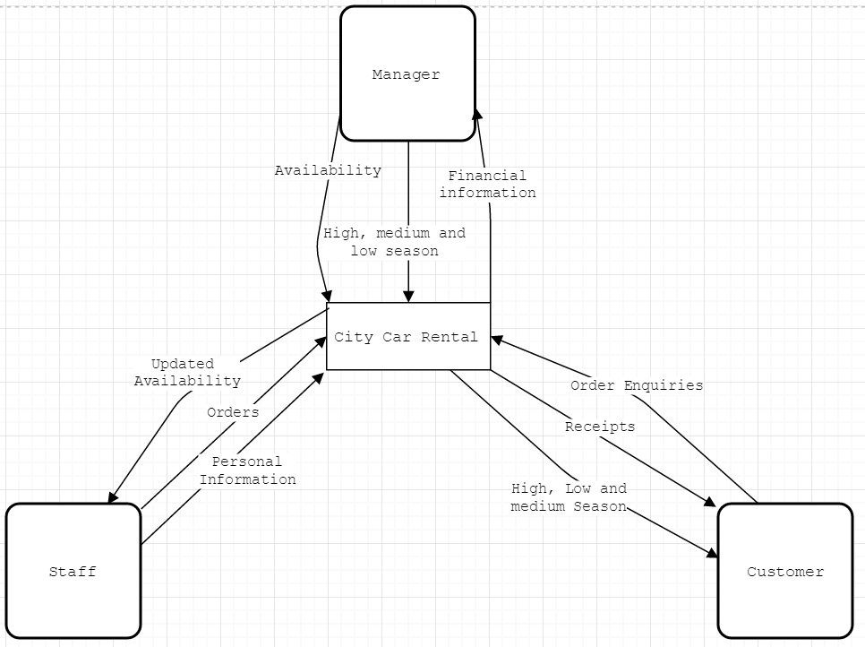

Level 1 Data Flow Diagram For Booking at City Car Rental

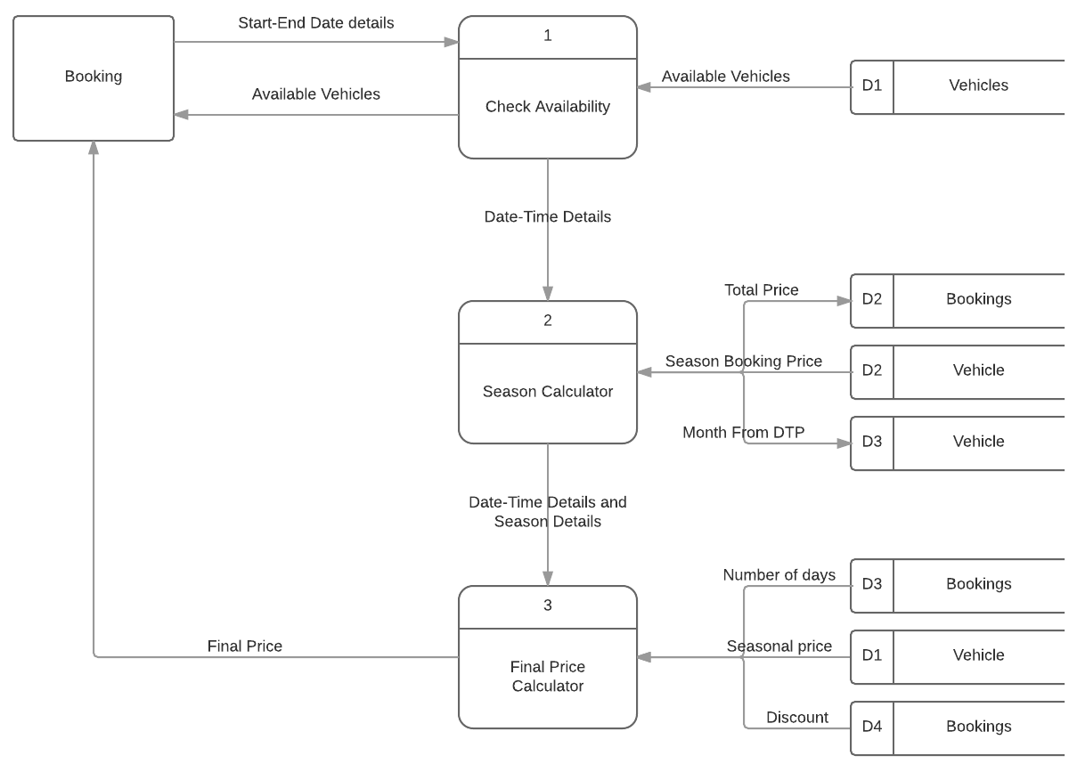

**Customer Details**

**Personal Details;**

Full Name: _____________________________

Title: _____________________________

Gender: ______________________________

**Location Details;**

Street Name: _____________________________

Door Number: _____________________________

Postcode: _____________________________

Town: _____________________________

**Contact details;**

Phone Number: +44___________________________

Email Address: ______________@_______________

Accept that the details on this form

may be archived in case of future bookings: □

**Staff Details Form**

*Note: This document will only be accessed by the manager*

**Personal Details;**

Full Name: _____________________________

Title: _____________________________

Gender: ______________________________

**Location Details;**

Street Name: _____________________________

Door Number: _____________________________

Postcode: _____________________________

Town: _____________________________

**Contact details;**

Phone Number: +44___________________________

Email Address: ______________@_______________

I Agree that the Business 'City Car Rental' will hold these

details for the duration of my employment: □

Date: __________

Signed: _______________

To agree on payment method and date, please speak with the manager

**Payment Details**

**Personal Details;**

Staff Full Name: _____________________________

Full Name: _____________________________

Title: _____________________________

**Contact details;**

Phone Number: +44___________________________

Email Address: ______________@______________

**Booking Details;**

Booking ID: _____________________________

Start Date _____________________________

Rental Vehicle: _____________________________

**Payment Details;**

Payment amount; £_________________________

Fully paid?: □

Date: ___________

Note: Payment method to be discussed from staff to customer and can be done through cash or card

**Vehicle Information Form**

**Vehicle Details;**

Registration: _____________

Type: _____________

Capacity: _____________

Rating: _____________

High Price: _____________

Medium Price: _____________

Low Price: _____________

Make: _____________

Model: _____________

Year: _____________

Mileage: _____________

MPG: _____________

Power: _____________

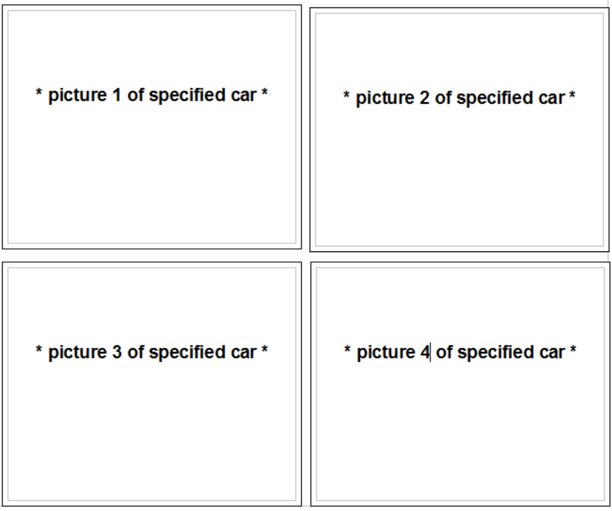

**Booking Details Form**

**Personal Details;**

Staff Full Name: _____________________________

Full Name: _____________________________

Title: _____________________________

**Contact details;**

Phone Number: +44___________________________

Email Address: ______________@______________

**Location Details;**

Street Name: _____________________________

Door Number: _____________________________

Postcode: _____________________________

Town: _____________________________

**Vehicle Details;**

Registration: _____________________________

Make: _____________________________

Model: _____________________________

Year: _____________________________

Mileage: _____________________________

(Before Rental)

**Booking Details;**

Booking ID: _____________________________

Start Date: _____________________________

End Date: _____________________________

Booked Date: _____________________________

Price of Vehicle:_____________________________

Deposit: _____________________________

Discount: _____________________________

Final Price: _____________________________

Specification requirements

**Splash Screen**

Form must;

* Be size 720x480 and have a pale blue background.
* Contain the company logo, address, phone number and welcome picture.
* Have text of font; Microsoft Sans Serif and size; 12pt for company information.
* Application must begin with an automatically timed splash screen that will appear for 3.5 seconds then load into the login menu.
* the splash screen will have the Logo of the business and the contact details.

**Login**

Form must;

* Be size 720x480 and have a pale blue background.
* Contain the company logo.
* Have a username label with text of font; Microsoft Sans Serif and size; 8pt.
* Have a password label with text of font; Microsoft Sans Serif and size; 8pt.
* Have a username Combo-box containing all staff usernames with text of font; Microsoft Sans Serif and size; 8pt.
* Have a password textbox with text of font; Microsoft Sans Serif and size; 8pt.
* Have a login button with text of font; Microsoft Sans Serif and size; 8pt.
* Have a close button with text of font; Microsoft Sans Serif and size; 8pt.
* Have a login title with text of font; Microsoft Sans Serif and size; 40pt.
* a drop-down menu for selecting a username
* a login that will only be permitted with the correct password
* a login button which is disabled until the password is entered
* a button to close the application
* multiple access levels for staff and managing staff

**Menu**

Form must;

* have buttons to navigate to each part of the form excluding the splash screen and a button to close the application
* Be size 480x668 and have a pale blue background
* Contain the company logo
* Have a booking button with text of font; Microsoft Sans Serif and size; 8pt.
* Have a customers button with text of font; Microsoft Sans Serif and size; 8pt.
* Have a payments button with text of font; Microsoft Sans Serif and size; 8pt.
* Have a staff button with text of font; Microsoft Sans Serif and size; 8pt.
* Have a close button with text of font; Microsoft Sans Serif and size; 8pt.
* Have a vehicles button with text of font; Microsoft Sans Serif and size; 8pt.
* Have a logout button with text of font; Microsoft Sans Serif and size; 8pt.
* Have a Menu title with text of font; Microsoft Sans Serif and size; 40pt.

**Booking**

Form must;

* Be size 1440x850 and have a pale blue background
* Contain the company logo
* Have a Close button with text of font; Microsoft Sans Serif and size; 8pt.
* Have a Booking title with text of font; Microsoft Sans Serif and size; 40pt.
* Have a Menu button with text of font; Microsoft Sans Serif and size; 8pt.
* Have a Booking ID textbox with text of font; Microsoft Sans Serif and size; 8pt.
* Have a Registration textbox with text of font; Microsoft Sans Serif and size; 8pt.
* Have a Customer ID textbox with text of font; Microsoft Sans Serif and size; 8pt.
* Have a Start Date textbox with text of font; Microsoft Sans Serif and size; 8pt.
* Have an End Date textbox with text of font; Microsoft Sans Serif and size; 8pt.
* Have a Booked Date textbox with text of font; Microsoft Sans Serif and size; 8pt.
* Have a Total Price textbox with text of font; Microsoft Sans Serif and size; 8pt.
* Have a Deposit textbox with text of font; Microsoft Sans Serif and size; 8pt.
* Have a Discount textbox with text of font; Microsoft Sans Serif and size; 8pt.
* Have a Final Price textbox with text of font; Microsoft Sans Serif and size; 8pt.
* Have a Start Date Date picker with text of font; Microsoft Sans Serif and size; 8pt.
* Have an End Date Date picker with text of font; Microsoft Sans Serif and size; 8pt.
* Have a Data grid view containing the booking table, customers table and vehicles table with text of font; Microsoft Sans Serif and size; 8pt.
* Have an Add button with text of font; Microsoft Sans Serif and size; 8pt.
* Have a Save button with text of font; Microsoft Sans Serif and size; 8pt.
* Have a Delete button with text of font; Microsoft Sans Serif and size; 8pt.
* Have a Print button with text of font; Microsoft Sans Serif and size; 8pt.
* Have a First Button with text of font; Microsoft Sans Serif and size; 8pt.
* Have a Next Button with text of font; Microsoft Sans Serif and size; 8pt.
* Have a Previous button with text of font; Microsoft Sans Serif and size; 8pt.
* Have a Last button with text of font; Microsoft Sans Serif and size; 8pt.
* Have a Check Availability button with text of font; Microsoft Sans Serif and size; 8pt.
* Have a search field picker combo-box with text of font; Microsoft Sans Serif and size; 8pt.
* Have a search textbox with text of font; Microsoft Sans Serif and size; 8pt.
* Have an Availability data grid view containing available vehicles with text of font; Microsoft Sans Serif and size; 8pt.

**Payments**

Form must;

* Be size 1080x540 and have a pale blue background
* Contain the company logo
* Have a Close button with text of font; Microsoft Sans Serif and size; 8pt.
* Have a Payments title with text of font; Microsoft Sans Serif and size; 40pt.
* Have a Menu button with text of font; Microsoft Sans Serif and size; 8pt.
* Have a Booking ID textbox with text of font; Microsoft Sans Serif and size; 8pt.
* Have a Payment ID textbox with text of font; Microsoft Sans Serif and size; 8pt.
* Have a Customer ID textbox with text of font; Microsoft Sans Serif and size; 8pt.
* Have a Staff ID textbox with text of font; Microsoft Sans Serif and size; 8pt.
* Have a Payment Date textbox with text of font; Microsoft Sans Serif and size; 8pt.
* Have a Payment textbox with text of font; Microsoft Sans Serif and size; 8pt.
* Have a Fully Paid textbox with text of font; Microsoft Sans Serif and size; 8pt.
* Have a search field picker combo-box with text of font; Microsoft Sans Serif and size; 8pt.
* Have a search textbox with text of font; Microsoft Sans Serif and size; 8pt.
* Have a data grid view containing the Payments table with text of font; Microsoft Sans Serif and size; 8pt.
* Have an Add button with text of font; Microsoft Sans Serif and size; 8pt.
* Have a Save button with text of font; Microsoft Sans Serif and size; 8pt.
* Have a Delete button with text of font; Microsoft Sans Serif and size; 8pt.
* Have a Print button with text of font; Microsoft Sans Serif and size; 8pt.
* Have a First Button with text of font; Microsoft Sans Serif and size; 8pt.
* Have a Next Button with text of font; Microsoft Sans Serif and size; 8pt.
* Have a Previous button with text of font; Microsoft Sans Serif and size; 8pt.
* Have a Last button with text of font; Microsoft Sans Serif and size; 8pt.

**Staff**

Form must;

* Be size 1080x540 and have a pale blue background
* Contain the company logo
* Have a Close button with text of font; Microsoft Sans Serif and size; 8pt.
* Have a Staff title with text of font; Microsoft Sans Serif and size; 40pt.
* Have a Menu button with text of font; Microsoft Sans Serif and size; 8pt.
* Have a Title textbox with text of font; Microsoft Sans Serif and size; 8pt.
* Have a Forename textbox with text of font; Microsoft Sans Serif and size; 8pt.
* Have a Surname textbox with text of font; Microsoft Sans Serif and size; 8pt.
* Have a Staff ID textbox with text of font; Microsoft Sans Serif and size; 8pt.
* Have an Address textbox with text of font; Microsoft Sans Serif and size; 8pt.
* Have a Town textbox with text of font; Microsoft Sans Serif and size; 8pt.
* Have a Postcode textbox with text of font; Microsoft Sans Serif and size; 8pt.
* Have a Phone Number textbox with text of font; Microsoft Sans Serif and size; 8pt.
* Have an Email textbox with text of font; Microsoft Sans Serif and size; 8pt.
* Have a Username textbox with text of font; Microsoft Sans Serif and size; 8pt.
* Have a Password textbox with text of font; Microsoft Sans Serif and size; 8pt.
* Have a search field picker combo-box with text of font; Microsoft Sans Serif and size; 8pt.
* Have a search textbox with text of font; Microsoft Sans Serif and size; 8pt.
* Have a data grid view containing the Payments table with text of font; Microsoft Sans Serif and size; 8pt.
* Have an Add button with text of font; Microsoft Sans Serif and size; 8pt.
* Have a Save button with text of font; Microsoft Sans Serif and size; 8pt.
* Have a Delete button with text of font; Microsoft Sans Serif and size; 8pt.
* Have a Print button with text of font; Microsoft Sans Serif and size; 8pt.
* Have a First Button with text of font; Microsoft Sans Serif and size; 8pt.
* Have a Next Button with text of font; Microsoft Sans Serif and size; 8pt.
* Have a Previous button with text of font; Microsoft Sans Serif and size; 8pt.
* Have a Last button with text of font; Microsoft Sans Serif and size; 8pt.

**Customer**

Form must;

* Be size 1080x540 and have a pale blue background
* Contain the company logo
* Have a Close button with text of font; Microsoft Sans Serif and size; 8pt.
* Have a Customer title with text of font; Microsoft Sans Serif and size; 40pt.
* Have a Menu button with text of font; Microsoft Sans Serif and size; 8pt.
* Have a search field picker combo-box with text of font; Microsoft Sans Serif and size; 8pt.
* Have a Title textbox with text of font; Microsoft Sans Serif and size; 8pt.
* Have a Forename textbox with text of font; Microsoft Sans Serif and size; 8pt.
* Have a Surname textbox with text of font; Microsoft Sans Serif and size; 8pt.
* Have a Customer ID textbox with text of font; Microsoft Sans Serif and size; 8pt.
* Have an Address textbox with text of font; Microsoft Sans Serif and size; 8pt.
* Have a Town textbox with text of font; Microsoft Sans Serif and size; 8pt.
* Have a Postcode textbox with text of font; Microsoft Sans Serif and size; 8pt.
* Have a Phone Number textbox with text of font; Microsoft Sans Serif and size; 8pt.
* Have an Email textbox with text of font; Microsoft Sans Serif and size; 8pt.
* Have a search textbox with text of font; Microsoft Sans Serif and size; 8pt.
* Have a data grid view containing the Customer table with text of font; Microsoft Sans Serif and size; 8pt.
* Have an Add button with text of font; Microsoft Sans Serif and size; 8pt.
* Have a Save button with text of font; Microsoft Sans Serif and size; 8pt.
* Have a Delete button with text of font; Microsoft Sans Serif and size; 8pt.
* Have a Print button with text of font; Microsoft Sans Serif and size; 8pt.
* Have a First Button with text of font; Microsoft Sans Serif and size; 8pt.
* Have a Next Button with text of font; Microsoft Sans Serif and size; 8pt.
* Have a Previous button with text of font; Microsoft Sans Serif and size; 8pt.
* Have a Last button with text of font; Microsoft Sans Serif and size; 8pt.

**Vehicle**

Form must;

* Be size 1080x540 and have a pale blue background
* Contain the company logo
* Have a Close button with text of font; Microsoft Sans Serif and size; 8pt.
* Have a Vehicle title with text of font; Microsoft Sans Serif and size; 40pt.
* Have a Menu button with text of font; Microsoft Sans Serif and size; 8pt.
* Have a Registration textbox with text of font; Microsoft Sans Serif and size; 8pt.
* Have a Type textbox with text of font; Microsoft Sans Serif and size; 8pt.
* Have a Capacity textbox with text of font; Microsoft Sans Serif and size; 8pt.
* Have a Rating textbox with text of font; Microsoft Sans Serif and size; 8pt.
* Have a High Price textbox with text of font; Microsoft Sans Serif and size; 8pt.
* Have a Medium Price textbox with text of font; Microsoft Sans Serif and size; 8pt.
* Have a Low Price textbox with text of font; Microsoft Sans Serif and size; 8pt.
* Have a Make textbox with text of font; Microsoft Sans Serif and size; 8pt.
* Have a Model textbox with text of font; Microsoft Sans Serif and size; 8pt.
* Have a Year textbox with text of font; Microsoft Sans Serif and size; 8pt.
* Have a Mileage textbox with text of font; Microsoft Sans Serif and size; 8pt.
* Have a MPG textbox with text of font; Microsoft Sans Serif and size; 8pt.
* Have a Power textbox with text of font; Microsoft Sans Serif and size; 8pt.
* Have a search field picker combo-box with text of font; Microsoft Sans Serif and size; 8pt.
* Have a search textbox with text of font; Microsoft Sans Serif and size; 8pt.
* Have a data grid view containing the Vehicles table with text of font; Microsoft Sans Serif and size; 8pt.
* Have an Add button with text of font; Microsoft Sans Serif and size; 8pt.
* Have a Save button with text of font; Microsoft Sans Serif and size; 8pt.
* Have a Delete button with text of font; Microsoft Sans Serif and size; 8pt.
* Have a Print button with text of font; Microsoft Sans Serif and size; 8pt.
* Have a First Button with text of font; Microsoft Sans Serif and size; 8pt.
* Have a Next Button with text of font; Microsoft Sans Serif and size; 8pt.
* Have a Previous button with text of font; Microsoft Sans Serif and size; 8pt.
* Have a Last button with text of font; Microsoft Sans Serif and size; 8pt.

**Invoice**

Form must;

* Be size 480x720 and have a pale blue background
* Contain the company logo
* Contain a list-box with the customers details
* Contain a list-box with the booking details
* Have a Invoice title with text of font; Microsoft Sans Serif and size; 40pt.

Limitations of the currents system

With the growth of City Car Rental in Recent times, the paper-based system has reached the end of its life cycle and is at its breaking point. The sheer size of all the files and records that the business has accumulated has gradually gotten out of hand and needs to be addressed. The rate at which important forms and records are being misplaced or damaged is increasing due to their large number. This is a few of the many reasons why the new system must be implemented very soon as everything is slowly becoming unmanageable due to the increasing number of bookings and customers.

Current system inputs/outputs

Data collected for input

Customer

* Customers Full Name
* Customers Address and postcode
* Customers contact details
* Customers Payment information (to make payments for rentals)

Payments

* Customer that is making the payment
* Staff member that is authorised to make the payment
* Payment amount
* Payment date
* Whether the rental is fully paid

Booking

* + Vehicle being rented
  + Customer making the booking
  + Booking start date
  + Booking end date
  + Date the booking is made
  + Total price of vehicle before discount or days calculated

Staff

* Staff Full Name
* Staff Address and postcode
* Staff contact details
* Staff username and password

Vehicle

* Vehicle Information
* Vehicle rental prices per day
* Whether the vehicle is refueled
* Whether the vehicle is damaged

Data to be calculated and output from the system

Discount

The discount off a rental at city car rental is calculated based on how long the rental is if it is over 7 days the customer gets a 5% discount and if the rental lasts for over 20 days the customer gets a 20% discount

Final Price

The final price is calculated with the price of the rental depending on the season, with the discount added and then multiplied by the number of days between the start date and end date

Methods to be used in the new system

With the new system, data will be entered in a very similar fashion to how it is entered now, data will be entered into the system using textboxes, this should keep the learning curve of the new system very low and retain the simplicity of the old system.

As the customer, staff, vehicles and payments forms are very similar, their layout and design functionality will be very alike, I will use textboxes to enter data, buttons to add, save and delete selected data, a combo-box and textbox to search data, a data-grid-view to view data that has been entered into the database and a selection of “First”, “Previous”, “Next”, “Last” buttons to navigate this data-grid-view, a logout button which brings the user back to the login menu and a close button which closes the entire application.

The Booking forms design has not yet been finalised but it will have the majority of the data entered through text boxes and the start/end date will be selected with date/time picker, however, the total price, discount and final price will be calculated automatically.

There will also be buttons to add, save and delete selected data, a combo-box and textbox to search data, multiple data-grid-views will be used to view data that has been entered into multiple databases so the data can be selected and a selection of “First”, “previous”, “next”, “last” buttons to navigate this data-grid-view, a logout button which brings the user back to the login menu, a close button which closes the entire application and a button to check the availability.

I used these to keep the simplicity from the previous system as I wanted to prevent making the new system over complicated and it ensures a small amount of validation within it as an invalid date cannot be selected with a date-time picker and the wrong customer and vehicle cannot be selected if it is clicked from the other data-grid-view.

Success criteria for the proposed program

These give a brief overview of the full system to be designed, these will be passed on to the manager to make sure he is on board with the proposed program.

1. The new system must be more efficient than the current paper-based system, this will allow the staff of City Car Rental to handle an increasing amount of customers.
2. The new system must be able to calculate rental prices based on the details of the booking entered, preventing human error in calculations unless the dates entered are incorrect.
3. The new system must be able to easily and quickly add, edit or delete existing customer details saving time for the employees to bring more customers into the business.
4. The new system must be aesthetically pleasing and forms must be in a

ergonomic layout to enable employees to efficiently navigate the system and make it more easily adapted from the current system.

Key Performance indicators

City Car Rental Business goals

* Expand customer base
* More efficiently deal with rentals
* Reduce errors in records and rentals
* Increase customer satisfaction
* Increase staff morale

How the New system will help reach these goals

Currently, due to the paper-based system, the customer records are very inefficient, this means that if they gain many more customers, the current system will become unusable. However, the new system will greatly improve this making everything orders of magnitude more efficient, for example, searching for customer archives will go from taking multiple minutes to taking seconds and organising all archives will go from taking up to hours to taking a couple of seconds. Therefore the new system will allow City Car Rental to greatly expand their customer base, achieving their desired goals.

As a DBMS is being used to create the new system, SQL Commands can be used to quickly sort, search, select, update, insert or delete records. This will allow City Car Rentals to deal with new or existing rentals much more efficiently than with the current system and help the business reach this goal.

As the new system will have validation when entering data and using date-time pickers will make it easier to input and check data, this will greatly reduce errors in typing or inputting the incorrect data. Also as the discount and prices are automatically calculated, this excludes maths errors from happening and will reduce errors further.

Due to the reasons above, customers will be dealt with much more quickly than before and fewer errors will be made with their details and bookings, this should inevitably increase customer satisfaction in comparison with the current system.

As all the tasks the staff will have to complete will be much easier to complete and much faster to complete than with the current system, this will surely increase the morale of all staff members as their job will not only be faster but also easier, the morale may not rise when the new system is first implemented as it may take some time for the staff to become accustomed to the new system but I will do my best to make the new system intuitive and easy to learn for the staff.

Objectives/ Performance indicators

1. Manipulate the data in all forms.
2. Delete data in all forms.

1. Add data into all forms.
2. Search the data of the records.
3. View the records.
4. Navigate to all forms.
5. Produce an invoice from bookings.
6. Display a splash screen to welcome the user when the program is first launched, this should contain the City Car Rental logo and contact details.
7. The login form should validate the login password, it should compare the selected username with the entered password and the stored password.
8. The navigation menu should allow the user to navigate to all forms

Design

Section 3



Abstraction

* I have used abstraction as it makes the system more organised in the development process and makes it much easier to understand the task at hand as it is broken down into smaller tasks.
* Abstraction will also aid in ensuring the system has met all objectives initially set out to be accomplished.

Level 1 Abstraction for City Car Rental booking system



Level 2 Staff Abstraction



Level 2 Customer Abstraction



Level 2 Payments Abstraction



Level 2 Vehicle Abstraction



Processes of The New System

Database processes

Data-grid – information is selected from a specific database table depending on the current form.

Check availability – vehicles will be selected based on which vehicles are not booked within the start and end date.

Search functions – this will search the database within a certain field for records containing characters input by the user.

Add processes – this inserts the data in the textboxes to the database into a new record for the table for each form.

Save processes – this updates the selected record with the data in the textboxes.

Delete processes – this deletes the selected record from the current data-grid-view.

Invoice processes

Customer details and booking details from the selected record will be added to two arrays from separate classes and then added to their own listboxes.

Bookings Form Calculation Processes

Discount – Calculates the discount depending on whether the booking is greater than 7 days or whether it is greater than 20 days.

Season – Calculates how much the customer needs to pay based on the high, low, medium seasons.

Final Price – Calculates the final price depending on the seasonal price, discount based on length of booking and number of days based on length of booking.

Login access

Username – filled by all records in the username field in the staff table from the SQL database.

Password – cross references the selected username record’s password with whatever is entered by the user

How the sub-programs and objectives link

1. Manipulate the data in all forms.
   1. Textboxes will be used to show the data from a selected record and the user will then be able to input different values into the record and save them, this will still be checked under validation.
   2. There will be automatic calculations for the season price, final price and discount, this will be useful if a customer needs to edit a booking.
2. Delete data in all forms.
   1. The booking, customer, payments, vehicles, and staff form all contain a delete button to delete the selected form from the program

1. Add data into all forms.
   1. The booking, customer, payments, vehicles, and staff form all contain a add button add the data from the textboxes to the database.
2. Search the data of the records.
   1. The booking, customer, payments, vehicles, and staff form all contain a function to search the primary key or other indexed field.
3. View the records.
   1. The booking, customer, payments, vehicles, and staff form will all contain data-grid-views to view the records in the database.
4. Navigate the records.
   1. The booking, customer, payments, vehicles, and staff form will all contain a first, previous, next and last function to aid the user in navigating the records from each table.
5. Produce an invoice from bookings.
   1. The bookings form will contain a print booking button which will place the customer details and booking details on a form with an invoice title

Validation within the system

The validation I will be including in my program will ensure that no unauthorized users enter the system and that no wildly incorrect data will be input or output from the system. Slightly incorrect data will still go through the system.

For example, if a customer's address is 70 Holywood Road and 71 Holywood Road is entered, the system will have no idea that this data is incorrect however if a customer's postcode is BT154DN and 70 Holywood Road is entered, the system will call an error that the data entered is incorrect. This will greatly reduce the number of incorrect inputs which will, in turn, save the business money and the employees time and frustration.

The automatic calculations for discount, season and final price will help improve with validation as there will be no mathematical errors with those calculations.

Using date-time pickers will aid in validation as an invalid date will not be able to be entered into the database and will help in making sure the correct date is selected.

I will also select the different data types for every field for all tables. This will ensure no data will be wildly incorrectly entered into the database as it will fall outside the constraints of the data type and throw a database error.

Try – catch statements will also be used to enclose some of the code in the new system, this will prevent errors if the system is used incorrectly and will reduce crashes of the system

If – else statements will be used to further validate the new system as it will ensure certain conditions apply before certain functions can be executed.

Files

The main areas of the program are contained in the Visual Studio project folder, this consists of the solution file (sln) which will then interact with other files in the project folder, like the form design files and classes.

The SQL database's data will be taken from the Primary Data File (.mdf) and Transaction Log Files(.ldf) for the City Car Rentals Database. There will also be query files that will be created with any new queries used in the creation of the SQL database.

Data Structures

Data is stored in a specific structure of tables connected with specific relationships in the relational database. These tables consist of Bookings, Vehicles, Customers, Staff and Payment.

The C# program in visual studio will make use of these files to display and edit data from it. The C# program will also make use of arrays, classes and data-grid-views to store and display various data.

Methods of Access

It will also make use of Random Access to various files. This is beneficial as it allows direct access to memory locations rather than sequenced access which is much slower. There will also be the use of Open Database Connectivity (ODBC) to a database via SQL meaning you can access files in a number of different databases.

Processing Routines

How the Processes manipulate the data

Check availability Process:

This selects from the vehicles table, it selects the vehicles that have no registered booking between the start date and end date to show which vehicles are available for rental.

Seasonal Process:

This process takes the start date from the date-time picker and finds what value the month is, if it is from January to April the process reads the low price of the selected vehicle and writes it to the total price textbox, if it is from May to August the process reads the High price of the selected vehicle and writes it to the total price textbox, if it is from September to December the process reads the Medium price of the selected vehicle and writes it to the total price textbox.

Discount Process:

A timespan is created that finds the number of days between the end date and the start date, it then takes the total price from the seasonal process and multiplies it by either 0.95 if the number of days is 7<days<20 and multiplies it by 0.8 if days >20.

Final Price:

This takes the previous to processes and the discount time span, it then takes the time span and multiplies it by the seasonal price and then multiplies it by the discount multiplier to get the total price with all things taken into account.

Connection between program and subprograms and external files

|  |  |  |
| --- | --- | --- |
| Form | Subprogram-connection | Interconnection |
| Splash Screen | Login | Just a start-up function, no connection to files |
| Login | Menu | Uses the Staff Table to read and compare username/password details to grant access to authorised users. |
| Menu | Login, Bookings, Customer, Staff, Vehicles, Payments | Navigation part of the system, no connection to external files |
| Bookings | Menu | Uses Bookings table to Read/Edit/Delete/Add/Select/Search records.  Uses Vehicles table to Select/Check Availability/Read records.  Uses Customer table to Select/Read records. |
| Customer | Menu | Uses Customer table to Read/Edit/Delete/Add/Select/Search records. |
| Staff | Menu | Uses Staff table to Read/Edit/Delete/Add/Select/Search records. |
| Vehicles | Menu | Uses Vehicles table to Read/Edit/Delete/Add/Select/Search records. |
| Payments | Menu | Uses Payments table to Read/Edit/Delete/Add/Select/Search records. |

Prototype

Section 4



Justification of Areas Included In The Prototype

The areas that have been included in the first prototype of the program are as follows:

* The SQL Database
  + I have created and completed the majority of the database from the information I have currently been provided with, I did this as I needed to ensure the link to SQL was working correctly in the C# program before continuing too far.
* The Splash Screen
  + I have included this as it was very simple and easy to create although in its current state it is purely functional and does not have the businesses desired design on it which will be added in a later prototype.
* The Login Form
  + This has been included as I wanted to ensure from the beginning that this program was secure, as I have already been given the information for the customers and the staff and I would need to make sure no one could gain unauthorized access to the program.
* The Navigation/Menu Form
  + I needed to include this as a way for me to navigate to the different areas of the program and it is a good foundation for the rest of the program to be created from as it acts as a hub that provides access to the rest of the program.
* The Customer’s Form
  + I created the customer’s form as the database for the program has already been created in SQL Server Express and I wanted to ensure all the features for linking to the database and modifying it were working and present before continuing on with the rest of the program.
* The Staff Form
  + As I already possessed the staff information and had the database in SQL created I decided to include it in the first prototype, secondly, the design and inner workings of the staff form are very similar to the customer’s form so there would not be much time used in creating this form and getting it to work.
* The Payments Form
  + The payments form is not entirely completed as I do not have all the information from the business to get the form running through SQL but the design of the payments form has been completed.
* The Vehicles Form
  + I created the vehicle’s form as the database for the program has already been created in SQL Server Express and I wanted to ensure all the features for linking to the database and modifying it were working and present before continuing on with the rest of the program.

Justification of Areas Omitted from the Prototype

Some areas and features have been omitted from the initial prototype that will be included in the final version of the program those are as follows:

* The Bookings Form
  + I am currently unable to complete the bookings form for the program as I do not currently have City Car Rentals records for the bookings and the design and code for the bookings will be the most time consuming and most difficult to create, it will be featured in the final program
* Data Validation
  + No forms of data validation have been included in the prototype as I will be the only user of the program and any data that will be entered will be for testing purposes only and will not be used in the business.
* Final Aesthetic Design
  + I have completed the design as far as the placements of everything but the final colours, logos, pictures and other aesthetic features have not yet been fully included, they will be included in the very final product, I decided to do this as it gives me flexibility as far as adding feature, as with all the aesthetic features included there is not much room for change with design and functional features

Proposed Interface Design

Splash Screen

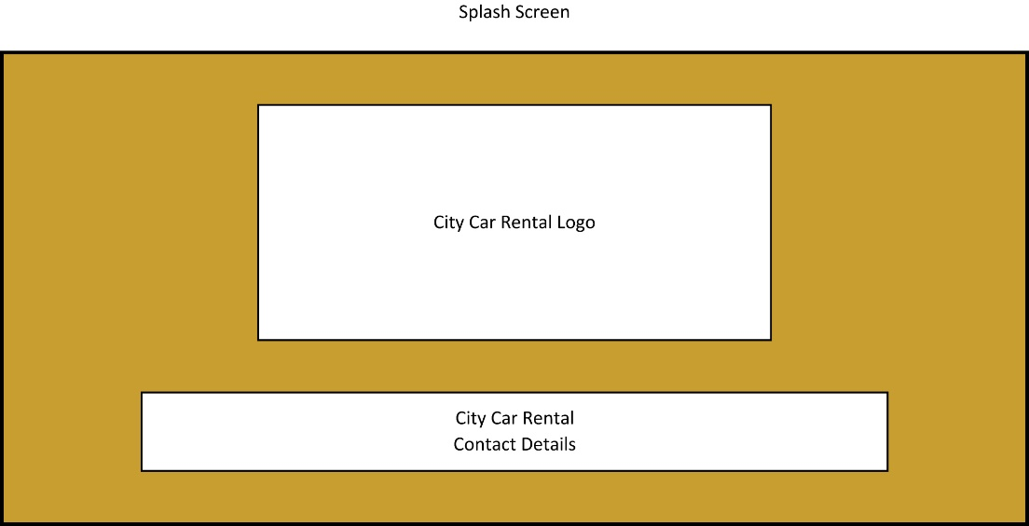

The proposed design of the splash screen is fully complete and should be fit for audience and the desired purpose. however, the colour of the form and location of the logo is not finalised, the location and layout of everything else will remain the same in the finalised system. This screen will show when the program opens, for 3.5 seconds and then shows the login form.

Timer – Shows splash screen for 3.5 seconds then loads the login Menu and closes the splash screen.

Login Form

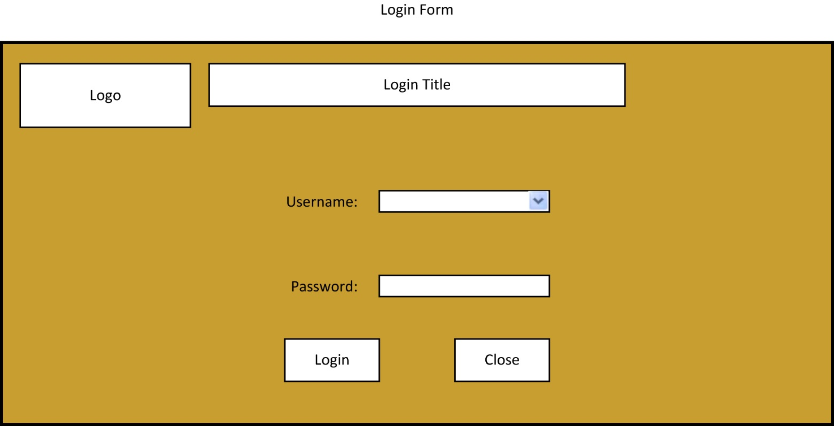

The proposed design of the login form is fully complete and should be fit for audience and the desired purpose. however, the colour of the form and location of the logo is not finalised, the location and layout of everything else will remain the same in the finalised system. the drop-down menu is filled by the SQL database with the usernames of staff and the password is validated by the SQL database.

The login button then either allows the user access if the password is correct or denies access if it is incorrect. The close button closes the program.

Username combo box – Displays a list of usernames for the system so the user can choose their profile.

Password text box – Allows the User to enter the password to their account.

Login Button – Checks if the password entered matches the username and loads the navigation menu and closes the login form if they are correct, otherwise it will display a message that the username or password are incorrect.

Close button – Closes the application when clicked.

Menu Form

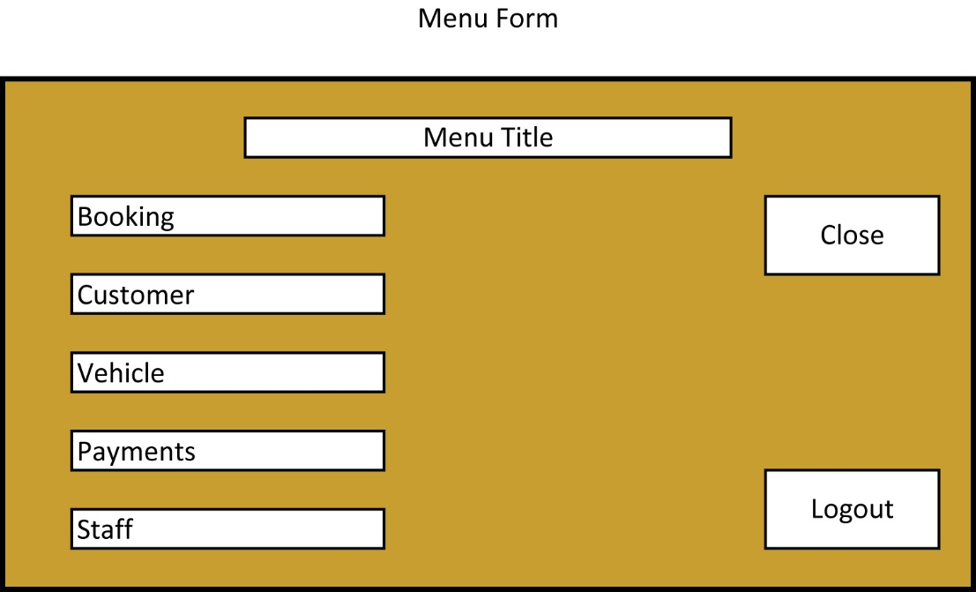

The proposed design of the menu form is fully complete and should be fit for audience and the desired purpose. however, the colour of the form and location of the logo is not finalised, the location and layout of everything else will remain the same in the finalised system.

The Bookings button opens the Bookings form and closes the menu form.

The Customers button opens the Customers form and closes the menu form.

The Vehicles button opens the Vehicles form and closes the menu form.

The Payments button opens the Payments form and closes the menu form.

The Staff button opens the Staff form and closes the menu form.

The Logout button opens the Login form and closes the menu form.

The close button closes the program.

Close button – Closes the application when clicked

Logout button – Returns the user to the login menu with all text boxes empty and closes the Navigation menu

Customer Button – opens the customer form and closes the navigation menu

Staff Button – Opens the Staff form and closes the navigation menu

Vehicles Button – Opens the Vehicles form and closes the navigation menu

Payments Button – Opens the Payments form and closes the Navigation menu

Bookings Button – Opens the Bookings form and Closes the navigation menu

Customer Form

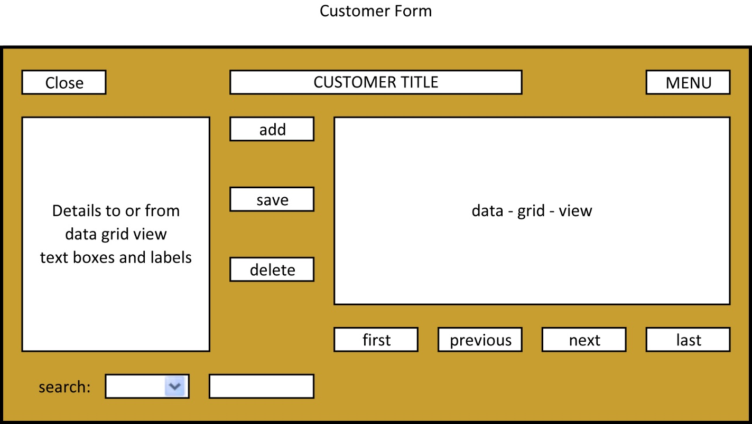

The proposed design of the customer form is fully complete and should be fit for audience and the desired purpose.

However, the colour of the form and location of the logo is not finalised, the location and layout of everything else will remain the same in the finalised system.

The add, save and delete buttons are linked to the database in SQL Server with insert, update and delete commands.

The Data Grid View is filled with information from the SQL databases Customer table.

The First button moves the position of the selected record to the first record.

The Previous button moves the position of the selected record to the previous record.

The Next button moves the position of the selected record to the next record.

The Last button moves the position of the selected record to the last record.

The search combo-box shows the indexed fields and the search text-box allows the user to enter details to search.

The details field allows the user to view the selected record, edit the selected record and add in a new records details.

Close Button – Closes the application when clicked

Menu Button – Opens the navigation menu and closes the Customer form

Text Boxes – Allows the user to enter data that can be added to the database

Add Button – Adds the data from the text boxes to the database as a record

Save Button – Saves any changes made to the database

Delete Button – Deletes the selected record from the database

First Button – Goes to the first record in the database

Previous Button – Goes to the previous record in the database from the selected record

Next Button – Goes to the next record in the database from the selected record

Last Button – Goes to the last record in the database

Search Combo box – Allows the user to select which field they wish to search

Search text box – Allows the user to enter the data they wish to search for

Staff Form

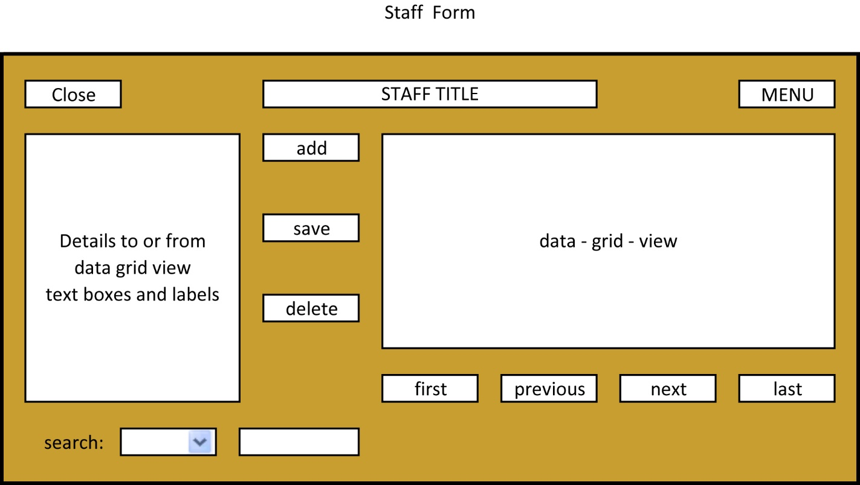

The proposed design of the staff form is fully complete and should be fit for audience and the desired purpose.

However, the colour of the form and location of the logo is not finalised, the location and layout of everything else will remain the same in the finalised system.

The proposed design of the customer form is fully complete and should be fit for audience and the desired purpose.

The add, save and delete buttons are linked to the database in SQL Server with insert, update and delete commands.

The Data Grid View is filled with information from the SQL databases Staff table.

The First button moves the position of the selected record to the first record.

The Previous button moves the position of the selected record to the previous record.

The Next button moves the position of the selected record to the next record.

The Last button moves the position of the selected record to the last record.

The search combo-box shows the indexed fields and the search text-box allows the user to enter details to search.

The details field allows the user to view the selected record, edit the selected record and add in a new records details.

Close Button – Closes the application when clicked

Menu Button – Opens the navigation menu and closes the Staff form

Text Boxes – Allows the user to enter data that can be added to the database

Add Button – Adds the data from the text boxes to the database as a record

Save Button – Saves any changes made to the database

Delete Button – Deletes the selected record from the database

First Button – Goes to the first record in the database

Previous Button – Goes to the previous record in the database from the selected record

Next Button – Goes to the next record in the database from the selected record

Last Button – Goes to the last record in the database

Search Combo box – Allows the user to select which field they wish to search

Search text box – Allows the user to enter the data they wish to search for

Payments Form

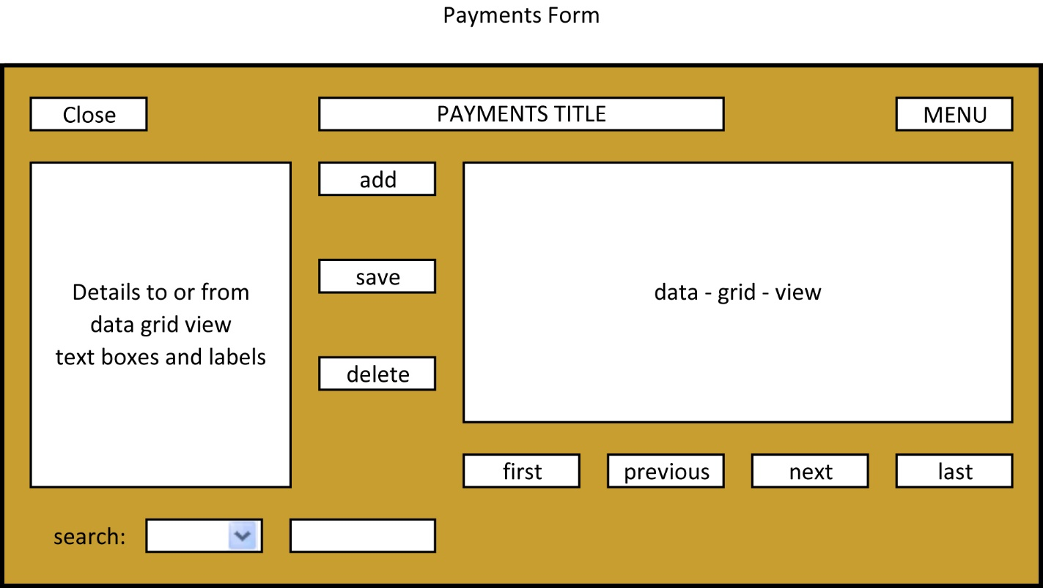

The proposed design of the payments form is fully complete and should be fit for audience and the desired purpose.

However, the colour of the form and location of the logo is not finalised, the location and layout of everything else will remain the same in the finalised system.

The add, save and delete buttons are linked to the database in SQL Server with insert, update and delete commands.

The Data Grid View is filled with information from the SQL databases Payments table.

The First button moves the position of the selected record to the first record. The Previous button moves the position of the selected record to the previous record.

The Next button moves the position of the selected record to the next record.

The Last button moves the position of the selected record to the last record.

The search combo-box shows the indexed fields and the search text-box allows the user to enter details to search.

The details field allows the user to view the selected record, edit the selected record and add in a new records details.

Close Button – Closes the application when clicked

Menu Button – Opens the navigation menu and closes the Payments form

Text Boxes – Allows the user to enter data that can be added to the database

Add Button – Adds the data from the text boxes to the database as a record

Save Button – Saves any changes made to the database

Delete Button – Deletes the selected record from the database

First Button – Goes to the first record in the database

Previous Button – Goes to the previous record in the database from the selected record

Next Button – Goes to the next record in the database from the selected record

Last Button – Goes to the last record in the database

Search Combo box – Allows the user to select which field they wish to search

Search text box – Allows the user to enter the data they wish to search for

Vehicles Form

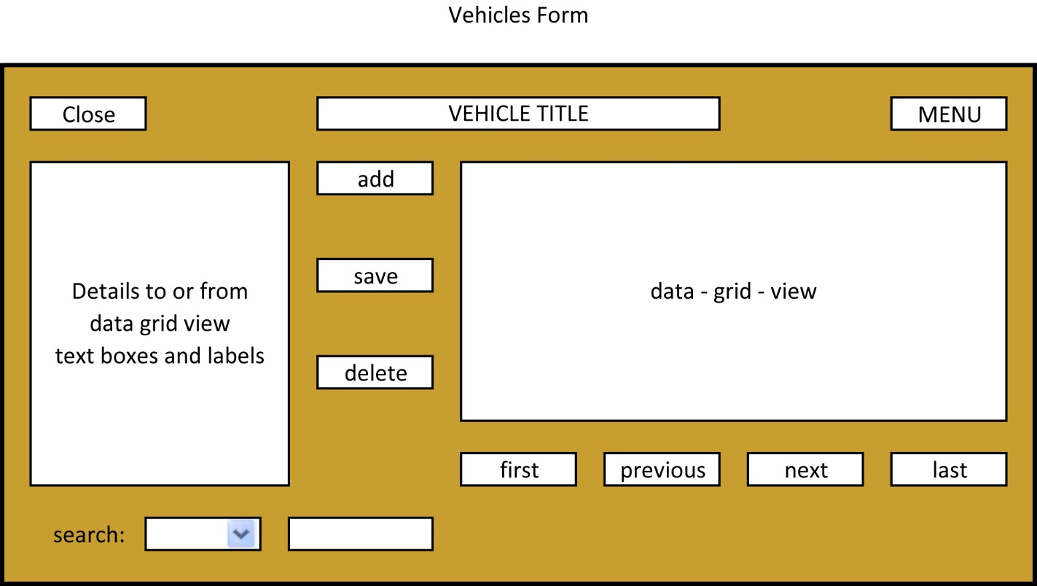

The proposed design of the vehicle form is fully complete and should be fit for audience and the desired purpose.

However, the colour of the form and location of the logo is not finalised, the location and layout of everything else will remain the same in the finalised system.

The add, save and delete buttons are linked to the database in SQL Server with insert, update and delete commands.

The Data Grid View is filled with information from the SQL databases Vehicle table.

The First button moves the position of the selected record to the first record.

The Previous button moves the position of the selected record to the previous record.

The Next button moves the position of the selected record to the next record.

The Last button moves the position of the selected record to the last record.

The search combo-box shows the indexed fields and the search text-box allows the user to enter details to search.

The details field allows the user to view the selected record, edit the selected record and add in a new records details.

Close Button – Closes the application when clicked

Menu Button – Opens the navigation menu and closes the Vehicle form

Text Boxes – Allows the user to enter data that can be added to the database

Add Button – Adds the data from the text boxes to the database as a record

Save Button – Saves any changes made to the database

Delete Button – Deletes the selected record from the database

First Button – Goes to the first record in the database

Previous Button – Goes to the previous record in the database from the selected record

Next Button – Goes to the next record in the database from the selected record

Last Button – Goes to the last record in the database

Search Combo box – Allows the user to select which field they wish to search

Search text box – Allows the user to enter the data they wish to search for

Booking Form

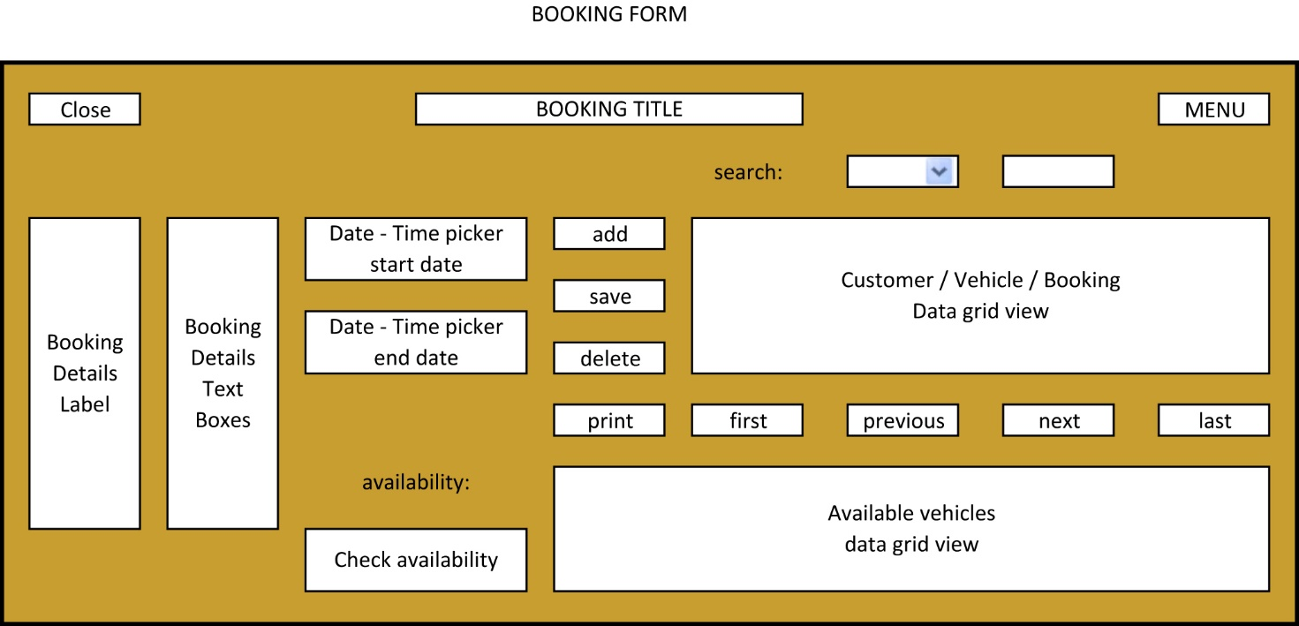

The proposed design of the booking form is fully complete and should be fit for audience and the desired purpose.

However, the colour of the form and location of the logo is not finalised, the location and layout of everything else will remain the same in the finalised system.

The proposed design of the Booking form is fully complete and should be fit for audience and the desired purpose.

The add, save and delete buttons are linked to the database in SQL Server with insert, update and delete commands.

The Data Grid Views are filled with information from the SQL databases Booking, vehicle, and customer table.

The First button moves the position of the selected record to the first record.

The Previous button moves the position of the selected record to the previous record.

The Next button moves the position of the selected record to the next record.

The Last button moves the position of the selected record to the last record.

The search combo-box shows the indexed fields and the search text-box allows the user to enter details to search.

The details field allows the user to view the selected record, edit the selected record and add in a new records details.

The date-time pickers allow the user to check the availability, calculate the final price and enters the start and end date into the details.

The print button shows the booking and customer details in the invoice form.

The check availability button checks what vehicles are available in between the start and end date.

Close Button – Closes the application when clicked

Menu Button – Opens the navigation menu and closes the Payments form

Text Boxes – Allows the user to enter data that can be added to the database

Add Button – Adds the data from the text boxes to the database as a record

Save Button – Saves any changes made to the database.

Delete Button – Deletes the selected record from the database.

First Button – Goes to the first record in the database.

Previous Button – Goes to the previous record in the database from the selected record.

Next Button – Goes to the next record in the database from the selected. record

Last Button – Goes to the last record in the database.

Search Combo box – Allows the user to select which field they wish to search.

Search text box – Allows the user to enter the data they wish to search for.

Start Date Date-Time Picker – Inputs the start date into the textbox for start date and is the start date for checking availability.

End Date Date-Time Picker – Inputs the end date into the textbox for end date and is the ending date for checking availability for which vehicles are availability.

Check Availability Button – Finds the available cars between the start and end dates in the date-time pickers.

Invoice Form

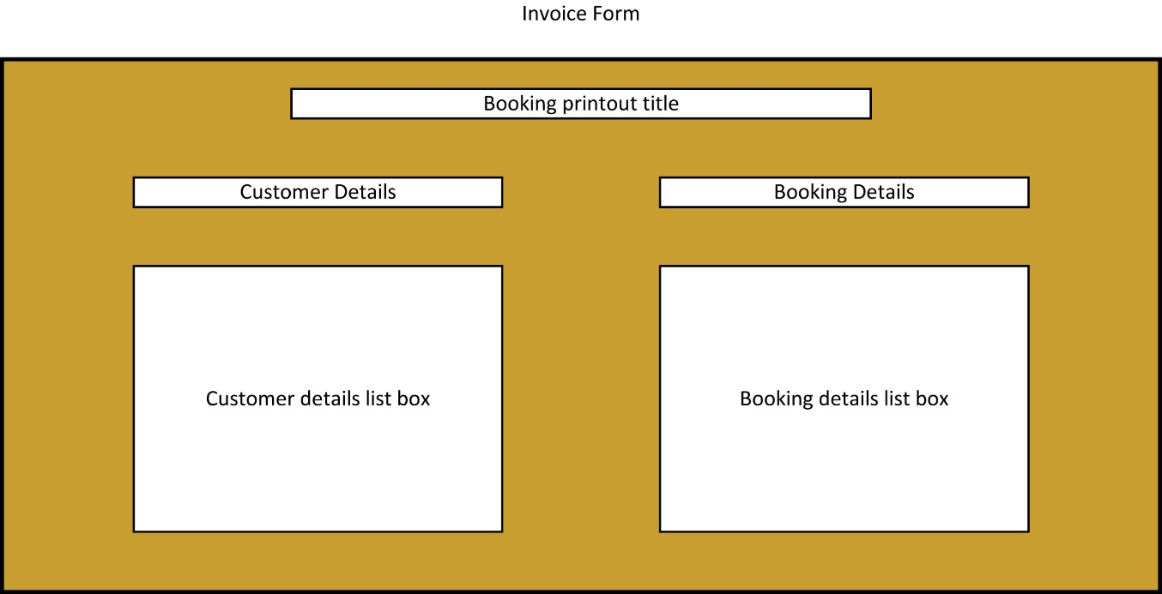

The proposed design of the invoice form is fully complete and should be fit for audience and the desired purpose.

However, the colour of the form and location of the logo is not finalised, the location and layout of everything else will remain the same in the finalised system.

The customer details list box shows the customer details from the selected record.

The Booking details list box shows the booking details from the selected record.

Testing using realistic data

Test plan

Login form

|  |  |  |
| --- | --- | --- |
| Test | Expected result | Evidence |
| Able to login using correct data | Menu form opens | 1.0 |

Menu form

|  |  |  |
| --- | --- | --- |
| Test | Expected result | Evidence |
| Customer button | Menu form will close and customer form will open | 2.0 |
| Close button | Application will close | 2.1 |

Customer form

|  |  |  |
| --- | --- | --- |
| Test | Expected result | Evidence |
| Data-grid-view | Data-grid-view displays customer details | 3.0 |
| Add button | Adds a customer to the database | 3.1 |
| Delete button | Deletes a customer from the database | 3.2 |

Evidence

Login Form

1.0

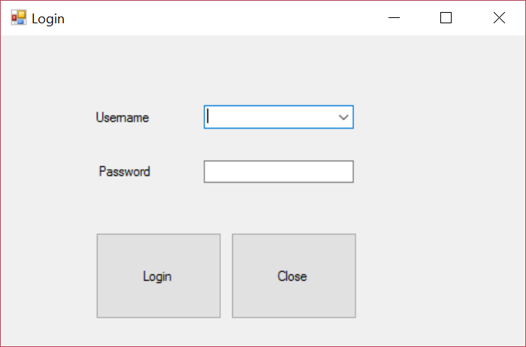

Login form loaded successfully with all textboxes blank

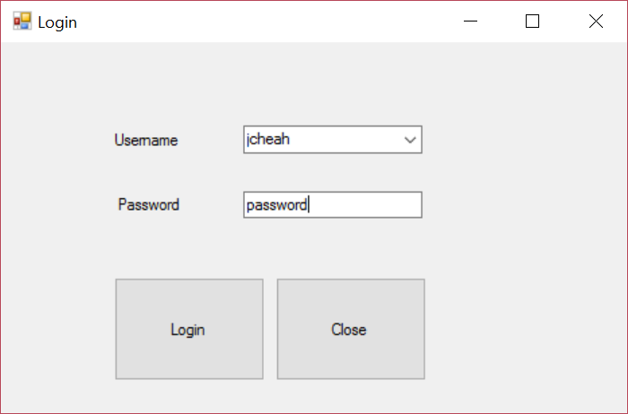

Comboboxes and textboxes able to enter data.

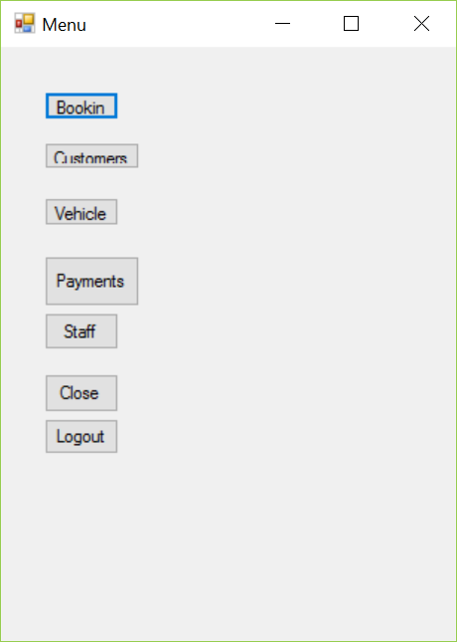

2.0



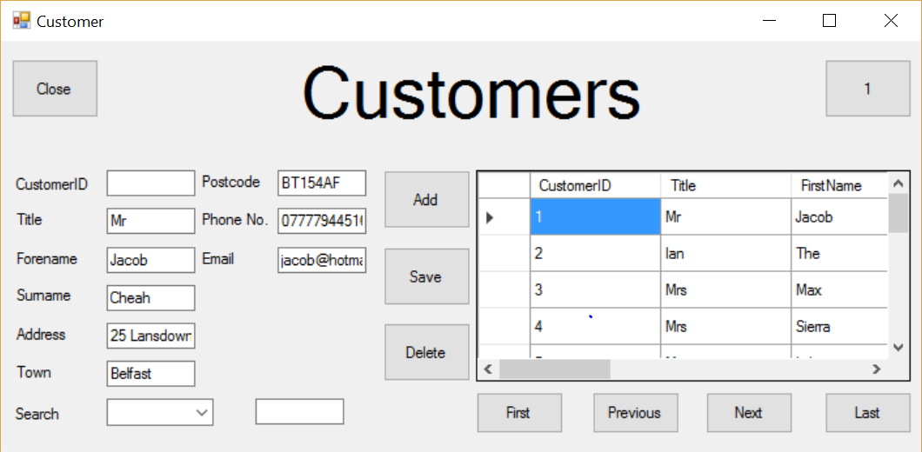

Customer form successfully opens and closes menu form.

2.1



Menu form successfully closes.

3.1



All information successfully displayed in data-grid-view.

3.2

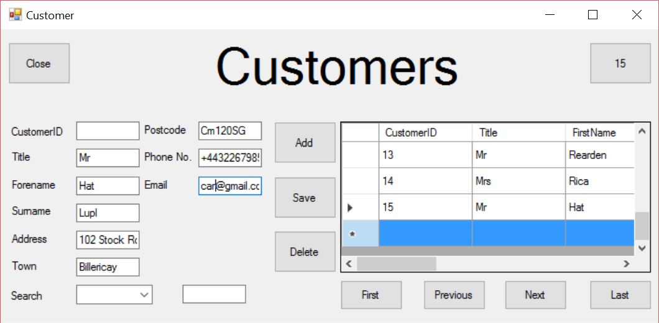

Customer was not successfully added.

Shortcomings of the prototype

As there were some forms absent from the prototype, there were many shortcomings to it.

The first and foremost as the Bookings Form was largely incomplete, there was very little functionality to it, bookings could not be checked for availability or made but the bookings could be viewed.

Also as the payments for was mostly just for show and had little functionality to it, no payments could be made, only viewed and as a consequence to this there are no invoices or receipts can be produced from the payments.

Furthermore, there are a lot of additional features that I would like to add to further increase the functionality and quality of the final program. A few examples of this are structures that will check if a car needs fuel, check if a car has been damaged and also to check if any extra charges apply to someone's rental based on any vehicle-related encounters with the law.

Finally the aesthetic of the program needs to be added with better titles and company logos and colours on all the forms to complete the look of the whole program and make it more pleasing to the eye and I may also consider making a night mode for the program as many time the employees can be working night shifts and may need to rent cars to people flying in, this would strain the employees eyes less when working at night.

Good Features of the prototype

* Almost all forms are correctly designed and have a pleasant layout, the only forms with design remaining are the navigation menu, the bookings form, the splash screen and the Invoice form.
* The Customer Form is successfully connected with the SQL customer table, this allows for the data-grid-view to display all records in the table.
* There are textboxes to allow the user to enter data.
* The first button allows the user to move their position in the data-grid-view of the customer form to the first record.
* The next button allows the user to move their position in the data-grid-view of the customer form to the next record.
* The previous button allows the user to move their position in the data-grid-view of the customer form to the previous record.
* The last button allows the user to move their position in the data-grid-view of the customer form to the last record.
* The close button successfully closes the program in the customer form.
* The menu button successfully closes the customer form and opens the menu form.
* The Staff Form is successfully connected with the SQL Staff table, this allows for the data-grid-view to display all records in the table.
* There are textboxes to allow the user to enter data.
* The first button allows the user to move their position in the data-grid-view of the Staff form to the first record.
* The next button allows the user to move their position in the data-grid-view of the Staff form to the next record.
* The previous button allows the user to move their position in the data-grid-view of the Staff form to the previous record.
* The last button allows the user to move their position in the data-grid-view of the Staff form to the last record.
* The close button successfully closes the program in the Staff form.
* The menu button successfully closes the Staff form and opens the menu form.
* The Vehicle Form is successfully connected with the SQL Vehicle table, this allows for the data-grid-view to display all records in the table.
* There are textboxes to allow the user to enter data.
* The first button allows the user to move their position in the data-grid-view of the Vehicle form to the first record.
* The next button allows the user to move their position in the data-grid-view of the Vehicle form to the next record.
* The previous button allows the user to move their position in the data-grid-view of the Vehicle form to the previous record.
* The last button allows the user to move their position in the data-grid-view of the Vehicle form to the last record.
* The close button successfully closes the program in the Vehicle form.
* The menu button successfully closes the Vehicle form and opens the menu form.
* The Payment Form is successfully connected with the SQL Payment table, this allows for the data-grid-view to display all records in the table.
* There are textboxes to allow the user to enter data.
* The first button allows the user to move their position in the data-grid-view of the Payment form to the first record.
* The next button allows the user to move their position in the data-grid-view of the Payment form to the next record.
* The previous button allows the user to move their position in the data-grid-view of the Payment form to the previous record.
* The last button allows the user to move their position in the data-grid-view of the Payment form to the last record.
* The close button successfully closes the program in the Payment form.
* The menu button successfully closes the Payment form and opens the menu form.

Suggestions for improvement from 3rd party

I have received constructive feedback from a third party about my prototype system with certain goals which the final system must reach.

1. Application must begin with an automatically timed splash screen that will appear for 3.5 seconds then load into the login menu.
   1. the splash screen will have the Logo of the business and the contact details.
2. Login menu must have:
   1. a drop-down menu for selecting a username
   2. a login that will only be permitted with the correct password
   3. a login button which is disabled until the password is entered
   4. a button to close the application
   5. multiple access levels for staff and managing staff
3. Navigation menu must have:
   1. have buttons to navigate to each part of the form excluding the splash screen and a button to close the application
4. Customer Form must have:
   1. a space to display customer details
   2. a button to close the application
   3. a text box to enter and edit the customer's details
   4. add, delete and save function
   5. navigation functions for first, previous, next, last
5. Payment Form must have:
   1. a space to display payment details
   2. a button to close the application
   3. a text box to enter and edit the payment details
   4. add, delete and save functions
   5. navigation functions for first, previous, next, last
6. Staff Form must have:
   1. space to display staff details
   2. a button to close the application
   3. a text box to enter and edit the staff details
   4. add, delete and save functions
   5. navigation functions for first, previous, next, last
7. Bookings form must have:
   1. a space to display booking details
   2. a button to close the application
   3. a text box to enter and edit the booking details
   4. add, delete and save functions
   5. navigation functions for first, previous, next, last
   6. Date picker for checking availability
   7. Date picker for making bookings
   8. multiple windows to check and select from different database tables

Post-Prototype Refinement

Section 5



Implications of the feedback of the prototype system for the re-design of the system.

There are many features that still needed to be added to the system before it is finalized and ready for testing, based on the third party feedback, many essential system components are still left to be added in:

* the design of the splash screen still needs to be completed
* the design of the menu form still needs to be completed
* the design of the booking form still needs to be completed
* the design of the payments form still needs to be completed
* the functions of the forms still need to be refined and in the case of the booking and payments form they still need to be created

Design implications due to feedback

The current design of the program will need to be revised before the final system is released. However, the proposed interface design that was shown in section 4 will need no changes and should coincide with the interface of the final system.

Additional files and data structures needed

C# Data Structures required

In order to produce an invoice form with all booking and customer details, I will be required to use 2 arraylists and 2 classes to hold the customer details for the selected booking record and transfer them to the class via the arraylist which will then be accessed by the invoice form.

C# Files needed

A logo file will be needed to be distributed to all forms in order for them to contain the company logo. I will create this in photoshop and implement it as a PNG file.

A new form will need to be created to store the invoice information, it will only contain listboxes and labels.

SQL Data Structures needed

An up to date Entity Relationship diagram will need to be declared and a diagram will need to be made to ensure accurate relation of the database. The customer ID will need an auto increment to ensure unique and valid data. The Staff ID will need an auto increment to ensure unique and valid data. The Payment ID will need an auto increment to ensure unique and valid data. The Vehicle ID will need an auto increment to ensure unique and valid data. The Booking ID will need an auto increment to ensure unique and valid data

Additional Processes needed

How the objectives have been met.

|  |  |
| --- | --- |
| Objectives | Achievements |
| Manipulate the data in all forms | The program can carry out calculations based on the defined discount, season and number of days, the user is also able to edit the data that has been entered into the database through the textboxes in the forms. |
| Add data in all forms | The Customer, Vehicle, Booking, Staff and Payments form all have buttons to add the details entered into the textboxes to the database. |
| Delete the data in all forms | The Customer, Vehicle, Booking, Staff and Payments form all have buttons to delete the selected record from the database. |
| View all forms | The Customer, Vehicle, Booking, Staff and Payments form all contain data-grid-views for viewing the records |
| Navigate all forms | The Customer, Vehicle, Booking, Staff and Payments form all have first, previous, next and last buttons to navigate the records. |
| Search data in the database | The Customer, Vehicle, Booking, Staff and Payments form all have search functions, to search the selected table. |
| Produce an invoice from a booking | The Booking form contains a button to print the selected booking, this produces an invoice containing the customer’s details and the details of the selected booking |
| Display a splash screen to welcome the user when the program is first launched, this should contain the City Car Rental logo and contact details. | The splash screen opens quickly and contains the company logo and contact details for the business. |
| The login form should validate the login password, it should compare the selected username with the entered password and the stored password. | The login form successfully ensures the correct login is entered before access is granted |
| The navigation menu should allow the user to navigate to all forms | The navigation menu Contains buttons to access all forms excluding the splash screen as I felt this was unnecessary, the menu form closes when any of these buttons are pressed, however, on each form there will be a button to return to the menu. |

ER Diagram

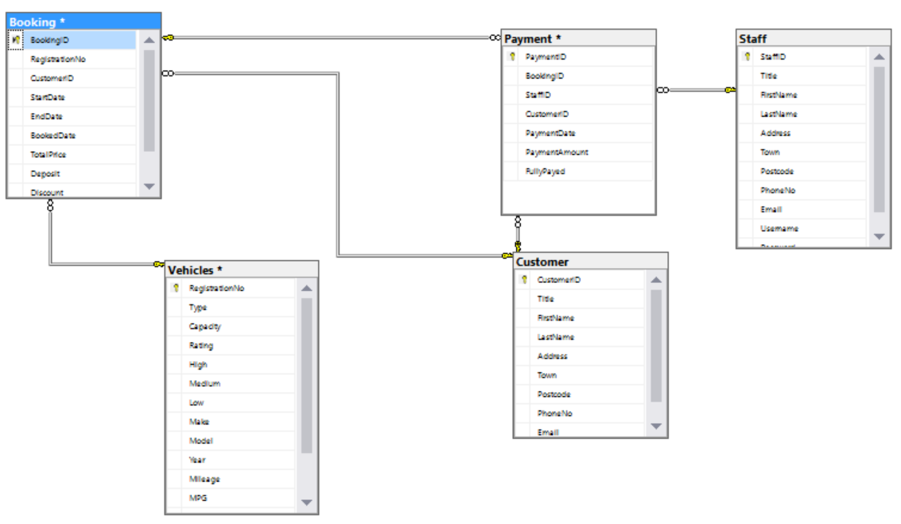

Data Model Normalised to Third Normal Form.

Vehicles table

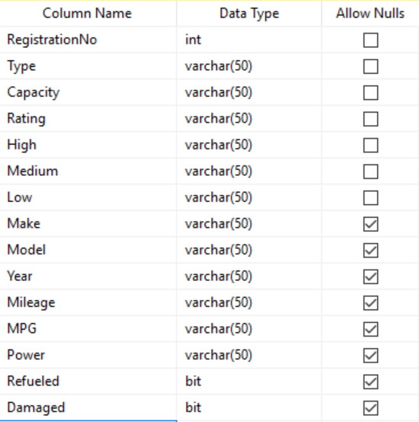

Customer table

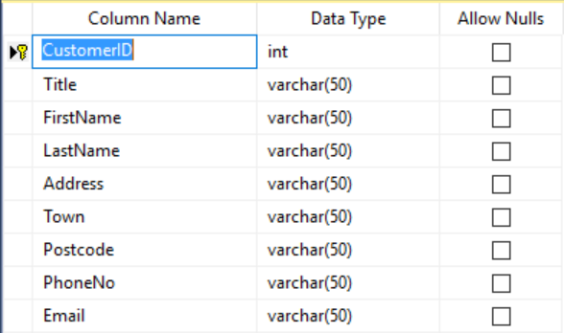

Staff Table

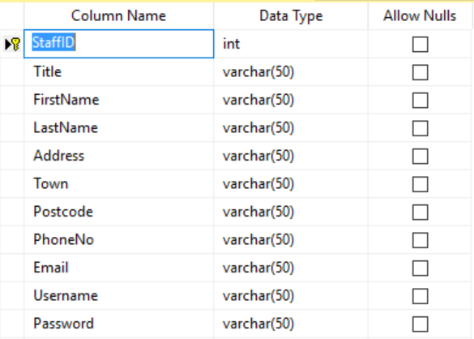

Payments table

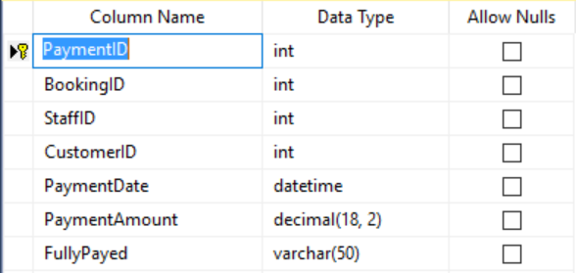

Booking table

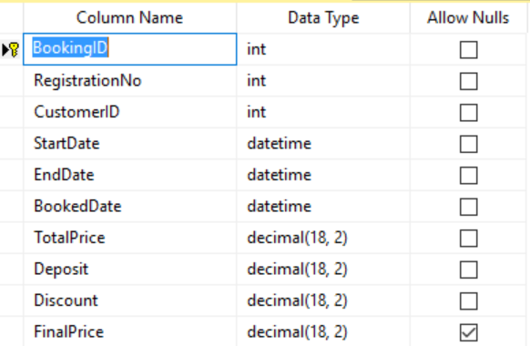

Software development

Section 6



User-defined Routines.

Splash Screen

Timer Routine

//Shows the splash screen for 3.5 seconds then opens the login form and hides the splash screen

private void timer1_Tick(object sender, EventArgs e)

{

Login login = new Login();

login.Show();

this.Hide();

timer1.Stop();

}

This timer is set to count down 3500ms, then load the login form and close the splash screen after this time.

Login Form

Closing Routine

private void closeBtn_Click(object sender, EventArgs e)

{

Application.Exit();

}

This closes ends the entire application when the close button is clicked.

Connection Routine

private void Login_Load(object sender, EventArgs e)

{

//Opens a conncetion to the Bookings Database

SqlConnection cn = new SqlConnection();

cn.ConnectionString =

"Data Source=Jacobs_Laptop\\SQLEXPRESS;" +

"Initial Catalog=BookingsDatabase;" +

"Integrated Security=True;";

cn.Open();

//selects the usernames from the Staff table and adds it to the username combobox

string sql = "select * from staff";

SqlCommand cmd = new SqlCommand(sql, cn);

SqlDataAdapter da = new SqlDataAdapter(cmd);

DataSet ds = new DataSet();

da.Fill(ds);

DataTable table = ds.Tables[0];

for (int i = 0; i < table.Rows.Count; i++)

{

cboUsername.Items.Add(table.Rows[i][9].ToString());

}

this.KeyPreview = true;

}

This opens a connection to the Staff table in the SQL database and adds the staff usernames to the “Username” combo-box.

Password Routine

private int linking(string user, string pass)

{

//Makes sure the password entered matches the password for the selected username

user.Trim();

pass.Trim();

SqlConnection cn = new SqlConnection();

cn.ConnectionString =

"Data Source=Jacobs_Laptop\\SQLEXPRESS;" +

"Initial Catalog=BookingsDatabase;" +

"Integrated Security=True;";

cn.Open();

string sql = "select * from staff where Username ='" + user + "' and Password ='" + pass + "' ";

SqlCommand cmd = new SqlCommand(sql, cn);

if (cmd.ExecuteScalar() != null)

return 1;

else

return 0;

}

}

This ensures that the password and username match and then returns a value to be used in the login button.

Login Button Routine

private void loginBtn_Click(object sender, EventArgs e)

{

//loads Navigation Menu given the password is correct

if (linking(cboUsername.Items[cboUsername.SelectedIndex].ToString(), txtPassword.Text) > 0)

{

this.Hide();

Menu nextScreen = new Menu();

nextScreen.Show();

}

else

{

MessageBox.Show("Please try again");

}

}

This checks the returned value and either grants or denies access, it will show a message box asking the user to try again if the returned value is 0.

Enter Routine

private void Login_KeyDown(object sender, KeyEventArgs e)

{

//allows the user to use the enter button to login

if (e.KeyCode == Keys.Enter)

{

loginBtn.PerformClick();

}

}

This allows the user to use the enter key to login.

Login Enabling Routine

private void txtPassword_TextChanged(object sender, EventArgs e)

{

//ensures the staff must enter something into the password textbox before being able to enter

if (txtPassword.TextLength > 0)

{

loginBtn.Enabled = true;

}

else

{

loginBtn.Enabled = false;

}

}

Ensures the user enters text into the password text-box before they are able to press the login button

Close Button

private void Closebtn_Click(object sender, EventArgs e)

{

//Closes the application

Application.Exit();

}

Closes the application

Menu form

Close Button

private void Closebtn_Click(object sender, EventArgs e)

{

//Closes the application

Application.Exit();

}

Closes the application

Logout Button routine

private void logoutbtnmenu_Click(object sender, EventArgs e)

{

//Shows the Login form and hides the menu

Login login = new Login();

login.Show();

this.Hide();

}

Closes the menu and opens the Login Menu

Booking Button

private void Bookingbtn_Click(object sender, EventArgs e)

{

//Shows the Booking form and hides the menu

Booking booking = new Booking();

booking.Show();

this.Hide();

}

Shows the Booking form and hides the menu

Customer Button

private void Customerbtn_Click(object sender, EventArgs e)

{

//Shows the Customer form and hides the menu

Customer Customer = new Customer();

Customer.Show();

this.Hide();

}

Shows the Customer form and hides the menu

Staff Button

private void Staffbtn_Click(object sender, EventArgs e)

{

//Shows the Staff form and hides the menu

Staff Staff = new Staff();

Staff.Show();

this.Hide();

}

Shows the Staff form and hides the menu

Vehicles Button

private void Vehiclebtn_Click(object sender, EventArgs e)

{

//Shows the Vehicle form and hides the menu

Vehicle Vehicle = new Vehicle();

Vehicle.Show();

this.Hide();

}

Shows the Vehicles form and hides the menu

Payments Button

private void Paymentsbtn_Click(object sender, EventArgs e)

{

//Shows the Payments form and hides the menu

Payments payments = new Payments();

payments.Show();

this.Hide();

}

Shows the Payments form and hides the menu

Customer Form

Close Button

private void Closebtn_Click(object sender, EventArgs e)

{

//Closes the application

Application.Exit();

}

Closes the application

Menu Button routine

private void logoutbtnmenu_Click(object sender, EventArgs e)

{

//Shows the Login form and hides the menu

Login login = new Login();

login.Show();

this.Hide();

}

Closes the menu and opens the Login Menu

Declaration and connection routine

SqlConnection cn = new SqlConnection("server=Jacobs_Laptop\\SQLEXPRESS; database=BookingsDatabase ;Trusted_Connection=True");

SqlCommand cmdcustomer = new SqlCommand();

SqlDataAdapter dacustomer = new SqlDataAdapter();

DataSet ds = new DataSet();

SqlCommandBuilder cb;

DataTable dt;

SqlDataAdapter changed;

This routine opens the connection to the database and declares the necessary datasets, SQL commands and datasets for use later

Details Filling

{

dataGridView1.DataSource = ds;

dataGridView1.DataMember = "Customer";

customerIDtxt.DataBindings.Add("Text", ds, "Customer.CustomerID");

titletxt.DataBindings.Add("Text", ds, "Customer.Title");

forenametxt.DataBindings.Add("Text", ds, "Customer.Firstname");

surnametxt.DataBindings.Add("Text", ds, "Customer.Lastname");

addresstxt.DataBindings.Add("Text", ds, "Customer.Address");

towntxt.DataBindings.Add("Text", ds, "Customer.Town");

postcodetxt.DataBindings.Add("Text", ds, "Customer.Postcode");

phonenumbertxt.DataBindings.Add("Text", ds, "Customer.PhoneNo");

emailtxt.DataBindings.Add("Text", ds, "Customer.Email");

}

This fills the textboxes of the details with the details from the selected record

Customer select

// TODO: This line of code loads data into the 'bookingsDatabaseDataSet2.Customer' table. You can move, or remove it, as needed.

this.customerTableAdapter.Fill(this.bookingsDatabaseDataSet2.Customer);

cn.Open();

cmdcustomer = new SqlCommand("Select * from Customer", cn);

dacustomer = new SqlDataAdapter(cmdcustomer);

dacustomer.Fill(ds, "Customer");

control();

cb = new SqlCommandBuilder(dacustomer);

string sql = "select * from staff";

SqlCommand cmd = new SqlCommand(sql, cn);

SqlDataAdapter da = new SqlDataAdapter(cmd);

da.Fill(ds);

DataTable table = ds.Tables[0];

cn.Close();

This selects the customer table from the SQL database.

Allows the user to add a new record to the database from the entered details in the textboxes.

Add Routine

private void addBtn_Click(object sender, EventArgs e)

{

this.BindingContext[ds, "Customer"].AddNew();

}

Saves any changes made to a record to the database.

Save Routine

private void saveBtn_Click(object sender, EventArgs e)

{

/* dataGridView1.EndEdit(); //very important step

dacustomer.Update(ds);

MessageBox.Show("Updated");

*/

this.BindingContext[ds, "Customer"].EndCurrentEdit();

if (ds.HasChanges() == true)

{

try

{

dacustomer.Update(ds, "Customer");

MessageBox.Show("Saved.");

}

catch

{

}

}

}

Delete Routine

private void deleteBtn_Click(object sender, EventArgs e)

{

int delrow;

delrow = this.BindingContext[ds, "Customer"].Position;

this.BindingContext[ds, "Customer"].RemoveAt(delrow);

try

{

dacustomer.Update(ds, "Customer");

MessageBox.Show("Field Deleted.");

}

catch

{

}

}

Deletes the selected record from the database.

Allows the user to navigate the data-grid-view by moving the selected record to the first record, previous record, next record or last record.

First, Previous, Next, Last Routine

private void btnNext_Click(object sender, EventArgs e)

{

this.BindingContext[ds, "Customer"].Position++;

}

private void btnPrevious_Click(object sender, EventArgs e)

{

this.BindingContext[ds, "Customer"].Position--;

}

private void btnFirst_Click(object sender, EventArgs e)

{

this.BindingContext[ds, "Customer"].Position = 0;

}

private void btnLast_Click(object sender, EventArgs e)

{

int vitri = this.BindingContext[ds, "Customer"].Count - 1;

this.BindingContext[ds, "Customer"].Position = vitri;

}

Search Routine

if (searchcbo.Items[searchcbo.SelectedIndex].ToString() == "CustomerID")

{

cn.Open();

//SqlDataAdapter changed;

changed = new SqlDataAdapter("select * from Customer where CustomerID like '" + textBox1.Text + "%'", cn);

dt = new DataTable();

changed.Fill(dt);

dataGridView1.DataSource = dt;

cn.Close();

}

if (searchcbo.Items[searchcbo.SelectedIndex].ToString() == "LastName")

{

cn.Open();

changed = new SqlDataAdapter("select * from Customer where LastName like '" + textBox1.Text + "%'", cn);

dt = new DataTable();

changed.Fill(dt);

dataGridView1.DataSource = dt;

cn.Close();

}

if (searchcbo.Items[searchcbo.SelectedIndex].ToString() == "Postcode")

{

cn.Open();

changed = new SqlDataAdapter("select * from Customer where Postcode like '" + textBox1.Text + "%'", cn);

dt = new DataTable();

changed.Fill(dt);

dataGridView1.DataSource = dt;

cn.Close();

}

This routine checks which field the user has decided to search and then uses a SQL command to search the selected field, all fields that are able to be searched are indexed from SQL.

Staff Form

Close Button

private void Closebtn_Click(object sender, EventArgs e)

{

//Closes the application

Application.Exit();

}

Closes the application

Menu Button routine

private void logoutbtnmenu_Click(object sender, EventArgs e)

{

//Shows the Login form and hides the menu

Login login = new Login();

login.Show();

this.Hide();

}

Closes the menu and opens the Login Menu

Declaration and connection routine

SqlConnection cn = new SqlConnection("server=Jacobs_Laptop\\SQLEXPRESS; database=BookingsDatabase ;Trusted_Connection=True");

SqlCommand cmdStaff= new SqlCommand();

SqlDataAdapter daStaff = new SqlDataAdapter();

DataTable dt = new DataTable();

SqlCommandBuilder cb;

This routine opens the connection to the database and declares the necessary datasets, SQL commands and datasets for use later

Details Filling

string StaffID = dataGridView1.SelectedRows[0].Cells[0].Value + string.Empty;

string Title = dataGridView1.SelectedRows[0].Cells[1].Value + string.Empty;

string FirstName = dataGridView1.SelectedRows[0].Cells[2].Value + string.Empty;

string LastName = dataGridView1.SelectedRows[0].Cells[3].Value + string.Empty;

string Address = dataGridView1.SelectedRows[0].Cells[4].Value + string.Empty;

string Town = dataGridView1.SelectedRows[0].Cells[5].Value + string.Empty;

string Postcode = dataGridView1.SelectedRows[0].Cells[6].Value + string.Empty;

string PhoneNo = dataGridView1.SelectedRows[0].Cells[7].Value + string.Empty;

string Email = dataGridView1.SelectedRows[0].Cells[8].Value + string.Empty;

string Username = dataGridView1.SelectedRows[0].Cells[9].Value + string.Empty;

string Password = dataGridView1.SelectedRows[0].Cells[10].Value + string.Empty;

staffIDtxt.Text = StaffID;

titletxt.Text = Title;

forenametxt.Text = FirstName;

surnametxt.Text = LastName;

addresstxt.Text = Address;

towntxt.Text = Town;

postcodetxt.Text = Postcode;

phonenumbertxt.Text = PhoneNo;

emailtxt.Text = Email;

usernametxt.Text = Username;

passwordtxt.Text = Password;

} }

This fills the textboxes of the details with the details from the selected record

Staff select

InitializeComponent();

cn.Open();

SqlDataAdapter da = new SqlDataAdapter("SELECT * FROM Staff", cn);

da.Fill(dt);

dataGridView1.DataSource = dt;

cn.Close();

This selects the customer table from the SQL database and adds it to the data-grid-view.

Allows the user to add a new record to the database from the entered details in the textboxes.

Add Routine

private void addBtn_Click(object sender, EventArgs e)

{

cn.Open();

string qur = "INSERT INTO Staff VALUES ('" + staffIDtxt.Text + "','" + titletxt.Text + "''"+ forenametxt.Text+"','"+ surnametxt.Text+ "','" + towntxt.Text + "''" + postcodetxt.Text + "','" + phonenumbertxt.Text + "','" + emailtxt.Text + "''" + usernametxt.Text + "','" + passwordtxt.Text + "')";

SqlCommand cmd = new SqlCommand(qur, cn);

cmd.ExecuteNonQuery();

cn.Close();

MessageBox.Show("Inserted sucessfully");

staffIDtxt.Text = "";

titletxt.Text = "";

forenametxt.Text = "";

surnametxt.Text = "";

towntxt.Text = "";

postcodetxt.Text = "";

phonenumbertxt.Text = "";

emailtxt.Text = "";

usernametxt.Text = "";

passwordtxt.Text = "";

}

Save Routine

private void saveBtn_Click(object sender, EventArgs e)

{

cn.Open();

string qur = "UPDATE Staff VALUES ('" + staffIDtxt.Text + "','" + titletxt.Text + "''" + forenametxt.Text + "','" + surnametxt.Text + "','" + towntxt.Text + "''" + postcodetxt.Text + "','" + phonenumbertxt.Text + "','" + emailtxt.Text + "''" + usernametxt.Text + "','" + passwordtxt.Text + "')";

SqlCommand cmd = new SqlCommand(qur, cn);

cmd.ExecuteNonQuery();

cn.Close();

MessageBox.Show("Inserted sucessfully");

staffIDtxt.Text = "";

titletxt.Text = "";

forenametxt.Text = "";

surnametxt.Text = "";

towntxt.Text = "";

postcodetxt.Text = "";

phonenumbertxt.Text = "";

emailtxt.Text = "";

usernametxt.Text = "";

passwordtxt.Text = "";

}

Saves any changes made to a record to the database.

Delete Routine

private void deleteBtn_Click(object sender, EventArgs e)

{

cmdStaff = new SqlCommand("DELETE STAFF where StafftID=@StaffID", cn);

cn.Open();

cmdStaff.Parameters.AddWithValue("@StaffID", cb );

try

{

//daStaff.Update("Payment");

MessageBox.Show("Field Deleted.");

}

catch

{

}

}

Deletes the selected record from the database.

Allows the user to navigate the data-grid-view by moving the selected record to the first record, previous record, next record or last record.

First, Previous, Next, Last Routine

private void btnNext_Click(object sender, EventArgs e)

{

this.BindingContext[ds, "Staff"].Position++;

}

private void btnPrevious_Click(object sender, EventArgs e)

{

this.BindingContext[ds, "Staff"].Position--;

}

private void btnFirst_Click(object sender, EventArgs e)

{

this.BindingContext[ds, "Staff"].Position = 0;

}

private void btnLast_Click(object sender, EventArgs e)

{

int vitri = this.BindingContext[ds, "Staff"].Count - 1;

this.BindingContext[ds, "Staff"].Position = vitri;

}

This routine checks which field the user has decided to search and then uses a SQL command to search the selected field, all fields that are able to be searched are indexed from SQL.

Search Routine

if (searchcbo.Items[searchcbo.SelectedIndex].ToString() == "StaffID")

{

cn.Open();

//SqlDataAdapter changed;

changed = new SqlDataAdapter("select * from Staff where StaffID like '" + textBox1.Text + "%'", cn);

dt = new DataTable();

changed.Fill(dt);

dataGridView1.DataSource = dt;

cn.Close();

}

if (searchcbo.Items[searchcbo.SelectedIndex].ToString() == "LastName")

{

cn.Open();

changed = new SqlDataAdapter("select * from Staff where LastName like '" + textBox1.Text + "%'", cn);

dt = new DataTable();

changed.Fill(dt);

dataGridView1.DataSource = dt;

cn.Close();

}

if (searchcbo.Items[searchcbo.SelectedIndex].ToString() == "Username")

{

cn.Open();

changed = new SqlDataAdapter("select * from Staff where Username like '" + textBox1.Text + "%'", cn);

dt = new DataTable();

changed.Fill(dt);

dataGridView1.DataSource = dt;

cn.Close();

}

Payments Form

Close Button

private void Closebtn_Click(object sender, EventArgs e)

{

//Closes the application

Application.Exit();

}

Closes the application

Menu Button routine

private void logoutbtnmenu_Click(object sender, EventArgs e)

{

//Shows the Login form and hides the menu

Login login = new Login();

login.Show();

this.Hide();

}

Closes the menu and opens the Login Menu

Declaration and connection routine

SqlConnection cn = new SqlConnection("server=Jacobs_Laptop\\SQLEXPRESS; database=BookingsDatabase ;Trusted_Connection=True");

SqlCommand cmdStaff= new SqlCommand();

SqlDataAdapter daStaff = new SqlDataAdapter();

DataTable dt = new DataTable();

SqlCommandBuilder cb;

This routine opens the connection to the database and declares the necessary datasets, SQL commands and datasets for use later

Allows the user to navigate the data-grid-view by moving the selected record to the first record, previous record, next record or last record.

First, Previous, Next, Last Routine

private void btnNext_Click(object sender, EventArgs e)

{

this.BindingContext[ds, "Payment"].Position++;

}

private void btnPrevious_Click(object sender, EventArgs e)

{

this.BindingContext[ds, " Payment "].Position--;

}

private void btnFirst_Click(object sender, EventArgs e)

{

this.BindingContext[ds, " Payment "].Position = 0;

}

private void btnLast_Click(object sender, EventArgs e)

{

int vitri = this.BindingContext[ds, " Payment "].Count - 1;

this.BindingContext[ds, " Payment "].Position = vitri;

}

This routine checks which field the user has decided to search and then uses a SQL command to search the selected field, all fields that are able to be searched are indexed from SQL.

Search Routine

if (searchcbo.Items[searchcbo.SelectedIndex].ToString() == "PaymentID")

{

cn.Open();

//SqlDataAdapter changed;

changed = new SqlDataAdapter("select * from Payment where PaymentID like '" + textBox1.Text + "%'", cn);

dt = new DataTable();

changed.Fill(dt);

dataGridView1.DataSource = dt;

cn.Close();

}

Details Filling

string PaymentID = dataGridView1.SelectedRows[0].Cells[0].Value + string.Empty;

string bookingID = dataGridView1.SelectedRows[0].Cells[1].Value + string.Empty;

string StaffID = dataGridView1.SelectedRows[0].Cells[2].Value + string.Empty;

string customerID = dataGridView1.SelectedRows[0].Cells[3].Value + string.Empty;

string paymentDate = dataGridView1.SelectedRows[0].Cells[4].Value + string.Empty;

string payment = dataGridView1.SelectedRows[0].Cells[5].Value + string.Empty;

string fullyPaid = dataGridView1.SelectedRows[0].Cells[6].Value + string.Empty;

staffIDtxt.Text = StaffID;

paymentIDtxt.Text = PaymentID;

bookingIDtxt.Text = bookingID;

customerIDtxt.Text = customerID;

paymentDatetxt.Text = paymentDate;

paymenttxt.Text = payment;

fullyPaidtxt.Text = fullyPaid;

This fills the textboxes of the details with the details from the selected record

Payment select

InitializeComponent();

cn.Open();

SqlDataAdapter da = new SqlDataAdapter("SELECT * FROM Payment", cn);

da.Fill(dt);

dataGridView1.DataSource = dt;

cn.Close();

This selects the Payments table from the SQL database and adds it to the data-grid-view.

Allows the user to add a new record to the database from the entered details in the textboxes.

Add Routine

private void addBtn_Click(object sender, EventArgs e)

{

cn.Open();

string qur = "INSERT INTO Payment VALUES ('" + staffIDtxt.Text + "','" + paymentIDtxt.Text + "''" + bookingIDtxt.Text + "','" + customerIDtxt.Text + "','" + paymentDatetxt.Text + "''" + paymenttxt.Text + "','" + fullyPaidtxt.Text + "')";

SqlCommand cmd = new SqlCommand(qur, cn);

cmd.ExecuteNonQuery();

cn.Close();

//Clears the textboxes after adding them

MessageBox.Show("Inserted sucessfully");

staffIDtxt.Text = "";

paymentIDtxt.Text = "";

bookingIDtxt.Text = "";

customerIDtxt.Text = "";

paymentDatetxt.Text = "";

paymenttxt.Text = "";

fullyPaidtxt.Text = ""; }

Save Routine

private void saveBtn_Click(object sender, EventArgs e)

{

cn.Open();

string qur = "UPDATE INTO Payment VALUES ('" + staffIDtxt.Text + "','" + paymentIDtxt.Text + "''" + bookingIDtxt.Text + "','" + customerIDtxt.Text + "','" + paymentDatetxt.Text + "''" + paymenttxt.Text + "','" + fullyPaidtxt.Text + "')";

SqlCommand cmd = new SqlCommand(qur, cn);

cmd.ExecuteNonQuery();

cn.Close();

//Clears the textboxes after adding them

MessageBox.Show("Inserted sucessfully");

staffIDtxt.Text = "";

paymentIDtxt.Text = "";

bookingIDtxt.Text = "";

customerIDtxt.Text = "";

paymentDatetxt.Text = "";

paymenttxt.Text = "";

fullyPaidtxt.Text = "";

Saves any changes made to a record to the database.

Delete Routine

private void deleteBtn_Click(object sender, EventArgs e)

{

//Deletes the selected record from the SQL Database

cmdStaff = new SqlCommand("DELETE Payment where PaymentID=@PaymentID", cn);

cn.Open();

cmdStaff.Parameters.AddWithValue("@PaymentID", cb);

try

{

//da.Update("Payment");

MessageBox.Show("Field Deleted.");

}

catch

{

} }

Deletes the selected record from the database.

Vehicles Form

Close Button

private void Closebtn_Click(object sender, EventArgs e)

{

//Closes the application

Application.Exit();

}

Closes the application

Menu Button routine

private void logoutbtnmenu_Click(object sender, EventArgs e)

{

//Shows the Login form and hides the menu

Login login = new Login();

login.Show();

this.Hide();

}

Closes the menu and opens the Login Menu

Declaration and connection routine

SqlConnection cn = new SqlConnection("server=Jacobs_Laptop\\SQLEXPRESS; database=BookingsDatabase ;Trusted_Connection=True");

SqlCommand cmdStaff= new SqlCommand();

SqlDataAdapter daStaff = new SqlDataAdapter();

DataTable dt = new DataTable();

SqlCommandBuilder cb;

This routine opens the connection to the database and declares the necessary datasets, SQL commands and datasets for use later

Details Filling

string Registration = dataGridView1.SelectedRows[0].Cells[0].Value + string.Empty;

string type = dataGridView1.SelectedRows[0].Cells[1].Value + string.Empty;

string capacity = dataGridView1.SelectedRows[0].Cells[2].Value + string.Empty;

string rating = dataGridView1.SelectedRows[0].Cells[3].Value + string.Empty;

string highPrice = dataGridView1.SelectedRows[0].Cells[4].Value + string.Empty;

string mediumPrice = dataGridView1.SelectedRows[0].Cells[5].Value + string.Empty;

string lowPrice = dataGridView1.SelectedRows[0].Cells[6].Value + string.Empty;

string make = dataGridView1.SelectedRows[0].Cells[7].Value + string.Empty;

string model = dataGridView1.SelectedRows[0].Cells[8].Value + string.Empty;

string year = dataGridView1.SelectedRows[0].Cells[9].Value + string.Empty;

string mpg = dataGridView1.SelectedRows[0].Cells[11].Value + string.Empty;

string power = dataGridView1.SelectedRows[0].Cells[12].Value + string.Empty;

string mileage = dataGridView1.SelectedRows[0].Cells[10].Value + string.Empty;

registrationtxt.Text = Registration;

typetxt.Text = type;

capacitytxt.Text = capacity;

ratingtxt.Text = rating;

highPricetxt.Text = highPrice;

mediumPricetxt.Text = mediumPrice;

lowPricetxt.Text = lowPrice;

maketxt.Text = make;

modeltxt.Text = model;

yeartxt.Text = year;

mpgtxt.Text = mpg;

powertxt.Text = power;

mileagetxt.Text = mileage;

} }

This fills the textboxes of the details with the details from the selected record

Staff select

InitializeComponent();

cn.Open();

SqlDataAdapter da = new SqlDataAdapter("SELECT * FROM Vehicles", cn);

da.Fill(dt);

dataGridView1.DataSource = dt;

cn.Close();

This selects the customer table from the SQL database and adds it to the data-grid-view.

Add Routine

private void addBtn_Click(object sender, EventArgs e)

{

cn.Open();

string qur = "INSERT INTO Vehicles VALUES ('" + registrationtxt.Text + "','" + typetxt.Text + "''" + capacitytxt.Text + "','" + ratingtxt.Text + "','" + highPricetxt.Text + "''" + mediumPricetxt.Text + "','" + lowPricetxt.Text + "','" + maketxt.Text + "''" + modeltxt.Text + "','" + yeartxt.Text + "','" + mpgtxt.Text + "''" + powertxt.Text + "')";

SqlCommand cmd = new SqlCommand(qur, cn);

cmd.ExecuteNonQuery();

cn.Close();

MessageBox.Show("Inserted sucessfully");

registrationtxt.Text = "";

typetxt.Text = "";

capacitytxt.Text = "";

ratingtxt.Text = "";

highPricetxt.Text = "";

mediumPricetxt.Text = "";

lowPricetxt.Text = "";

maketxt.Text = "";

modeltxt.Text = "";

yeartxt.Text = "";

mpgtxt.Text = "";

powertxt.Text = "";

mileagetxt.Text = "";

}

Allows the user to add a new record to the database from the entered details in the textboxes.

Save Routine

private void saveBtn_Click(object sender, EventArgs e)

{

cn.Open();

string qur = "UPDATE Vehicles VALUES ('" + registrationtxt.Text + "','" + typetxt.Text + "''" + capacitytxt.Text + "','" + ratingtxt.Text + "','" + highPricetxt.Text + "''" + mediumPricetxt.Text + "','" + lowPricetxt.Text + "','" + maketxt.Text + "''" + modeltxt.Text + "','" + yeartxt.Text + "','" + mpgtxt.Text + "''" + powertxt.Text + "')";

SqlCommand cmd = new SqlCommand(qur, cn);

cmd.ExecuteNonQuery();

cn.Close();

MessageBox.Show("Inserted sucessfully");

registrationtxt.Text = "";

typetxt.Text = "";

capacitytxt.Text = "";

ratingtxt.Text = "";

highPricetxt.Text = "";

mediumPricetxt.Text = "";

lowPricetxt.Text = "";

maketxt.Text = "";

modeltxt.Text = "";

yeartxt.Text = "";

mpgtxt.Text = "";

powertxt.Text = "";

mileagetxt.Text = "";

}

Saves any changes made to a record to the database.

Delete Routine

private void deleteBtn_Click(object sender, EventArgs e)

{

//change to vehicles

cmdStaff = new SqlCommand("DELETE STAFF where StaffID=@StaffID", cn);

cn.Open();

cmdStaff.Parameters.AddWithValue("@StaffID", cb);

try

{

//daStaff.Update("Vehicles");

MessageBox.Show("Field Deleted.");

}

catch

{

}

}

Deletes the selected record from the database.

Allows the user to navigate the data-grid-view by moving the selected record to the first record, previous record, next record or last record.

First, Previous, Next, Last Routine

private void btnNext_Click(object sender, EventArgs e)

{

this.BindingContext[dt, "Vehicles"].Position++;

}

private void btnPrevious_Click(object sender, EventArgs e)

{

this.BindingContext[dt, "Vehicles"].Position--;

}

private void btnFirst_Click(object sender, EventArgs e)

{

this.BindingContext[dt, "Vehicles"].Position = 0;

}

private void btnLast_Click(object sender, EventArgs e)

{

int vitri = this.BindingContext[dt, "Vehicles"].Count - 1;

this.BindingContext[dt, "Vehicles"].Position = vitri;

}

Booking Details

Close Button

private void Closebtn_Click(object sender, EventArgs e)

{

//Closes the application

Application.Exit();

}

Closes the application

Menu Button routine

private void logoutbtnmenu_Click(object sender, EventArgs e)

{

//Shows the Login form and hides the menu

Login login = new Login();

login.Show();

this.Hide();

}

Closes the menu and opens the Login Menu

Declaration and connection routine

SqlConnection cn = new SqlConnection("server=Jacobs_Laptop\\SQLEXPRESS; database=BookingsDatabase ;Trusted_Connection=True");

// A new SQL command, data adapter and data set are declared

SqlCommand cmdmakebooking = new SqlCommand();

SqlDataAdapter damakebooking = new SqlDataAdapter();

DataTable ds = new DataTable();

DataTable dt = new DataTable();

DataTable dv = new DataTable();

DataTable veh = new DataTable();

SqlCommandBuilder cb;

// **********************************************************************

// Set up an ArrayList so that we can store all the variables we need to

// pass to the invoice form.

// **********************************************************************

ArrayList arrayListBookingDetails = new ArrayList();

ArrayList arrayListCustomerDetails = new ArrayList();

// **********************************************************************

// Declare a variable to hold the message

// **********************************************************************

This routine opens the connection to the database and declares the necessary datasets, SQL commands and datasets for use later

Details Filling

string bookingId = dataGridView1.SelectedRows[0].Cells[0].Value.ToString();

string registration = dataGridView1.SelectedRows[0].Cells[1].Value.ToString();

string customerID = dataGridView1.SelectedRows[0].Cells[2].Value.ToString();

string startDate = dataGridView1.SelectedRows[0].Cells[3].Value.ToString();

string endDate = dataGridView1.SelectedRows[0].Cells[4].Value.ToString();

string bookedDate = dataGridView1.SelectedRows[0].Cells[5].Value.ToString();

string totalPrice = dataGridView1.SelectedRows[0].Cells[6].Value.ToString();

string deposit = dataGridView1.SelectedRows[0].Cells[7].Value.ToString();

string discount = dataGridView1.SelectedRows[0].Cells[8].Value.ToString();

string finalPrice = dataGridView1.SelectedRows[0].Cells[9].Value.ToString();

bookingIdtxt.Text = bookingId;

registrationtxt.Text = registration;

customerIDtxt.Text = customerID;

startDatetxt.Text = startDate;

endDatetxt.Text = endDate;

bookedDatetxt.Text = bookedDate;

totalPricetxt.Text = totalPrice;

deposittxt.Text = deposit;

discounttxt.Text = discount;

finalPricetxt.Text = finalPrice;

// The cost variables are added to the ArrayList so they can be passed to the Invoice form

// as one object and then used in the invoice form to display the invoice

bookIngaRRAY.arrayListBookingDetails.Add("Booking Start Date: ");

bookIngaRRAY.arrayListBookingDetails.Add(startDate);

bookIngaRRAY.arrayListBookingDetails.Add("Booking End Date: ");

bookIngaRRAY.arrayListBookingDetails.Add(endDate);

bookIngaRRAY.arrayListBookingDetails.Add("Booking Date: ");

bookIngaRRAY.arrayListBookingDetails.Add(bookedDate);

bookIngaRRAY.arrayListBookingDetails.Add("Cost of Booking: £");

bookIngaRRAY.arrayListBookingDetails.Add(totalPrice);

bookIngaRRAY.arrayListBookingDetails.Add("Discount %");

bookIngaRRAY.arrayListBookingDetails.Add(discount);

bookIngaRRAY.arrayListBookingDetails.Add("Customer Deposit: £");

bookIngaRRAY.arrayListBookingDetails.Add(deposit);

bookIngaRRAY.arrayListBookingDetails.Add("Final Cost of Booking: £");

bookIngaRRAY.arrayListBookingDetails.Add(finalPrice);

} }

This fills the textboxes of the details with the details from the selected record and fills an array-list with the selected booking details.

Staff select

InitializeComponent();

cn.Open();

SqlDataAdapter da = new SqlDataAdapter("SELECT * FROM Booking", cn);

da.Fill(ds);

dataGridView1.DataSource = ds;

SqlDataAdapter db = new SqlDataAdapter("SELECT * FROM Customer", cn);

db.Fill(dt);

dataGridView3.DataSource = dt;

SqlDataAdapter dc = new SqlDataAdapter("SELECT * FROM Vehicles", cn);

dc.Fill(dv);

dataGridView4.DataSource = dv;

cn.Close();

// default check-in date to tomorrow

dtpStartDate.Value = DateTime.Today.AddDays(1);

// default check-out date to 1 week after check-in date

dtpEndDate.Value = DateTime.Today.AddDays(8);

This selects the booking/vehicles/customer table from the SQL database and adds it to the data-grid-views. It also sets the dates of the date-time pickers to tomorrow and a week from now.

Add Routine

private void addBtn_Click(object sender, EventArgs e)

{

cn.Open();

string qur = "INSERT INTO Booking VALUES ('" + bookingIdtxt.Text + "','" + registrationtxt.Text + "''" + customerIDtxt.Text + "','" + startDatetxt.Text + "','" + endDatetxt.Text + "''" + bookedDatetxt.Text + "','" + totalPricetxt.Text + "','" + deposittxt.Text + "''" + discounttxt.Text + "','" + finalPricetxt.Text + "')";

SqlCommand cmd = new SqlCommand(qur, cn);

cmd.ExecuteNonQuery();

cn.Close();

MessageBox.Show("Inserted sucessfully");

bookingIdtxt.Text = "";

registrationtxt.Text = "";

customerIDtxt.Text = "";

startDatetxt.Text = "";

endDatetxt.Text = "";

bookedDatetxt.Text = "";

totalPricetxt.Text = "";

deposittxt.Text = "";

discounttxt.Text = "";

finalPricetxt.Text = "";

}

Allows the user to add a new record to the database from the entered details in the textboxes.

Save Routine

private void saveBtn_Click(object sender, EventArgs e)

{

cn.Open();

string qur = "UPDATE Booking VALUES ('" + bookingIdtxt.Text + "','" + registrationtxt.Text + "''" + customerIDtxt.Text + "','" + startDatetxt.Text + "','" + endDatetxt.Text + "''" + bookedDatetxt.Text + "','" + totalPricetxt.Text + "','" + deposittxt.Text + "''" + discounttxt.Text + "','" + finalPricetxt.Text + "')";

SqlCommand cmd = new SqlCommand(qur, cn);

cmd.ExecuteNonQuery();

cn.Close();

MessageBox.Show("Inserted sucessfully");

bookingIdtxt.Text = "";

registrationtxt.Text = "";

customerIDtxt.Text = "";

startDatetxt.Text = "";

endDatetxt.Text = "";

bookedDatetxt.Text = "";

totalPricetxt.Text = "";

deposittxt.Text = "";

discounttxt.Text = "";

finalPricetxt.Text = "";

}

Saves any changes made to a record to the database.

Delete Routine

private void deleteBtn_Click(object sender, EventArgs e)

{

//change to vehicles

cmdmakebooking = new SqlCommand("DELETE Booking where BookingID=@BookingID", cn);

cn.Open();

cmdmakebooking.Parameters.AddWithValue("@BookingID", cb);

try

{

//daStaff.Update("Booking");

MessageBox.Show("Field Deleted.");

}

catch

{

}

}

Deletes the selected record from the database.

Allows the user to navigate the data-grid-view by moving the selected record to the first record, previous record, next record or last record.

First, Previous, Next, Last Routine

private void btnNext_Click(object sender, EventArgs e)

{

this.BindingContext[ds, "Booking"].Position++;

}

private void btnPrevious_Click(object sender, EventArgs e)

{

this.BindingContext[ds, "Booking"].Position--;

}

private void btnFirst_Click(object sender, EventArgs e)

{

this.BindingContext[ds, "Booking"].Position = 0;

}

private void btnLast_Click(object sender, EventArgs e)

{

int vitri = this.BindingContext[ds, "Booking"].Count - 1;

this.BindingContext[ds, "Booking"].Position = vitri;

}

Customer Details Filling

private void dataGridView3_CellClick(object sender, DataGridViewCellEventArgs e)

{

try

{

string customerID;

// The cost variables are added to the ArrayList so they can be passed to the Invoice form

// as one object and then used in the invoice form to display the invoice

if ((customerID = dataGridView3.SelectedRows[0].Cells[0].Value.ToString()) == null)

{

customerID = dataGridView1.SelectedRows[0].Cells[2].Value.ToString();

}

else

{

customerID = dataGridView3.SelectedRows[0].Cells[0].Value.ToString();

}

string FirstName = dataGridView3.SelectedRows[0].Cells[2].Value.ToString();

string Lastname = dataGridView3.SelectedRows[0].Cells[3].Value.ToString();

string Address = dataGridView3.SelectedRows[0].Cells[4].Value.ToString();

string PhoneNumber = dataGridView3.SelectedRows[0].Cells[7].Value.ToString();

string Email = dataGridView3.SelectedRows[0].Cells[8].Value.ToString();

//customerIDtxt.Text = customerID;

CustomerArray.arrayListCustomerDetails.Add("Customer ID: ");

CustomerArray.arrayListCustomerDetails.Add(customerID);

CustomerArray.arrayListCustomerDetails.Add("Customer First Name: ");

CustomerArray.arrayListCustomerDetails.Add(FirstName);

CustomerArray.arrayListCustomerDetails.Add("Customer Surname: ");

CustomerArray.arrayListCustomerDetails.Add(Lastname);

CustomerArray.arrayListCustomerDetails.Add("Customer Address: ");

CustomerArray.arrayListCustomerDetails.Add(Address);

CustomerArray.arrayListCustomerDetails.Add("Customer Phone Number: ");

CustomerArray.arrayListCustomerDetails.Add(PhoneNumber);

CustomerArray.arrayListCustomerDetails.Add("Customer Email: ");

CustomerArray.arrayListCustomerDetails.Add(Email);

}

catch { }

}

This fills some of the textboxes of the details with the customer details from the selected customer record and fills an array-list with the selected customer details.

Seasonal Routine

private void dataGridView4_CellClick(object sender, DataGridViewCellEventArgs e)

{

try

{

string RegistrationNo = dataGridView4.SelectedRows[0].Cells[0].Value.ToString(); // + string.Empty;

registrationtxt.Text = RegistrationNo;

int dtpsdmonth = dtpStartDate.Value.Month;

if (dtpsdmonth == 1 || dtpsdmonth == 2 || dtpsdmonth == 3 || dtpsdmonth == 4)

{

totalPricetxt.Text = dataGridView4.SelectedRows[0].Cells[6].Value.ToString();

}

if (dtpsdmonth == 5 || dtpsdmonth == 6 || dtpsdmonth == 7 || dtpsdmonth == 8)

{

totalPricetxt.Text = dataGridView4.SelectedRows[0].Cells[8].Value.ToString();

}

if (dtpsdmonth == 9 || dtpsdmonth == 10 || dtpsdmonth == 11 || dtpsdmonth == 12)

{

totalPricetxt.Text = dataGridView4.SelectedRows[0].Cells[7].Value.ToString();

}

}

catch { }

}

This checks which season the start date is in which finds the total price based off the selected vehicle.

This calculates the final price of the booking based off the number of days between the end and start date, the season and any discount that needs to be applied

Final Price calculator

public void calculatetotalPrice()

{

TimeSpan dtpsdDays = dtpEndDate.Value - dtpStartDate.Value;

int days = (int)dtpsdDays.TotalDays;

decimal totalPrice = 0;

decimal discountMultiplier = 0;

if (days <= 7)

{

discountMultiplier = 1;

}

else if (days > 7 && days <= 20)

{

discountMultiplier = Convert.ToDecimal(0.95);

}

else

{

discountMultiplier = Convert.ToDecimal(0.8);

}

int dtpsdmonth = dtpStartDate.Value.Month;

decimal season = 0;

if (dtpsdmonth == 1 || dtpsdmonth == 2 || dtpsdmonth == 3 || dtpsdmonth == 4)

{

string LowSeason = dataGridView4.SelectedRows[0].Cells[6].Value.ToString();

season = Convert.ToDecimal(LowSeason);

}

if (dtpsdmonth == 5 || dtpsdmonth == 6 || dtpsdmonth == 7 || dtpsdmonth == 8)

{

string HighSeason = dataGridView4.SelectedRows[0].Cells[8].Value.ToString();

season = Convert.ToDecimal(HighSeason);

}

if (dtpsdmonth == 9 || dtpsdmonth == 10 || dtpsdmonth == 11 || dtpsdmonth == 12)

{

string MidSeason = dataGridView4.SelectedRows[0].Cells[7].Value.ToString();

season = Convert.ToDecimal(MidSeason);

}

totalPrice = season * days * discountMultiplier;

finalPricetxt.Text = Convert.ToString(totalPrice);

}

Disables the add button if the start or end date changes and inputs the start or end date into the text-boxes.

Start-End Date input and add button disabling

private void dtpStartDate_ValueChanged(object sender, EventArgs e)

{

SqlDateTime sd = dtpStartDate.Value;

startDatetxt.Text = Convert.ToString(sd);

addBtn.Enabled = false;

}

private void dtpEndDate_ValueChanged(object sender, EventArgs e)

{

SqlDateTime ed = dtpEndDate.Value;

endDatetxt.Text = Convert.ToString(ed);

addBtn.Enabled = false;

}

Print Button

private void BtnPrint_Click(object sender, EventArgs e)

{

BookingPrintout Invoice_book = new BookingPrintout();

//BookingPrintout Invoice_cust = new BookingPrintout(arrayListCustomerDetails);

Invoice_book.Show();

// Invoice_cust.Show();

}

Loads the invoice form when the button is clicked.

Invoice Form

Filling listboxes

for (int i = 0; i < bookIngaRRAY.arrayListBookingDetails.Count; i++)

{

listBoxBookingDetails.Items.Add(Convert.ToString(bookIngaRRAY.arrayListBookingDetails[i]));

}

for (int i = 0; i < CustomerArray.arrayListCustomerDetails.Count; i++)

{

listBoxCustomerDetails.Items.Add(Convert.ToString(CustomerArray.arrayListCustomerDetails[i]));

}

Evidence of Validation.

Vehicles



The data types used in the database gives the program a degree of validation as it will not allow the user to enter a data type outside of what is defined above. For example, something other than a Boolean structure cannot be entered into the damaged or refuelled section and if this is done, it will return a database error. The allow nulls column is another form of database validation as it defines which fields must be filled before allowing the user to enter the data into the database, this will also return a database error. There is also a declared primary key for the registrationNo meaning it must be unique and if repeated will cause another database error.

Try-catch statements have also been used to prevent program crashes and similar errors adding further validation. If statements have also been used for the search function to ensure the correct fields are being searched and adds more validation to the system.

Customer



The data types used in the database gives the program a degree of validation as it will not allow the user to enter a data type outside of what is defined above. For example, something other than a varchar data type cannot be entered into the first name section and if this is done, it will return a database error. The allow nulls column is another form of database validation as it defines which fields must be filled before allowing the user to enter the data into the database, this will also return a database error. There is also a declared primary key for the CustomerID meaning it must be unique and if repeated will cause another database error.

Try-catch statements have also been used to prevent program crashes and similar errors adding further validation. If statements have also been used for the search function to ensure the correct fields are being searched and adds more validation to the system.

Staff



The data types used in the database gives the program a degree of validation as it will not allow the user to enter a data type outside of what is defined above. For example, something other than a varchar data type cannot be entered into the first name section and if this is done, it will return a database error. The allow nulls column is another form of database validation as it defines which fields must be filled before allowing the user to enter the data into the database, this will also return a database error. There is also a declared primary key for the StaffID meaning it must be unique and if repeated will cause another database error.

Try-catch statements have also been used to prevent program crashes and similar errors adding further validation. If statements have also been used for the search function to ensure the correct fields are being searched and adds more validation to the system.

Payment



The data types used in the database gives the program a degree of validation as it will not allow the user to enter a data type outside of what is defined above. For example, something other than a date-time structure cannot be entered into the payment date section and if this is done, it will return a database error. The allow nulls column is another form of database validation as it defines which fields must be filled before allowing the user to enter the data into the database, this will also return a database error. There is also a declared primary key for the paymentID meaning it must be unique and if repeated will cause another database error. There are also foreign keys for the bookingID, staffID and customerID ensuring data consistency and correct data independence.

Try-catch statements have also been used to prevent program crashes and similar errors adding further validation. If statements have also been used for the search function to ensure the correct fields are being searched and adds more validation to the system.

Booking



The data types used in the database gives the program a degree of validation as it will not allow the user to enter a data type outside of what is defined above. For example, something other than a date-time structure cannot be entered into the start date date section and if this is done, it will return a database error. The allow nulls column is another form of database validation as it defines which fields must be filled before allowing the user to enter the data into the database, this will also return a database error. There is also a declared primary key for the Booking ID meaning it must be unique and if repeated will cause another database error. There are also foreign keys for the RegistrationNo and customerID ensuring data consistency and correct data independence.

Try-catch statements have also been used to prevent program crashes and similar errors adding further validation. If statements have also been used for the search function to ensure the correct fields are being searched and adds more validation to the system.

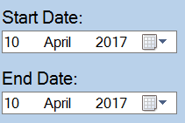

The date-time pickers are another form of validation as it prevents incorrect formatting and incorrect syntax when entering dates and also reduces the possibility of the incorrect dates being entered all together.

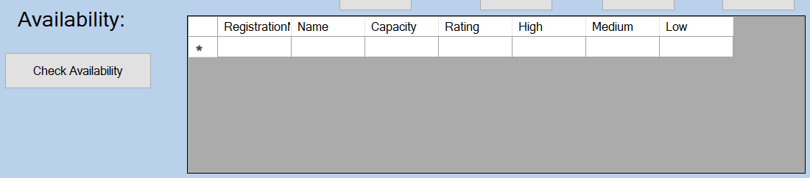

The check availability system aid in validating the entire system as it prevents double bookings for the same vehicle and allows employees to easily see which vehicles are available.

Variables and actual data structures used to create the solution

Actual Data Structures used

* Array Lists
* Array Lists were used to display details in the invoice form, there are two array lists containing booking details and customer details

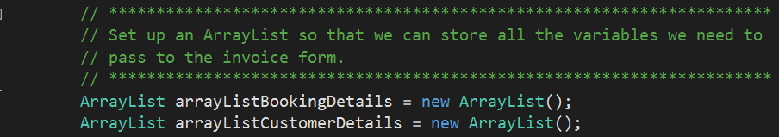

* Classes
  + 2 global classes were used to hold the array lists so they could be passed to the invoice form from the booking form



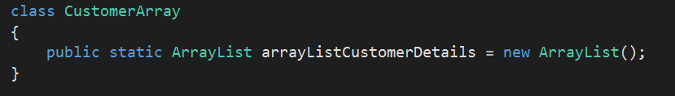



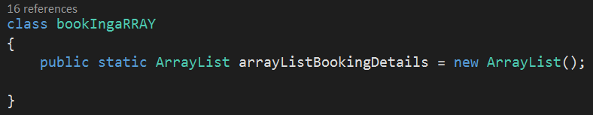

* Data-grid-views
  + Many data-grid-views have been used to show the records from various database tables

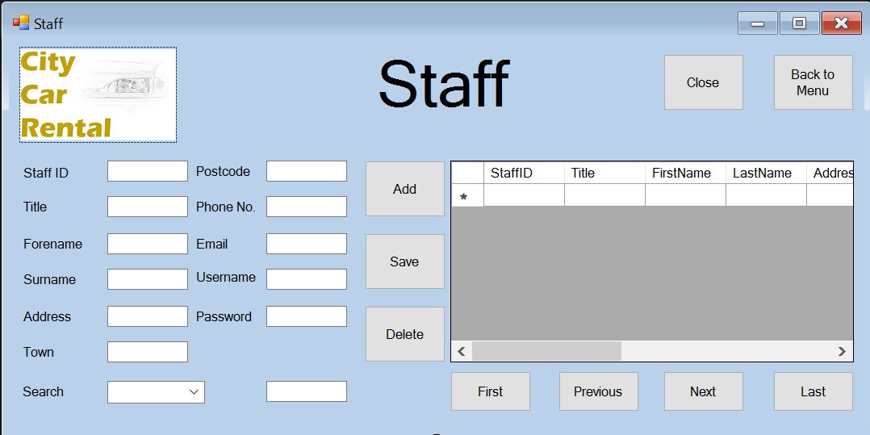

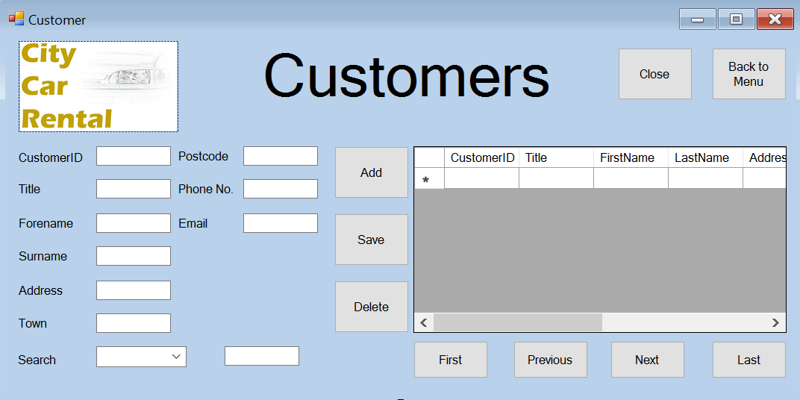

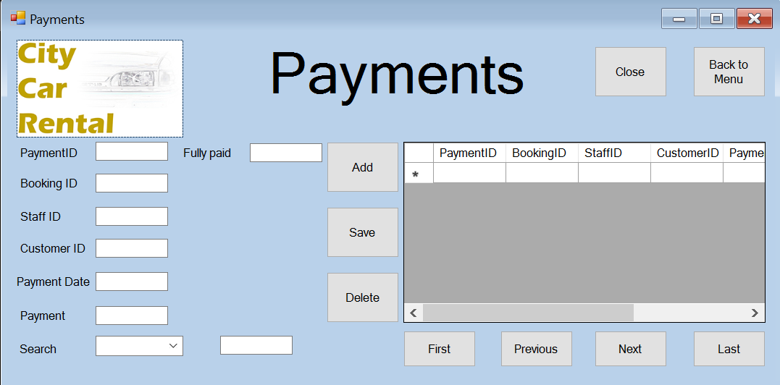

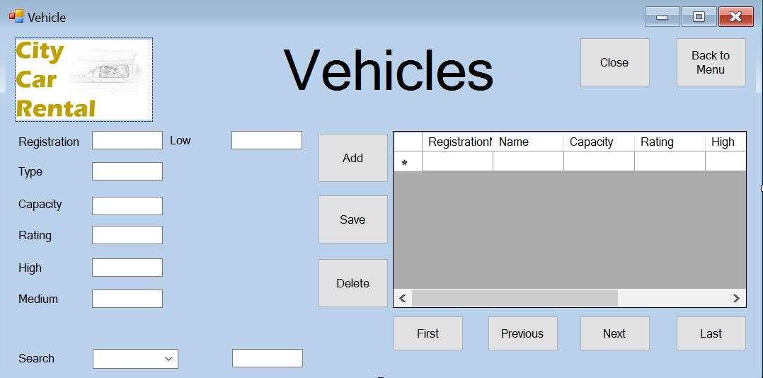

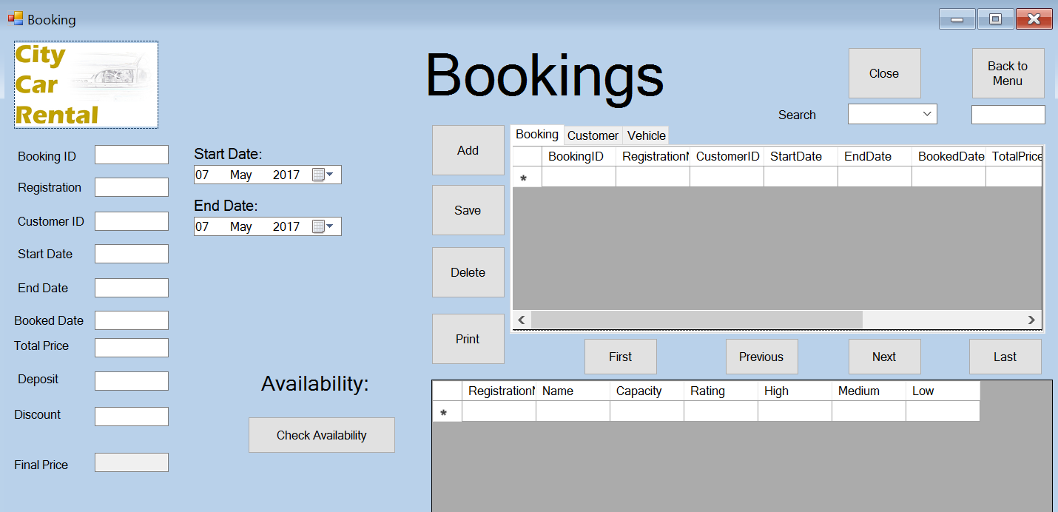

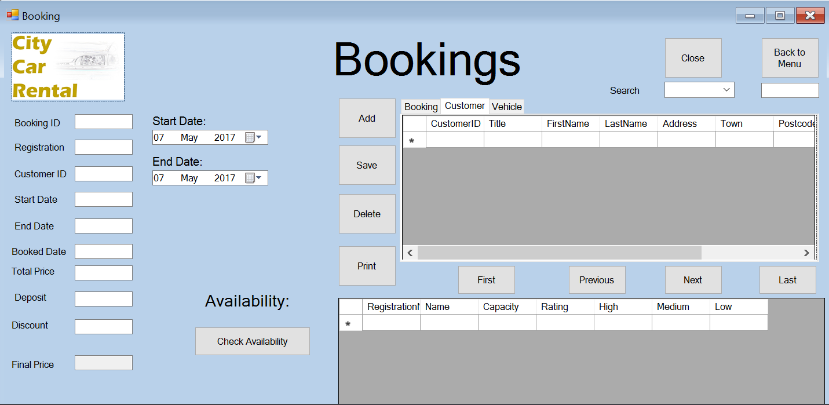

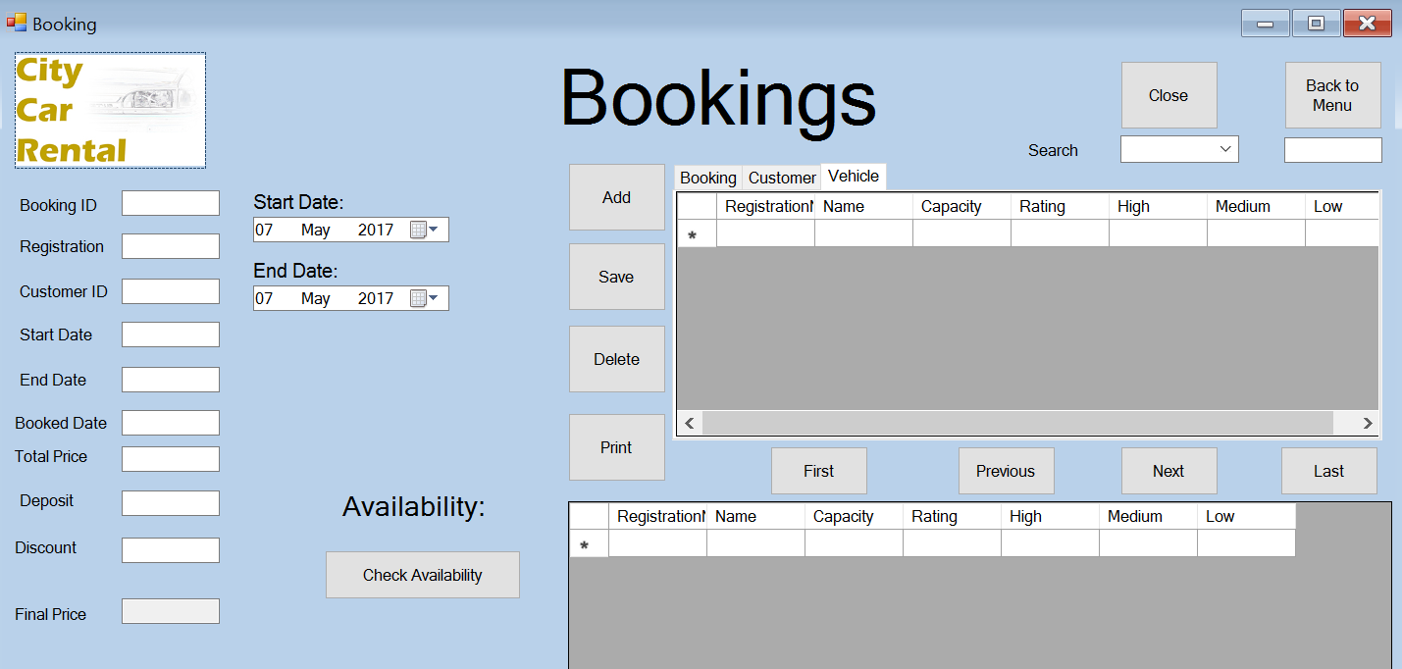

Variables used to create the solution

Splash Screen

Timer1 – to countdown the 3.5 seconds for the splash screen.

Login

Cn – Creates the connection to SQL to be opened and closed in the login form.

Sql – selects the staff table from the database.

Da – creates a SQL adapter that can be used.

Cmd – creates a SQL command that can be used.

Ds – creates a dataset to hold SQL data.

Table – declares a data table to produce data.

nextScreen – shows the menu form if login is granted access

user – holds the entered username

pass – holds the entered password

txtPassword – Contains the entered password from the user

cboUsername – Allows the username to be chosen by the user

Menu

Login – used to show the login form

Staff – used to show the staff form

Customer – used to show the customer form

Payments – used to show they payments form

Vehicles – used to show the vehicles form

Booking – used to show the bookings form

Staff

Cn – Creates the connection to SQL to be opened and closed in the login form.

DaStaff – creates a SQL adapter that can be used.

CmdStaff – creates a SQL command that can be used.

Dt – creates a data table to hold SQL data.

Da – creates a SQL adapter that is used to select from staff.

Qur – used to update staff values

Cmd – creates a SQL command that can be used.

staffIDtxt – used to enter and show details.

Titletxt – used to enter and show details.

Forenametxt – used to enter and show details.

Surnametxt – used to enter and show details.

Towntxt – used to enter and show details.

Postcodetxt – used to enter and show details.

Phonenumbertxt – used to enter and show details.

Emailtxt – used to enter and show details.

Usernametxt – used to enter and show details.

Passwordtxt – used to enter and show details.

StaffID – used to display data in data-grid-view.

Title – used to display data in data-grid-view.

FirstName – used to display data in data-grid-view.

LastName – used to display data in data-grid-view.

Address – used to display data in data-grid-view.

Town – used to display data in data-grid-view.

Postcode – used to display data in data-grid-view.

PhoneNo – used to display data in data-grid-view.

Email – used to display data in data-grid-view.

Username – used to display data in data-grid-view.

Password – used to display data in data-grid-view.

nextScreen – shows the menu

Payments

Cn – Creates the connection to SQL to be opened and closed in the login form.

DaStaff – creates a SQL adapter that can be used.

CmdStaff – creates a SQL command that can be used.

Dt – creates a data table to hold SQL data.

Da – creates a SQL adapter that is used to select from staff.

Qur – used to update staff values

Cmd – creates a SQL command that can be used.

staffIDtxt – used to enter and show details.

PaymentIDtxt – used to enter and show details.

bookingIDtxt– used to enter and show details.

customerIDtxt – used to enter and show details.

paymentDatetxt – used to enter and show details.

paymenttxt – used to enter and show details.

fullyPaidtxt – used to enter and show details.

StaffID – used to enter and show details.

PaymentID – used to enter and show details.

bookingID – used to enter and show details.

customerID – used to enter and show details.

paymentDate – used to enter and show details.

payment – used to enter and show details.

fullyPaid – used to enter and show details.

nextScreen – shows the menu

Vehicles

Cn – Creates the connection to SQL to be opened and closed in the login form.

DaStaff – creates a SQL adapter that can be used.

CmdStaff – creates a SQL command that can be used.

Dt – creates a data table to hold SQL data.

Da – creates a SQL adapter that is used to select from staff.

Qur – used to update staff values

Cmd – creates a SQL command that can be used.

Registrationtxt – used to enter and show details.

Registration – used to display data in data-grid-view.

Typetxt – used to enter and show details.

type – used to display data in data-grid-view.

capacitytxt – used to enter and show details.

capacity – used to display data in data-grid-view.

ratingtxt – used to enter and show details.

rating – used to display data in data-grid-view.

highPricetxt – used to enter and show details.

highPrice – used to display data in data-grid-view.

mediumPricetxt – used to enter and show details.

mediumPrice – used to display data in data-grid-view.

lowPricetxt – used to enter and show details.

lowPrice – used to display data in data-grid-view.

maketxt – used to enter and show details.

make – used to display data in data-grid-view.

modeltxt – used to enter and show details.

model – used to display data in data-grid-view.

yeartxt – used to enter and show details.

year – used to display data in data-grid-view.

mpgtxt – used to enter and show details.

mpg – used to display data in data-grid-view.

powertxt – used to enter and show details.

power – used to display data in data-grid-view.

mileagetxt – used to enter and show details.

mileage – used to display data in data-grid-view.

nextScreen – shows the menu

Booking

Cn – Creates the connection to SQL to be opened and closed in the login form.

Damakebooking – creates a SQL adapter that can be used.

Cmdmakebooking – creates a SQL command that can be used.

Ds – creates a data table to hold SQL data.

Dt – creates a data table to hold SQL data.

Dv – creates a data table to hold SQL data.

Veh – creates a data table to hold SQL data.

Cb – used in creating SQL commands

Da – creates a SQL adapter that is used to select from staff.

Qur – used to update staff values

Cmd – creates a SQL command that can be used.

staffIDtxt – used to enter and show details.

bookingIdtxt – used to enter and show details.

bookingId – used to display data in data-grid-view.

registrationtxt – used to enter and show details.

registration – used to display data in data-grid-view.

customerIDtxt – used to enter and show details.

customerID – used to display data in data-grid-view.

startDatetxt – used to enter and show details.

startDate – used to display data in data-grid-view.

endDatetxt – used to enter and show details.

endDate – used to display data in data-grid-view.

bookedDatetxt – used to enter and show details.

bookedDate – used to display data in data-grid-view.

totalPricetxt – used to enter and show details.

totalPrice – used to display data in data-grid-view.

deposittxt – used to enter and show details.

deposit – used to display data in data-grid-view.

discounttxt – used to enter and show details.

discount – used to display data in data-grid-view.

finalPricetxt – used to enter and show details.

finalPrice – used to display data in data-grid-view.

nextScreen – shows the menu.

customerID – used to display data in data-grid-view.

FirstName – used to display data in data-grid-view.

Lastname – used to display data in data-grid-view.

Address – used to display data in data-grid-view.

PhoneNumber – used to display data in data-grid-view.

Email – used to display data in data-grid-view.

dtpsdDays – used to find the number of days between the end and start date.

days – holds the number of days between end date n start date.

totalPrice – holds the final calculated price.

discountMultiplier – holds the value for the discount.

Dtpsdmonth – finds the month that the start date is in to find the season price.

Season – Holds the value of the seasons price.

Sd – Holds the start date value.

Ed - holds the end date value.

Invoice_book – shows the invoice form with all details.

Evidence of the completed user interface

Splash Screen

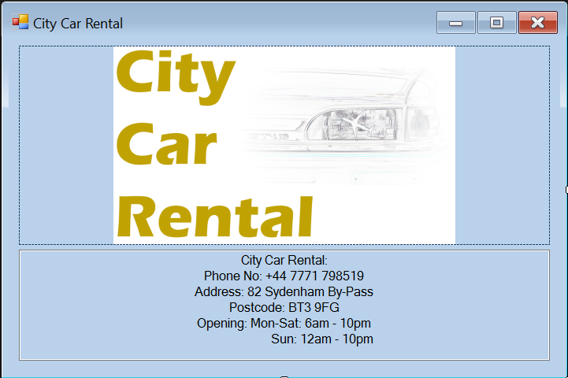

The Design has been completed with company logos and colour, this coincides with the proposed design and no changes have been made to it.

Login Form

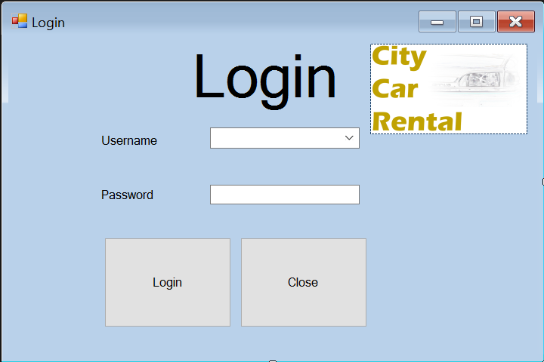

The Login form is complete for the placement of the objects, the colour and adding of graphics to the program, with company logos and colour, this coincides with the proposed design and no changes have been made to it.

Menu Form

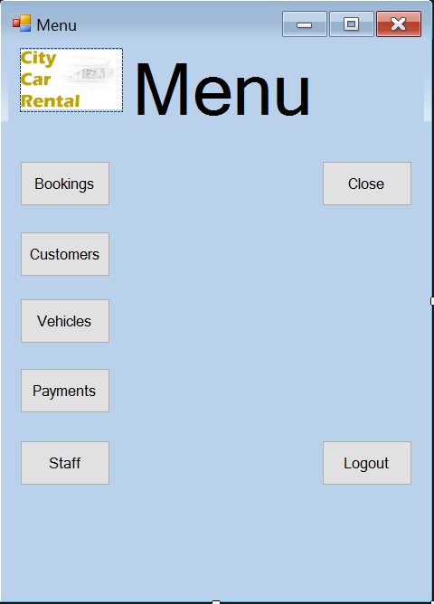

The design of the menu form is now complete with design and aesthetic. Furthermore, the function of the form is working perfectly and all buttons are operational, with company logos and colour, this coincides with the proposed design and no changes have been made to it.

Customer Form

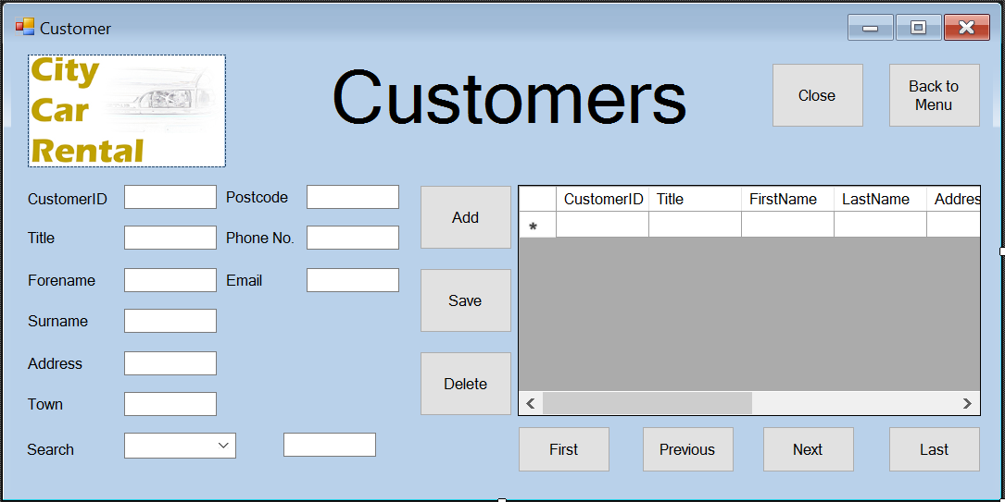

The design of the customer form is complete, with company logos and colour, this has minor changes with the proposed design and changes have only been made to logo location and close button.

Staff Form

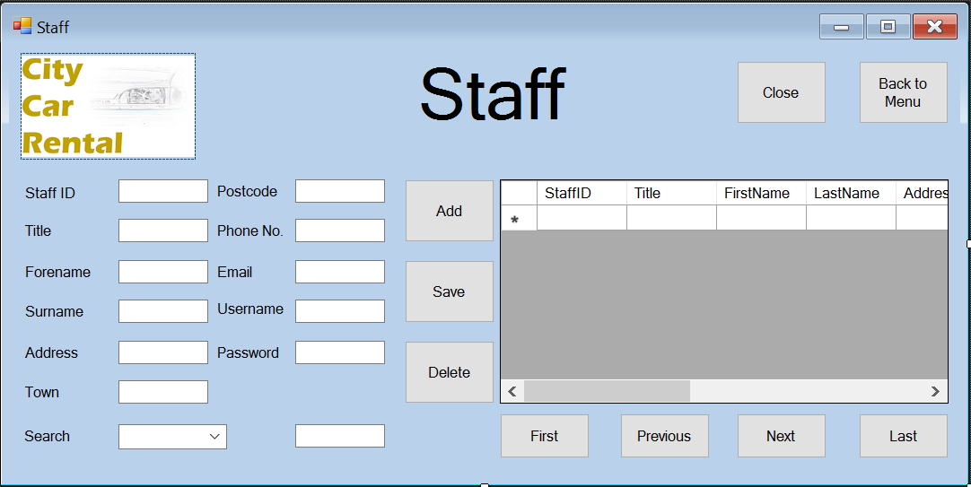

The design of the staff form is complete, with company logos and colour, this has minor changes with the proposed design and changes have only been made to logo location and close button.

Payments Form

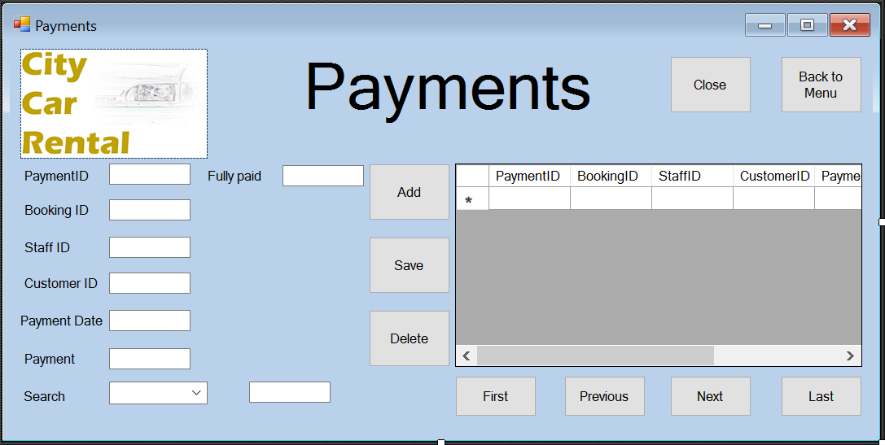

The design of the payments form is complete, with company logos and colour, this has minor changes with the proposed design and changes have only been made to logo location and close button.

Vehicles Form

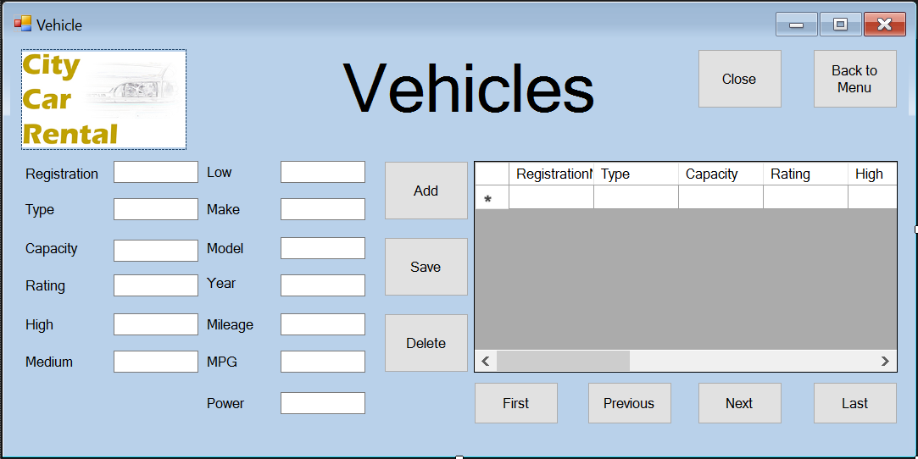

The design of the vehicles form is complete, with company logos and colour, this has minor changes with the proposed design and changes have only been made to logo location and close button.

Bookings Form

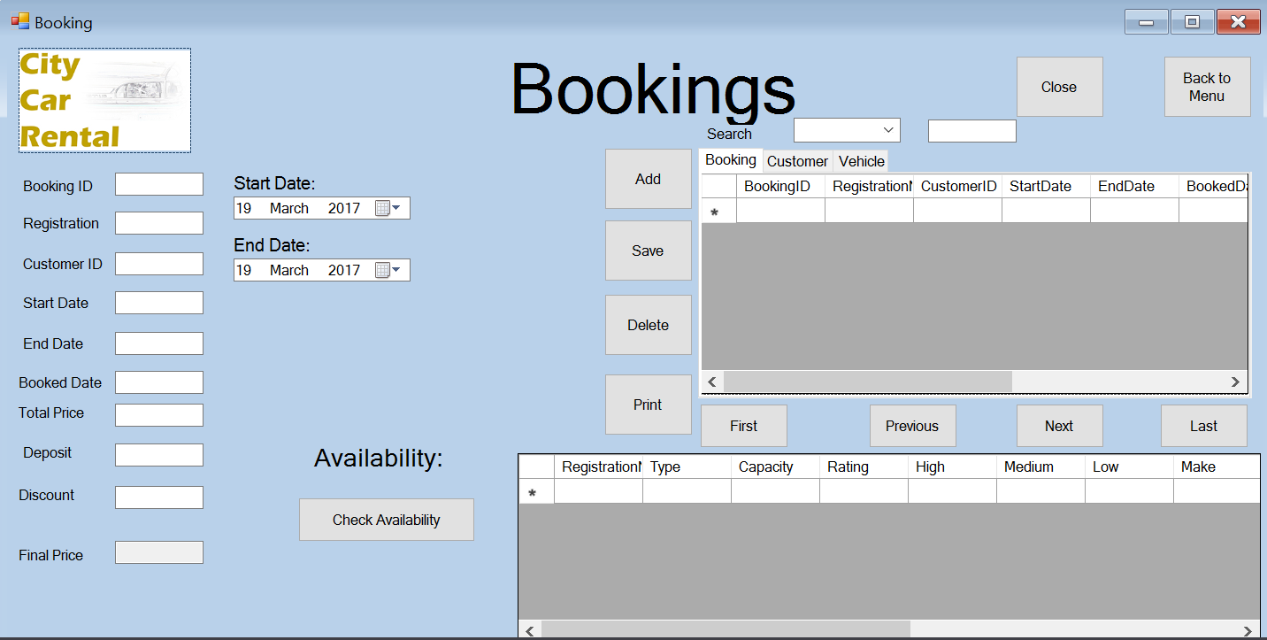

The design of the Bookings form is complete, with company logos and colour, this has minor changes with the proposed design and changes have only been made to logo location and close button.

Invoice Form

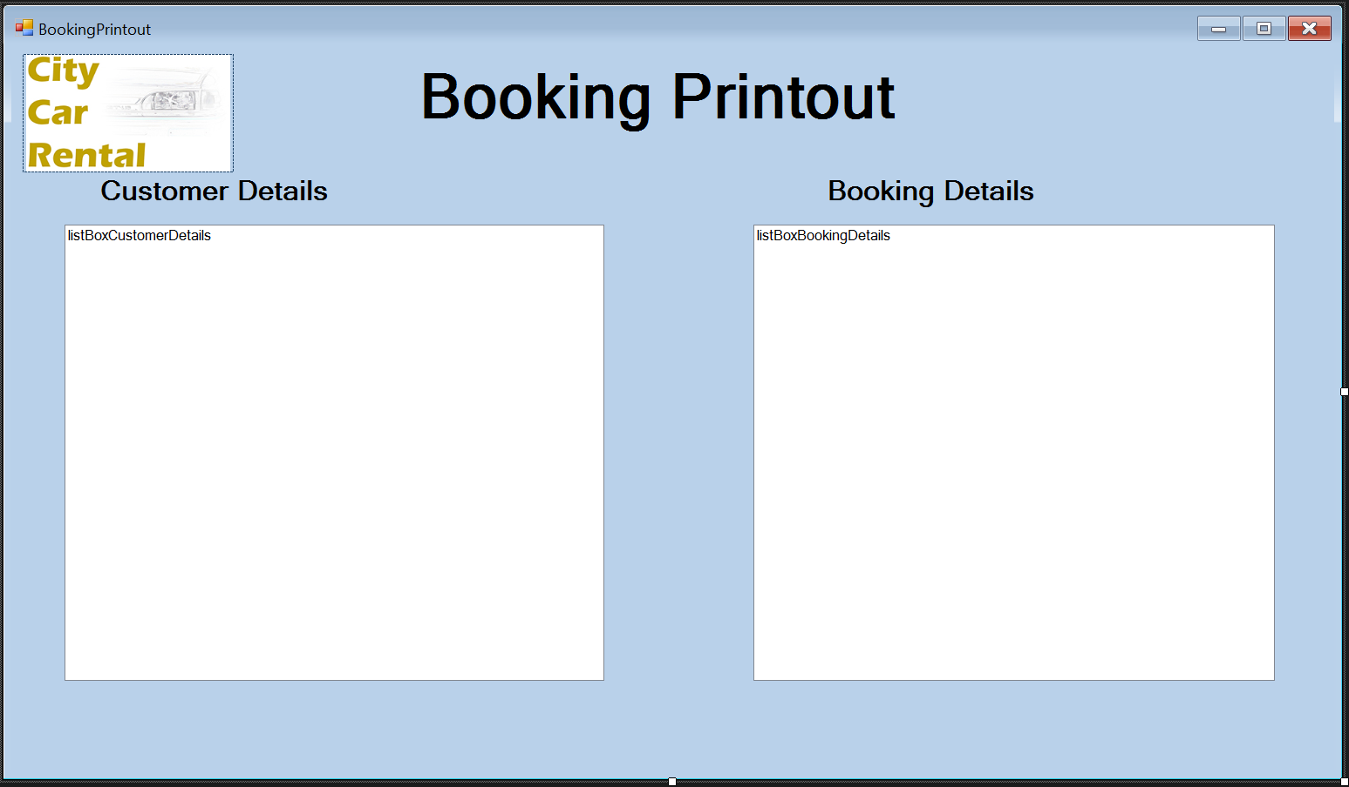

The design of the Invoice form is complete, with company logos and colour, this has minor changes with the proposed design and changes have only been made to logo location and close button.

Full description of the features that make the solution fit for audience and purpose

Data-grid-views

the use of data-grid-views will aid the user in viewing the records as they will be automatically shown when the form opens

Date-time pickers

The date-time pickers will aid the users of the system as it prevents incorrect formatting and incorrect syntax when entering dates and also reduces the possibility of the incorrect dates being entered all together.

Check availability

The check availability system will help the employees in using the system as it prevents double bookings for the same vehicle and allows employees to easily see which vehicles are available.

Comboboxes

These have been implemented in the search functions and in the login form, these aid the user in operating the system as it helps them know what fields/usernames can be chosen from.

Adding facilities

This allows the user to very easily add new records to the database through a button instead of a SQL query.

Saving facilities

This allows the user to very easily save current records to the database through a button and selecting a record from the data-grid-view instead of a SQL query.

Deleting facilities

This allows the user to very easily delete current records to the database through a button and selecting a record from the data-grid-view instead of a SQL query.

Developmental testing

Section 7



Developmental Testing

Modular Testing

In alpha testing, I expect to find many problems with my current code, however, I plan to rectify this before final testing, I will only be testing the program using normal data and not extreme data, that will come in final testing, I will only be highlighting upon problems with the system before it comes to the final testing in which I will be going over all functions of all forms and showing that they are all working as intended.

Splash screen

Working as intended – No problems to comment on

Login Form

Working as intended – No problems to comment on

Menu Form

Vehicles button leads to nothing and the menu remains open

All other functions working as intended

Booking Form

Check availability is not functioning and therefore the add button cannot be tested until this is amended.

First, next, previous, last buttons not functional – result is program crashes.

Search function not working, code not present.

Final price calculations cannot be checked as check availability is not working.

Add button not working – system crashes

Save button not working – system crashes

Invoice form

Booking details successfully shown in the Invoice form

Customer details not shown.

Customer form

Working as intended – No problems to comment on

Staff form

Delete button not working – Shows field deleted but field remains

Search function not working – nothing happens

Add button not working – system crashes

Save button not working – system crashes

Vehicles form

Delete button not working – Shows field deleted but field remains

Search function not working – nothing happens

All records replaced with the letter x, must redo vehicles table and vehicles form

Add button not working – system crashes

Save button not working – system crashes

Payments form

Delete button not working – Shows field deleted but field remains

Search function not working – nothing happens

Add button not working – system crashes

Save button not working – system crashes

Actions taken to overcome these problems

Menu form

The code for this was present, however, the event was not attached to the code and this simply needed to be amended in the properties window for the button to function as it should

Booking form

First, next, previous, last button, code was not working as I had used data tables instead of data sets, causing the program to crash whenever the buttons were pressed, I changed the code to use the data grid view instead of the database to change the position. Old code has been commented out.

Amended first, next, previous, last buttons

private void btnNext_Click(object sender, EventArgs e)

{

//this.BindingContext[ds, "Booking"].Position++;

int next = this.dataGridView1.CurrentRow.Index + 1;

this.dataGridView1.CurrentCell = this.dataGridView1.Rows[next].Cells[this.dataGridView1.CurrentCell.ColumnIndex];

}

private void btnPrevious_Click(object sender, EventArgs e)

{

//this.BindingContext[ds, "Booking"].Position--;

int prev = this.dataGridView1.CurrentRow.Index - 1;

this.dataGridView1.CurrentCell = this.dataGridView1.Rows[prev].Cells[this.dataGridView1.CurrentCell.ColumnIndex];

}

private void btnFirst_Click(object sender, EventArgs e)

{

// this.BindingContext[ds, "Booking"].Position = 0;

this.dataGridView1.CurrentCell = this.dataGridView1.Rows[0].Cells[this.dataGridView1.CurrentCell.ColumnIndex];

}

private void btnLast_Click(object sender, EventArgs e)

{

//int vitri = this.BindingContext[ds, "Booking"].Count - 1;

//this.BindingContext[ds, "Booking"].Position = vitri;

int last = this.dataGridView1.RowCount - 1;

this.dataGridView1.CurrentCell = this.dataGridView1.Rows[last].Cells[this.dataGridView1.CurrentCell.ColumnIndex];

}

Check availability is now working as there was previously some problems with the connections to the SQL database, and with the data table, the code has been modified for this to work.

Amended check availablility

DataTable avail = new DataTable();

cn.Open();

SqlCommand command = new SqlCommand();

command.Connection = cn; //new SqlConnection(Properties.Resources.BookingsDatabase_Connection);

command.CommandText = "select * from Vehicles where RegistrationNo NOT IN (select RegistrationNo from Booking where (StartDate >= @StartDate and StartDate < @EndDate) OR (EndDate > @StartDate and EndDate <= @EndDate))";

command.Parameters.Add("@StartDate", SqlDbType.DateTime).Value = dtpStartDate.Value.Date;

command.Parameters.Add("@EndDate", SqlDbType.DateTime).Value = dtpEndDate.Value.Date;

cn.Close();

SqlDataAdapter da = new SqlDataAdapter(command);

da.Fill(avail);

dgvAvailability.DataSource = avail;

The add button had problems with the SQL query used to add new records, this resulted in the program crashing without much error report, the syntax was changed and more variables were added to execute the query successfully

Amended add button

private void addBtn_Click(object sender, EventArgs e)

{

cn.Open();

string qur = "INSERT INTO Booking (registrationNo, customerID, startDate, endDate, bookedDate, totalPrice, deposit, discount, finalPrice) VALUES (@registrationNo, @customerID, @startDate, @endDate, @bookedDate, @totalPrice, @deposit, @discount, @finalPrice)";

SqlCommand cmd = new SqlCommand(qur, cn);

// cmd.Parameters.AddWithValue("@bookingID", bookingIdtxt.Text);

cmd.Parameters.AddWithValue("@registrationNo", registrationtxt.Text);

cmd.Parameters.AddWithValue("@customerID", customerIDtxt.Text);

cmd.Parameters.AddWithValue("@startDate", startDatetxt.Text);

cmd.Parameters.AddWithValue("@endDate", endDatetxt.Text);

cmd.Parameters.AddWithValue("@bookedDate", bookedDatetxt.Text);

cmd.Parameters.AddWithValue("@totalPrice", totalPricetxt.Text);

cmd.Parameters.AddWithValue("@deposit", deposittxt.Text);

cmd.Parameters.AddWithValue("@discount", discounttxt.Text);

cmd.Parameters.AddWithValue("@finalPrice", finalPricetxt.Text);

cmd.ExecuteNonQuery();

cn.Close();

MessageBox.Show("Inserted sucessfully");

bookingIdtxt.Text = "";

registrationtxt.Text = "";

customerIDtxt.Text = "";

startDatetxt.Text = "";

endDatetxt.Text = "";

bookedDatetxt.Text = "";

totalPricetxt.Text = "";

deposittxt.Text = "";

discounttxt.Text = "";

finalPricetxt.Text = "";

}

The save button had an incorrect query and needed extra variables and parameters added, this prevented the form from crashing and made the save button work correctly

Amended save button

private void saveBtn_Click(object sender, EventArgs e)

{

cn.Open();

string qur = "UPDATE Booking SET registrationNo=@registrationNo, CustomerID=@CustomerID, startDate=@startDate, endDate=@endDate, bookedDate=@bookedDate, totalPrice=@totalPrice, deposit=@deposit, discount=@discount, finalPrice=@finalPrice where bookingID= @bookingID";

SqlCommand cmd = new SqlCommand(qur, cn);

cmd.Parameters.AddWithValue("@CustomerID", SqlDbType.Int).Value = customerIDtxt.Text;

cmd.Parameters.AddWithValue("@BookingID", SqlDbType.Int).Value = bookingIdtxt.Text;

cmd.Parameters.AddWithValue("@registrationNo", SqlDbType.Int).Value = registrationtxt.Text;

cmd.Parameters.AddWithValue("@startDate", SqlDbType.DateTime).Value = startDatetxt.Text;

cmd.Parameters.AddWithValue("@endDate", SqlDbType.DateTime).Value = endDatetxt.Text;

cmd.Parameters.AddWithValue("@bookedDate", SqlDbType.DateTime).Value = bookedDatetxt.Text;

cmd.Parameters.AddWithValue("@totalPrice", SqlDbType.Int).Value = totalPricetxt.Text;

cmd.Parameters.AddWithValue("@deposit", SqlDbType.Decimal).Value = deposittxt.Text;

cmd.Parameters.AddWithValue("@discount", SqlDbType.Decimal).Value = discounttxt.Text;

cmd.Parameters.AddWithValue("@finalPrice", SqlDbType.Int).Value = finalPricetxt.Text;

cmd.ExecuteNonQuery();

cn.Close();

MessageBox.Show("Inserted sucessfully");

bookingIdtxt.Text = "";

registrationtxt.Text = "";

customerIDtxt.Text = "";

startDatetxt.Text = "";

endDatetxt.Text = "";

bookedDatetxt.Text = "";

totalPricetxt.Text = "";

deposittxt.Text = "";

discounttxt.Text = "";

finalPricetxt.Text = "";

}

Staff Form

The delete button was using the wrong variable to check which record needed to be deleted and now is using the correct variable, the command was also not being executed and now is, this corrects the issues with the record not being deleted.

Amended delete button

private void deleteBtn_Click(object sender, EventArgs e)

{

cmdStaff = new SqlCommand("DELETE STAFF where StaffID=@StaffID", cn);

cn.Open();

cmdStaff.Parameters.AddWithValue("@StaffID", Convert.ToInt32(StaffID));

try

{

cmdStaff.ExecuteNonQuery();

//daStaff.Update("Booking");

MessageBox.Show("Field Deleted.");

cn.Close();

}

catch

{

}

The code for the search function was not present, therefore the search function was not functional.

Amended Search Function

private void textBox1_TextChanged(object sender, EventArgs e)

{

if (searchcbo.Items[searchcbo.SelectedIndex].ToString() == "StaffID")

{

cn.Open();

//SqlDataAdapter changed;

changed = new SqlDataAdapter("select * from Staff where StaffID like '" + textBox1.Text + "%'", cn);

dt = new DataTable();

changed.Fill(dt);

dataGridView1.DataSource = dt;

cn.Close();

}

if (searchcbo.Items[searchcbo.SelectedIndex].ToString() == "LastName")

{

cn.Open();

changed = new SqlDataAdapter("select * from Staff where LastName like '" + textBox1.Text + "%'", cn);

dt = new DataTable();

changed.Fill(dt);

dataGridView1.DataSource = dt;

cn.Close();

}

if (searchcbo.Items[searchcbo.SelectedIndex].ToString() == "Username")

{

cn.Open();

changed = new SqlDataAdapter("select * from Staff where Username like '" + textBox1.Text + "%'", cn);

dt = new DataTable();

changed.Fill(dt);

dataGridView1.DataSource = dt;

cn.Close();

}

}

}

The add button had problems with the SQL query used to add new records, this resulted in the program crashing without much error report, the syntax was changed and more variables were added to execute the query successfully

Amended add button

private void addBtn_Click(object sender, EventArgs e)

{

cn.Open();

string qur = "INSERT INTO Staff VALUES ( @StaffID, @Title, @FirstName, @LastName, @Town, @Postcode, @PhoneNo, @Email, @Username, @Password)";

//'" + staffIDtxt.Text + "','" + titletxt.Text + "''"+ forenametxt.Text+"','"+ surnametxt.Text+ "','" + towntxt.Text + "''" + postcodetxt.Text + "','" + phonenumbertxt.Text + "','" + emailtxt.Text + "''" + usernametxt.Text + "','" + passwordtxt.Text + "')";

SqlCommand cmd = new SqlCommand(qur, cn);

cmd.Parameters.AddWithValue("@StaffID", staffIDtxt.Text);

cmd.Parameters.AddWithValue("@Title", titletxt.Text);

cmd.Parameters.AddWithValue("@FirstName", forenametxt.Text);

cmd.Parameters.AddWithValue("@LastName", surnametxt.Text);

cmd.Parameters.AddWithValue("@Town", towntxt.Text);

cmd.Parameters.AddWithValue("@Postcode", postcodetxt.Text);

cmd.Parameters.AddWithValue("@PhoneNo", phonenumbertxt.Text);

cmd.Parameters.AddWithValue("@Email", emailtxt.Text);

cmd.Parameters.AddWithValue("@Username", usernametxt.Text);

cmd.Parameters.AddWithValue("@Password", passwordtxt.Text);

try

{

cmd.ExecuteNonQuery();

MessageBox.Show("Inserted sucessfully");

staffIDtxt.Text = "";

titletxt.Text = "";

forenametxt.Text = "";

surnametxt.Text = "";

towntxt.Text = "";

postcodetxt.Text = "";

phonenumbertxt.Text = "";

emailtxt.Text = "";

usernametxt.Text = "";

passwordtxt.Text = "";

}

catch

{

}

cn.Close();

dataGridView1.DataSource = dt;

The save button had an incorrect query and needed extra variables and parameters added, this prevented the form from crashing and made the save button work correctly

Amended save button

private void saveBtn_Click(object sender, EventArgs e)

{

cn.Open();

string qur = "UPDATE Staff SET Title = @Title, FirstName = @FirstName, LastName = @LastName, Town = @Town, Postcode = @Postcode, PhoneNo = @PhoneNo, Email = @Email, Username = @Username, Password = @Password where StaffID = @StaffID ";

SqlCommand cmd = new SqlCommand(qur, cn);

cmd.Parameters.AddWithValue("@StaffID", SqlDbType.Int).Value = staffIDtxt.Text;

cmd.Parameters.AddWithValue("@Title", SqlDbType.VarChar).Value = titletxt.Text;

cmd.Parameters.AddWithValue("@FirstName", SqlDbType.VarChar).Value = forenametxt.Text;

cmd.Parameters.AddWithValue("@LastName", SqlDbType.VarChar).Value = surnametxt.Text;

cmd.Parameters.AddWithValue("@Town", SqlDbType.VarChar).Value = towntxt.Text;

cmd.Parameters.AddWithValue("@Postcode", SqlDbType.VarChar).Value = postcodetxt.Text;

cmd.Parameters.AddWithValue("@PhoneNo", SqlDbType.VarChar).Value = phonenumbertxt.Text;

cmd.Parameters.AddWithValue("@Email", SqlDbType.VarChar).Value = emailtxt.Text;

cmd.Parameters.AddWithValue("@Username", SqlDbType.VarChar).Value = usernametxt.Text;

cmd.Parameters.AddWithValue("@Password", SqlDbType.VarChar).Value = passwordtxt.Text;

cmd.ExecuteNonQuery();

cn.Close();

MessageBox.Show("Inserted sucessfully");

staffIDtxt.Text = "";

titletxt.Text = "";

forenametxt.Text = "";

surnametxt.Text = "";

towntxt.Text = "";

postcodetxt.Text = "";

phonenumbertxt.Text = "";

emailtxt.Text = "";

usernametxt.Text = "";

passwordtxt.Text = "";

dataGridView1.DataSource = dt;

}

Vehicles form

The delete button was using the wrong variable to check which record needed to be deleted and now is using the correct variable, the command was also not being executed and now is, this corrects the issues with the record not being deleted.

Amended delete button

private void deleteBtn_Click(object sender, EventArgs e)

{

cmdStaff = new SqlCommand("DELETE Vehicle where RegistrationNo=@RegistrationNo", cn);

cn.Open();

cmdStaff.Parameters.AddWithValue("@RegistrationNo", Convert.ToInt32(Registration));

try

{

cmdStaff.ExecuteNonQuery();

//daStaff.Update("Booking");

MessageBox.Show("Field Deleted.");

cn.Close();

}

catch

{

}

The code for the search function was not present, therefore the search function was not functional.

Amended Search Function

private void textBox1_TextChanged(object sender, EventArgs e)

{

if (searchcbo.Items[searchcbo.SelectedIndex].ToString() == "RegistrationNo")

{

cn.Open();

//SqlDataAdapter changed;

changed = new SqlDataAdapter("select * from Vehicle where RegistrationNo like '" + textBox1.Text + "%'", cn);

dt = new DataTable();

changed.Fill(dt);

dataGridView1.DataSource = dt;

cn.Close();

}

if (searchcbo.Items[searchcbo.SelectedIndex].ToString() == "Model")

{

cn.Open();

changed = new SqlDataAdapter("select * from Vehicle where Model like '" + textBox1.Text + "%'", cn);

dt = new DataTable();

changed.Fill(dt);

dataGridView1.DataSource = dt;

cn.Close();

}

}

The add button had problems with the SQL query used to add new records, this resulted in the program crashing without much error report, the syntax was changed and more variables were added to execute the query successfully

Amended add button

private void addBtn_Click(object sender, EventArgs e)

{

cn.Open();

string qur = "INSERT INTO Vehicle(Name, Capacity, Rating, High, Medium, Low, RegistrationNo) VALUES ( @Name, @Capacity, @Rating, @High, @Medium, @Low, @RegistrationNo)";

SqlCommand cmd = new SqlCommand(qur, cn);

cmd.Parameters.AddWithValue("@RegistrationNo", registrationtxt.Text);

cmd.Parameters.AddWithValue("@Name", typetxt.Text);

cmd.Parameters.AddWithValue("@Capacity", capacitytxt.Text);

cmd.Parameters.AddWithValue("@Rating", ratingtxt.Text);

cmd.Parameters.AddWithValue("@High", highPricetxt.Text);

cmd.Parameters.AddWithValue("@Medium", mediumPricetxt.Text);

cmd.Parameters.AddWithValue("@Low", lowPricetxt.Text);

try

{

cmd.ExecuteNonQuery();

MessageBox.Show("Inserted sucessfully");

registrationtxt.Text = "";

typetxt.Text = "";

capacitytxt.Text = "";

ratingtxt.Text = "";

highPricetxt.Text = "";

mediumPricetxt.Text = "";

lowPricetxt.Text = "";

}

catch

{

}

cn.Close();

}

The save button had an incorrect query and needed extra variables and parameters added, this prevented the form from crashing and made the save button work correctly

Amended save button

private void saveBtn_Click(object sender, EventArgs e)

{

cn.Open();

string qur = "UPDATE Vehicle SET Name= @Name, Capacity=@Capacity, Rating=@Rating, High=@High, Medium=@Medium, Low=@Low where RegistrationNo=@RegistrationNo";// make=@make, model=@model, year=@year, mileage=@mileage, mpg=@mpg, power=@power, refueled=@refueled, damaged=@damaged where RegistrationNo=@RegistrationNo";

SqlCommand cmd = new SqlCommand(qur, cn);

cmd.Parameters.AddWithValue("@Name", SqlDbType.VarChar).Value = typetxt.Text;

cmd.Parameters.AddWithValue("@Capacity", SqlDbType.VarChar).Value = capacitytxt.Text;

cmd.Parameters.AddWithValue("@Rating", SqlDbType.VarChar).Value = ratingtxt.Text;

cmd.Parameters.AddWithValue("@High", SqlDbType.VarChar).Value = highPricetxt.Text;

cmd.Parameters.AddWithValue("@Medium", SqlDbType.VarChar).Value = mediumPricetxt.Text;

cmd.Parameters.AddWithValue("@Low", SqlDbType.VarChar).Value = lowPricetxt.Text;

cmd.Parameters.AddWithValue("@RegistrationNo", SqlDbType.Int).Value = registrationtxt.Text;

cmd.ExecuteNonQuery();

cn.Close();

MessageBox.Show("Inserted sucessfully");

registrationtxt.Text = "";

typetxt.Text = "";

capacitytxt.Text = "";

ratingtxt.Text = "";

highPricetxt.Text = "";

mediumPricetxt.Text = "";

lowPricetxt.Text = "";

}

The vehicles table had to be remade with fewer fields and the form for vehicles had to be re-made. The new vehicles table had to be filled with records also.

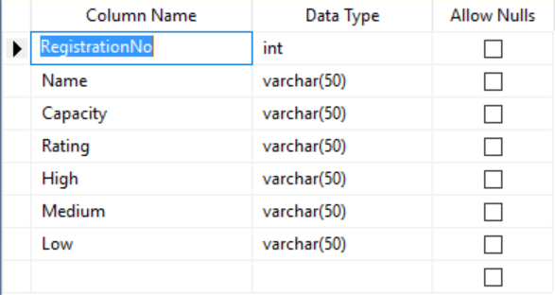

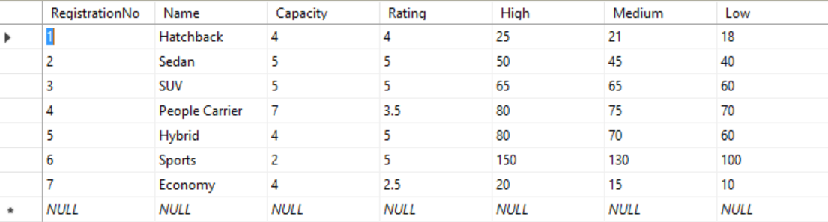

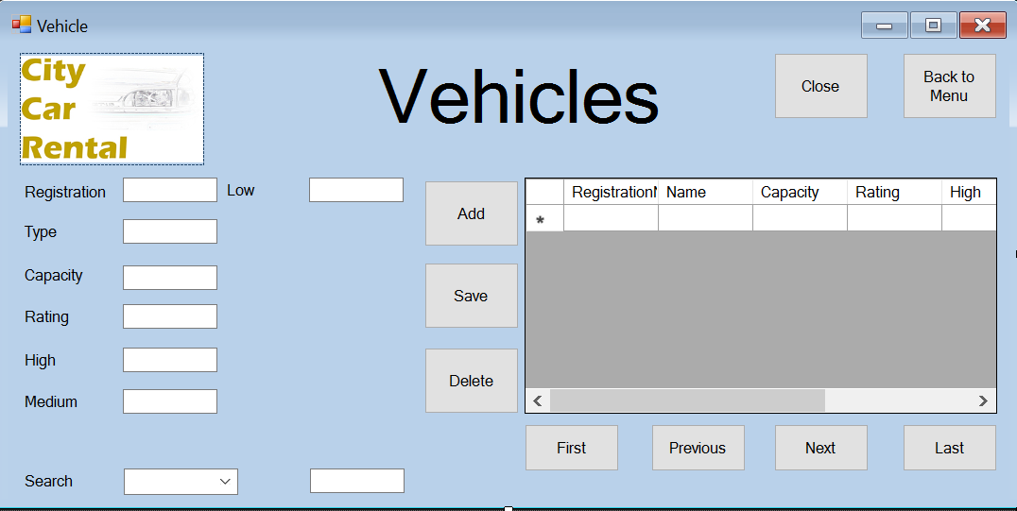

Payments form

The delete button was using the wrong variable to check which record needed to be deleted and now is using the correct variable, the command was also not being executed and now is, this corrects the issues with the record not being deleted.

Amended delete button

private void deleteBtn_Click(object sender, EventArgs e)

{

//Deletes the selected record from the SQL Database

cmdStaff = new SqlCommand("DELETE Payment where PaymentID=@PaymentID", cn);

cn.Open();

cmdStaff.Parameters.AddWithValue("@PaymentID", Convert.ToInt32(PaymentID));

try

{

cmdStaff.ExecuteNonQuery();

//daStaff.Update("Booking");

MessageBox.Show("Field Deleted.");

cn.Close();

}

catch

{

}

}

The code for the search function was not present, therefore the search function was not functional.

Amended Search Function

private void textBox1_TextChanged(object sender, EventArgs e)

{

if (searchcbo.Items[searchcbo.SelectedIndex].ToString() == "PaymentID")

{

cn.Open();

//SqlDataAdapter changed;

changed = new SqlDataAdapter("select * from Payment where PaymentID like '" + textBox1.Text + "%'", cn);

dt = new DataTable();

changed.Fill(dt);

dataGridView1.DataSource = dt;

cn.Close();

}

if (searchcbo.Items[searchcbo.SelectedIndex].ToString() == "StaffID")

{

cn.Open();

changed = new SqlDataAdapter("select * from Payment where StaffID like '" + textBox1.Text + "%'", cn);

dt = new DataTable();

changed.Fill(dt);

dataGridView1.DataSource = dt;

cn.Close();

}

if (searchcbo.Items[searchcbo.SelectedIndex].ToString() == "BookingID")

{

cn.Open();

changed = new SqlDataAdapter("select * from Payment where BookingID like '" + textBox1.Text + "%'", cn);

dt = new DataTable();

changed.Fill(dt);

dataGridView1.DataSource = dt;

cn.Close();

}

}

The add button had problems with the SQL query used to add new records, this resulted in the program crashing without much error report, the syntax was changed and more variables were added to execute the query successfully

Amended add button

private void addBtn_Click(object sender, EventArgs e)

{

//inserts a new record into the SQL databse

cn.Open();

string qur = "INSERT INTO Payment(staffID, bookingID, CustomerID, PaymentDate, paymentamount, fullyPayed) VALUES ( @staffID, @bookingID, @CustomerID, @PaymentDate, @paymentamount, @fullyPayed)";

SqlCommand cmd = new SqlCommand(qur, cn);

cmd.Parameters.AddWithValue("@staffID", staffIDtxt.Text);

// cmd.Parameters.AddWithValue("@paymentID", paymentIDtxt.Text);

cmd.Parameters.AddWithValue("@bookingID", bookingIDtxt.Text);

cmd.Parameters.AddWithValue("@CustomerID", customerIDtxt.Text);

cmd.Parameters.AddWithValue("@PaymentDate", paymentDatetxt.Text);

cmd.Parameters.AddWithValue("@paymentamount", paymenttxt.Text);

cmd.Parameters.AddWithValue("@fullyPayed", fullyPaidtxt.Text);

//+ staffIDtxt.Text + "','" + paymentIDtxt.Text + "''" + bookingIDtxt.Text + "','" + customerIDtxt.Text + "','" + paymentDatetxt.Text + "''" + paymenttxt.Text + "','" + fullyPaidtxt.Text + "')";

cmd.ExecuteNonQuery();

cn.Close();

//Clears the textboxes after adding them

MessageBox.Show("Inserted sucessfully");

staffIDtxt.Text = "";

paymentIDtxt.Text = "";

bookingIDtxt.Text = "";

customerIDtxt.Text = "";

paymentDatetxt.Text = "";

paymenttxt.Text = "";

fullyPaidtxt.Text = "";

}

The save button had an incorrect query and needed extra variables and parameters added, this prevented the form from crashing and made the save button work correctly

Amended save button

private void saveBtn_Click(object sender, EventArgs e)

{

//Inserts the textbox data into the SQL database to edit a particular record and save it

cn.Open();

string qur = "UPDATE Payment SET bookingID= @bookingID, CustomerID=@CustomerID, paymentamount=@paymentamount, fullyPayed=@fullyPayed, staffID=@staffID where paymentID=@paymentID";// make=@make, model=@model, year=@year, mileage=@mileage, mpg=@mpg, power=@power, refueled=@refueled, damaged=@damaged where RegistrationNo=@RegistrationNo";

SqlCommand cmd = new SqlCommand(qur, cn);

cmd.Parameters.AddWithValue("@bookingID", SqlDbType.Int).Value = bookingIDtxt.Text;

cmd.Parameters.AddWithValue("@CustomerID", SqlDbType.Int).Value = customerIDtxt.Text;

//cmd.Parameters.AddWithValue("@PaymentDate", SqlDbType.NVarChar).Value = paymentDatetxt.Text;

cmd.Parameters.AddWithValue("@paymentamount", SqlDbType.Decimal).Value = paymenttxt.Text;

cmd.Parameters.AddWithValue("@fullyPayed", SqlDbType.VarChar).Value = fullyPaidtxt.Text;

cmd.Parameters.AddWithValue("@staffID", SqlDbType.Int).Value = staffIDtxt.Text;

cmd.Parameters.AddWithValue("@paymentID", SqlDbType.Int).Value = paymentIDtxt.Text;

cmd.ExecuteNonQuery();

cn.Close();

/* // cmd.Parameters.AddWithValue("@paymentID", paymentIDtxt.Text);

cmd.Parameters.AddWithValue("@bookingID", bookingIDtxt.Text);

cmd.Parameters.AddWithValue("@CustomerID", customerIDtxt.Text);

cmd.Parameters.AddWithValue("@PaymentDate", paymentDatetxt.Text);

cmd.Parameters.AddWithValue("@paymentamount", paymenttxt.Text);

cmd.Parameters.AddWithValue("@fullyPayed", fullyPaidtxt.Text);*/

//Clears the textboxes after saving them

MessageBox.Show("Inserted sucessfully");

staffIDtxt.Text = "";

paymentIDtxt.Text = "";

bookingIDtxt.Text = "";

customerIDtxt.Text = "";

paymentDatetxt.Text = "";

paymenttxt.Text = "";

fullyPaidtxt.Text = "";

}

Testing

Section 8



Testing

Splash screen

|  |  |  |
| --- | --- | --- |
| Test | Expected Result | Evidence |
| Splash Screen – Opening | Splash screen opens and shows all pictures and information. | 1.0 |
| Splash Screen closing | Splash Screen closes after 3.5 seconds | 1.1 |
| Login Form Opens | Login form Opens | 1.2 |

Evidence

1.0

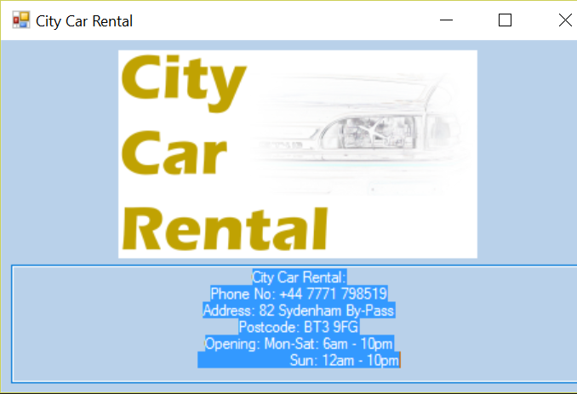

1.1

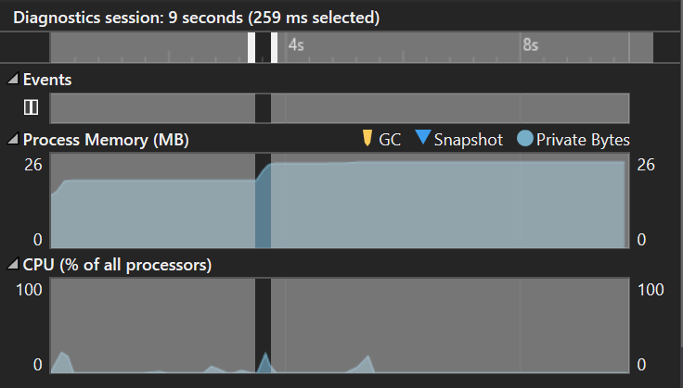

*As can be seen the login form event occurs at 3.5 seconds and takes ~260ms to open the login form*

1.2

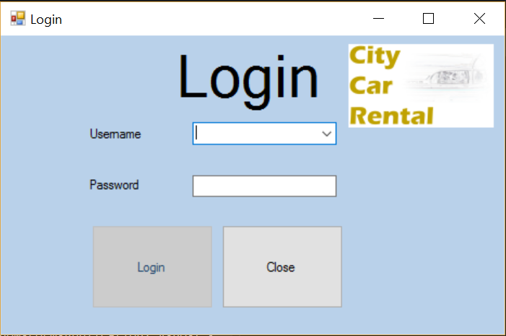

Login Form

|  |  |  |
| --- | --- | --- |
| Test | Expected Result | Evidence |
| Close Button | Closes the entire application | 2.0 |
| Login Button – Password acceptance (Empty Password) | Login Button shouldn’t be able to be clicked | 2.1 |
| Username Combo-box | Combo-box should be filled by all staff usernames | 2.2 |
| Login Button – Password acceptance (Correct Password) | Login should be granted; the login form should close and the menu should open. | 2.3.a |
| Login Button – Password acceptance (Incorrect Password) | Login should not be granted; a message box should appear alerting the user to the incorrect password. | 2.3.b |

2.0



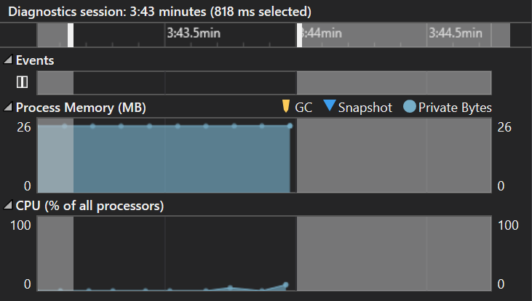

*As shown, when the close button is pressed the application will close*

2.1



*As shown, the login button is greyed out and cannot be pressed*

2.2

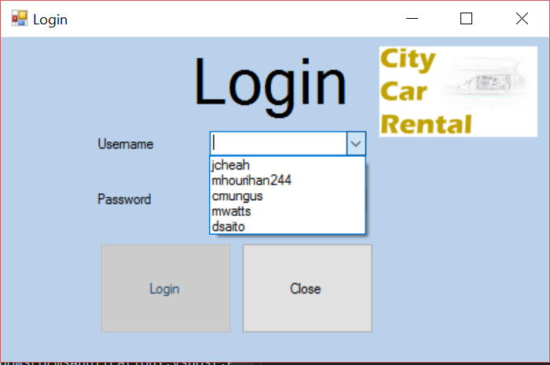

The combobox is successfully filled by the usernames in the SQL Database

2.3.a

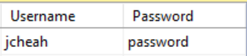

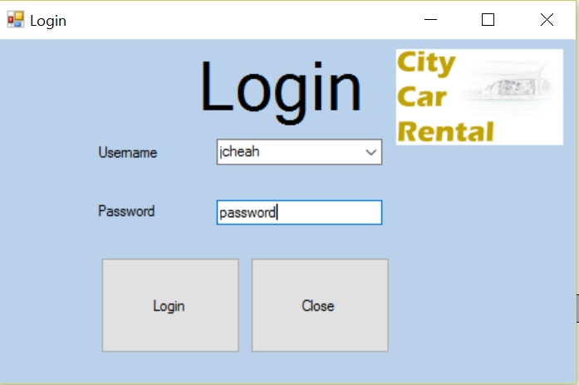

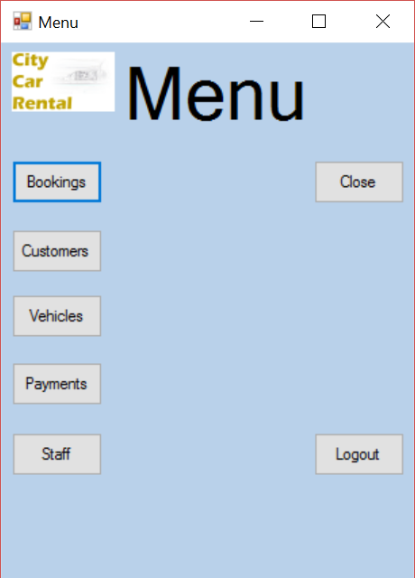

As shown above, when the correct username and password are entered, access is granted to the system and the login form closes.

2.3.b



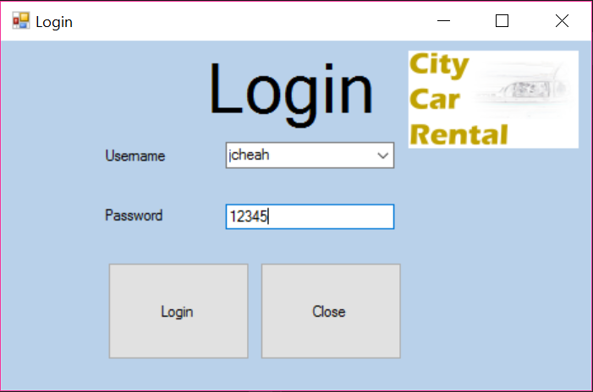

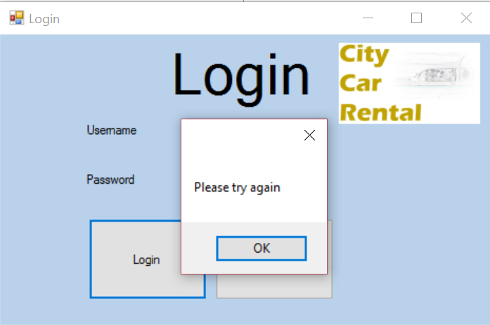

As shown above, the system will not grant access if the incorrect password is entered.

Menu form

|  |  |  |
| --- | --- | --- |
| Test | Expected Result | Evidence |
| Close button | Application closes | 3.0 |
| Logout Button | Menu form closes Login form opens | 3.1 |
| Customer Button | Menu form closes Customer form opens | 3.2 |
| Vehicles Button | Menu form closes Vehicles form opens | 3.3 |
| Staff Button | Menu form closes Staff form opens | 3.4 |
| Payments Button | Menu form closes Payments form opens | 3.5 |
| Bookings Button | Menu form closes Bookings form opens | 3.6 |

3.0

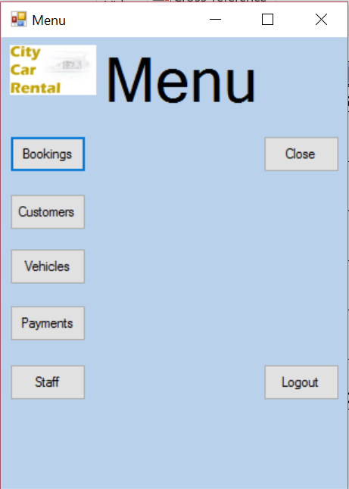

*As shown, when the close button is pressed the application will close*

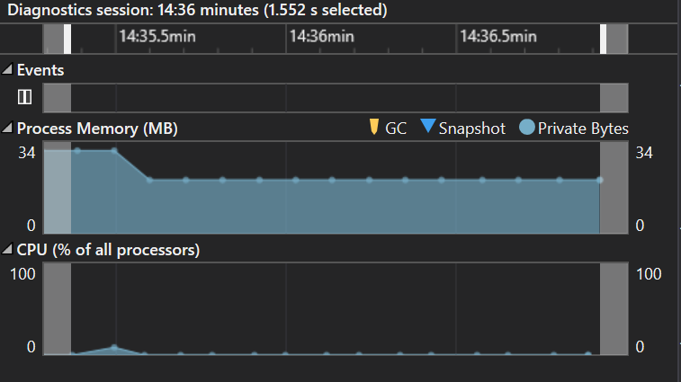

3.1





As shown above, the navigation menu will close and the login form will open with both fields empty, keeping the system secure.

3.2



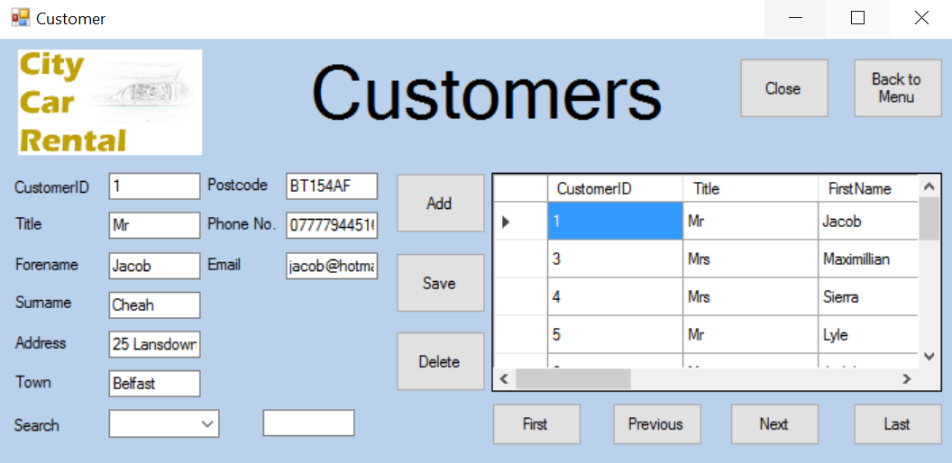

As shown above, the customer form will open normally and the navigation menu will close.

3.3



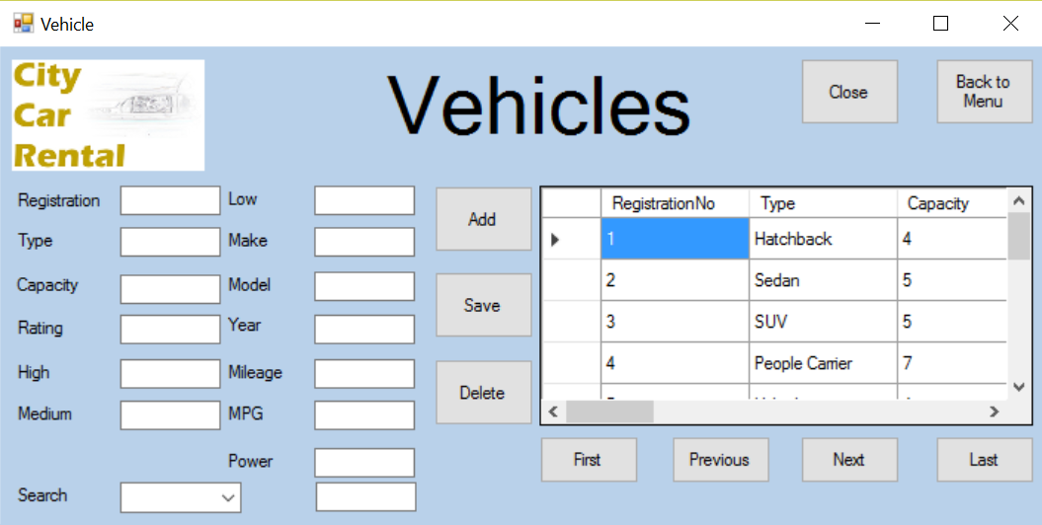

As shown above, the Vehicles form will open normally and the navigation menu will close.

3.4



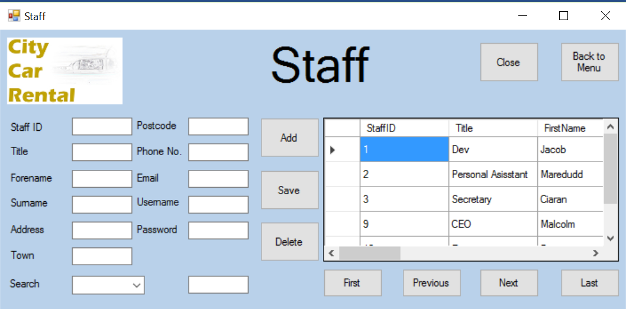

As shown above, the staff form will open normally and the navigation menu will close.

3.5



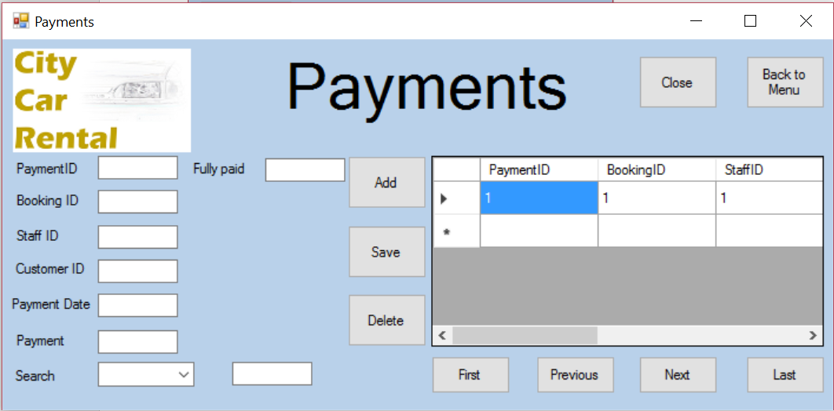

As shown above, the payments form will open normally and the navigation menu will close.

3.6



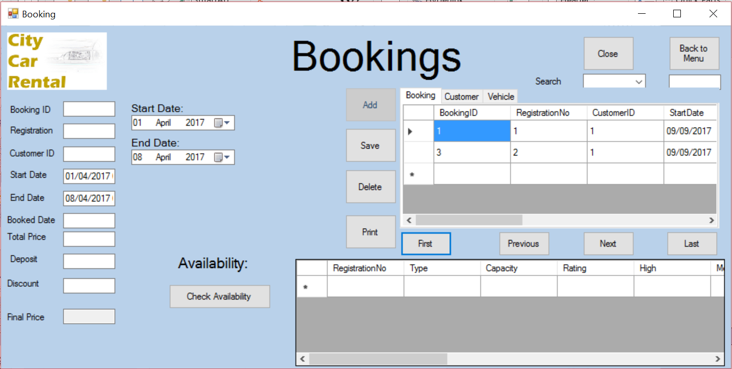

As shown above, the bookingse form will open normally and the navigation menu will close.

Customer form

|  |  |  |
| --- | --- | --- |
| Test | Expected Result | Evidence |
| Close button | Application should close | 3.0 |
| Data-grid-view | Data-grid-view should display all records from the customer table | 3.1 |
| Add button | The data entered into the textboxes should be added to the database | 3.2 |
| Save button | This should save the edited details from the textboxes into the database | 3.3 |
| Delete button | This should delete the selected record from the database  A message box should appear alerting the user that a field has been deleted | 3.4.a  3.4.b |
| First button | Moves the selected record to the first in the database table | 3.5 |
| Next button | Moves the selected record to the next in the database table | 3.6 |
| Previous button | Moves the selected record to the previous in the database table | 3.7 |
| Last button | Moves the selected record to the last in the database table | 3.8 |
| Menu button | Closes the current form and opens the menu form | 3.9 |
| Text-boxes | User should be able to enter data into the textboxes | 3.10 |
| Search combo-box | Should display all indexed fields | 3.11 |
| Search textbox | Should allow the user to enter search data  Should automatically search the table when data is entered | 3.12.a  3.12.b |

3.0



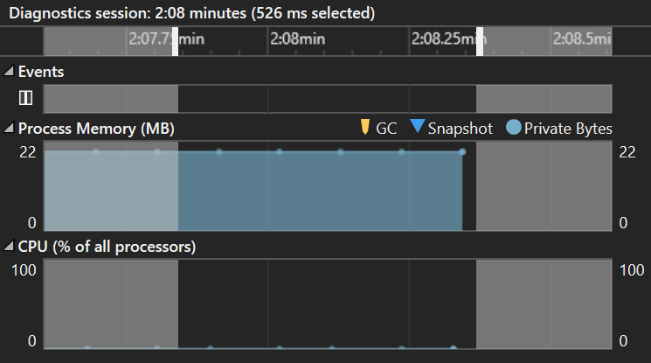

As shown above, the customer form will close very quickly

3.1

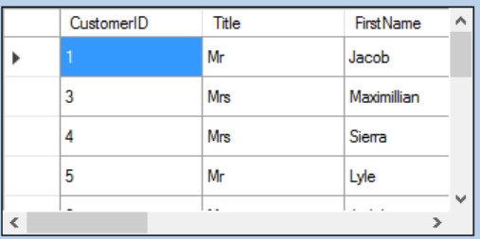

As shown above, the data-grid-view is filled by the Customers table in the SQL database

3.2/3.10

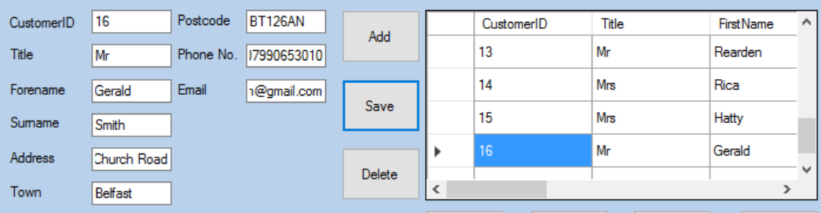

As shown above, you are able to enter details into the textboxes and add in a new customer.

3.3



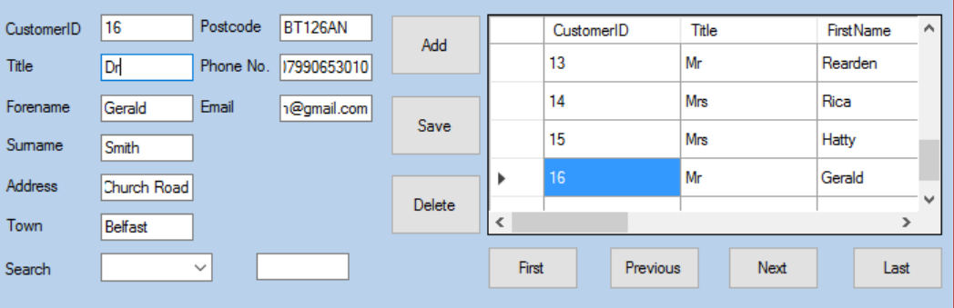

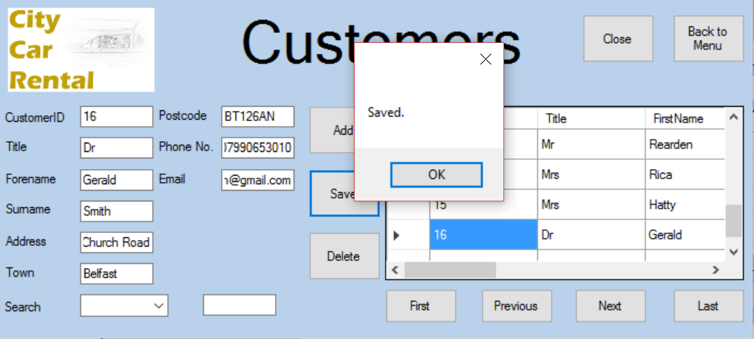

As shown above, you are successfully able to change the details in the customer form

3.4.a

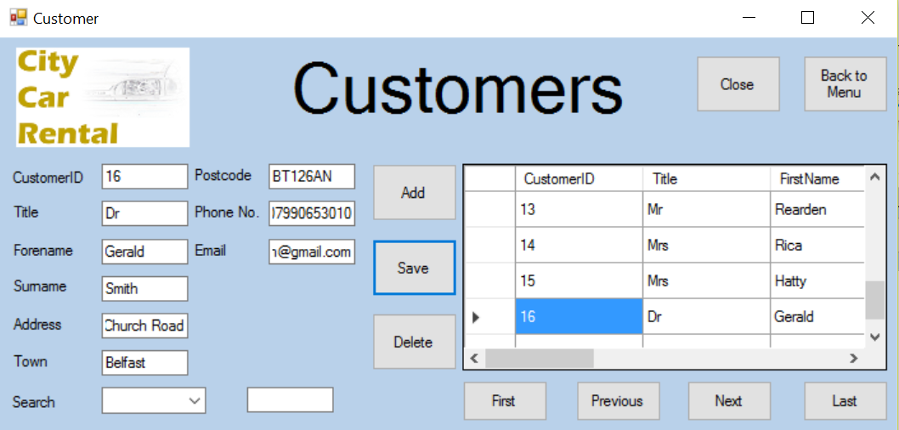

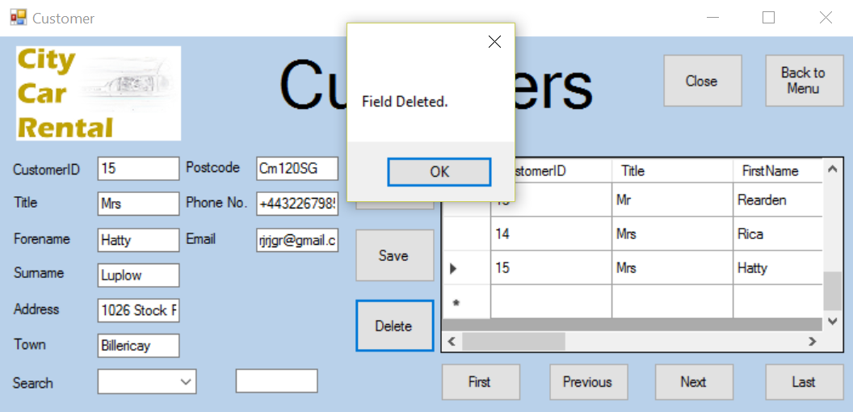

As shown above, you are successfully able to delete a customer record.

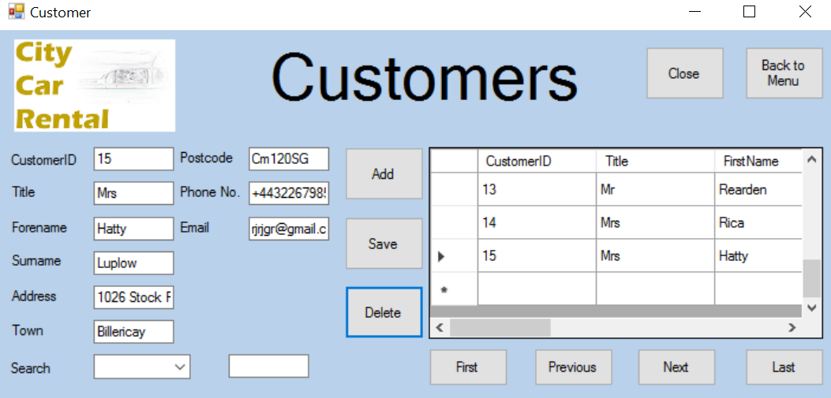

4.4.b

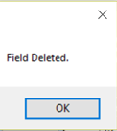

As shown above, the message box shows when a file has been deleted

4.5

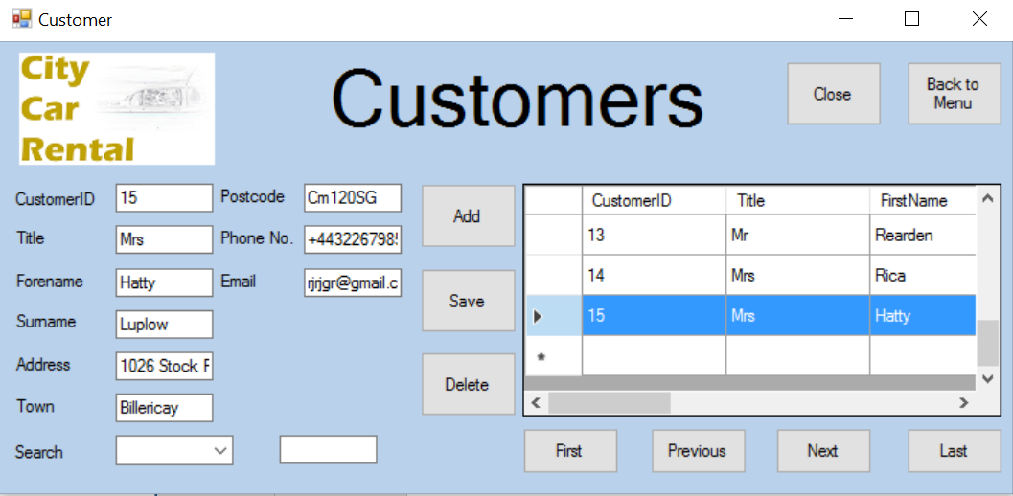

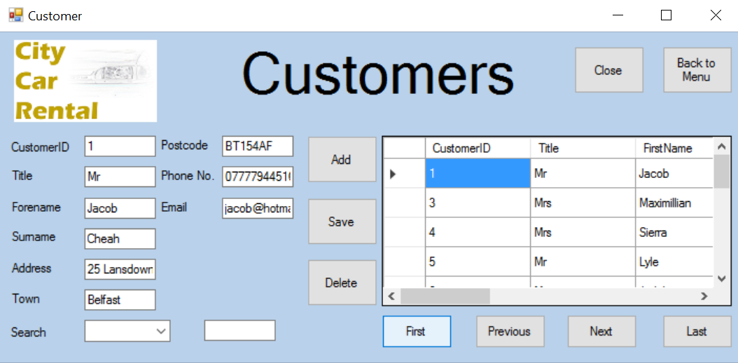

As shown above, the first button successfully moves the users position in the data grid view

4.6

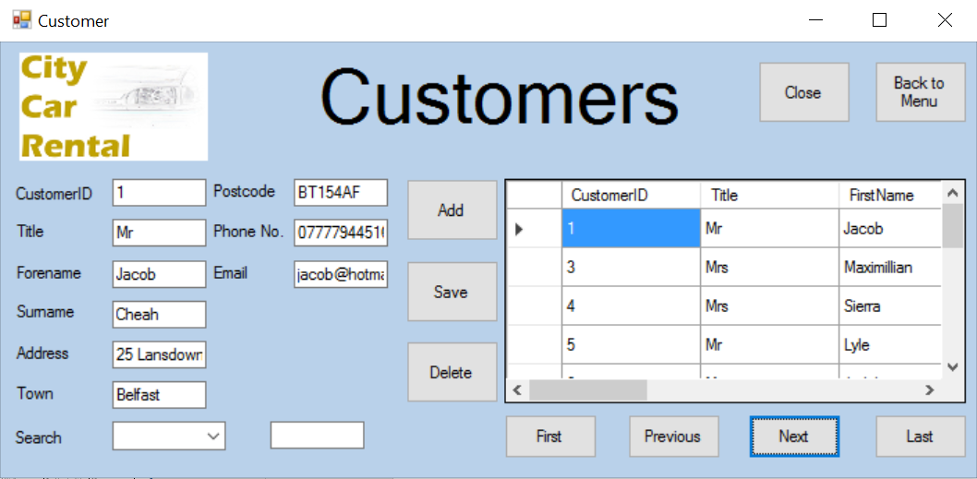

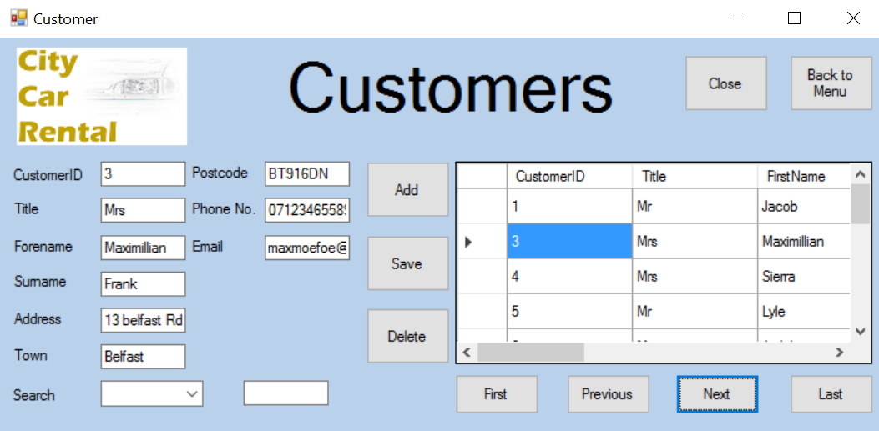

As shown above, the next button successfully moves the users position in the data grid view

4.7



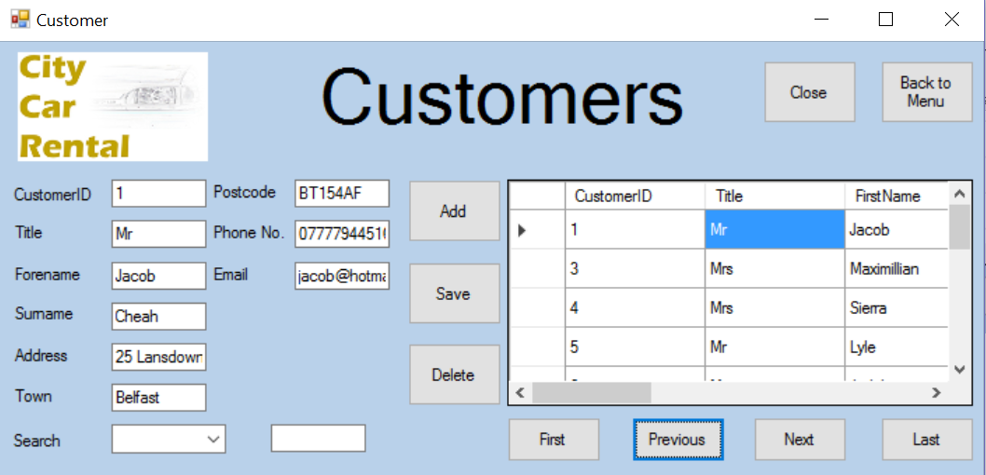

As shown above, the previous button successfully moves the users position in the data grid view

4.8



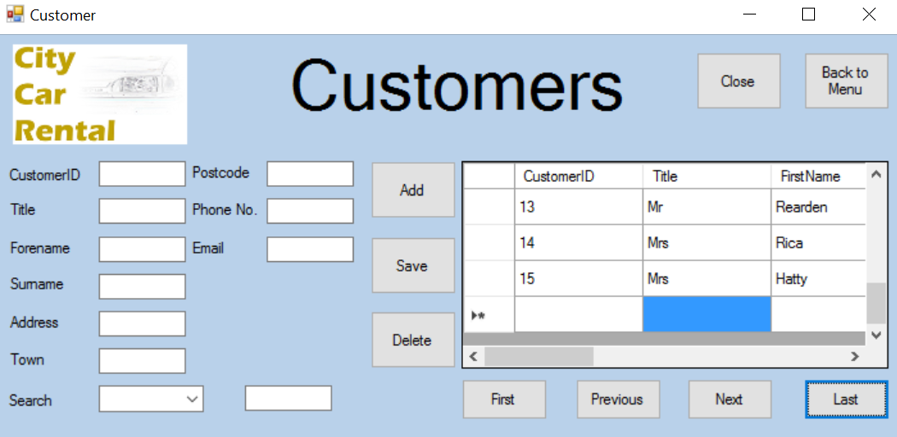

As shown above, the first button successfully moves the users position in the data grid view

4.9





As shown above, the menu button successfully closes the customer form and opens the menu form

4.11

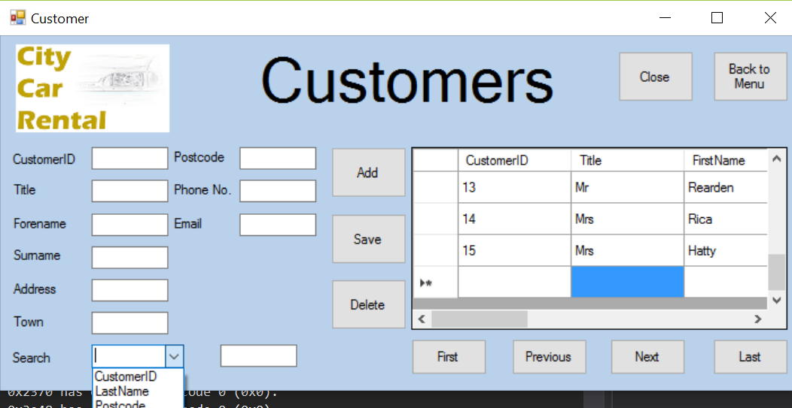

As shown above, the combobox successfully loads the the indexed fields

4.12

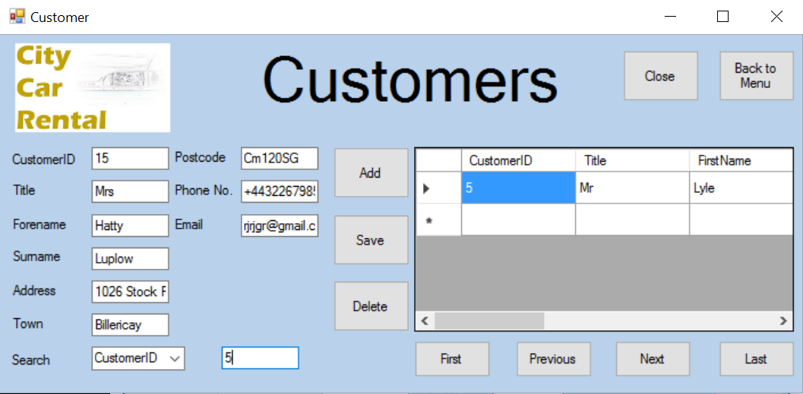

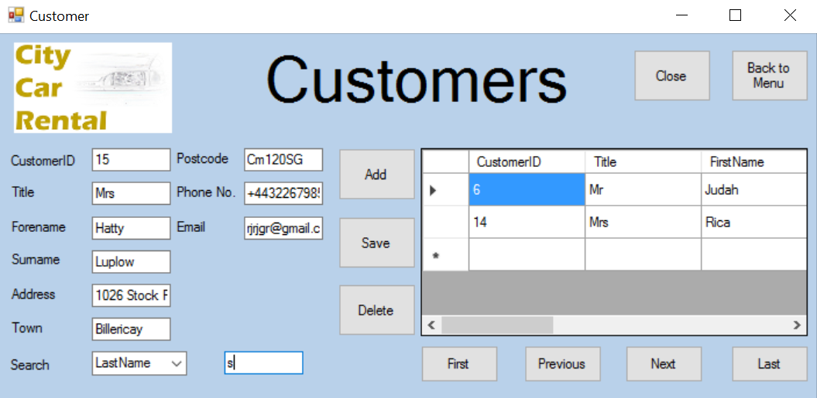

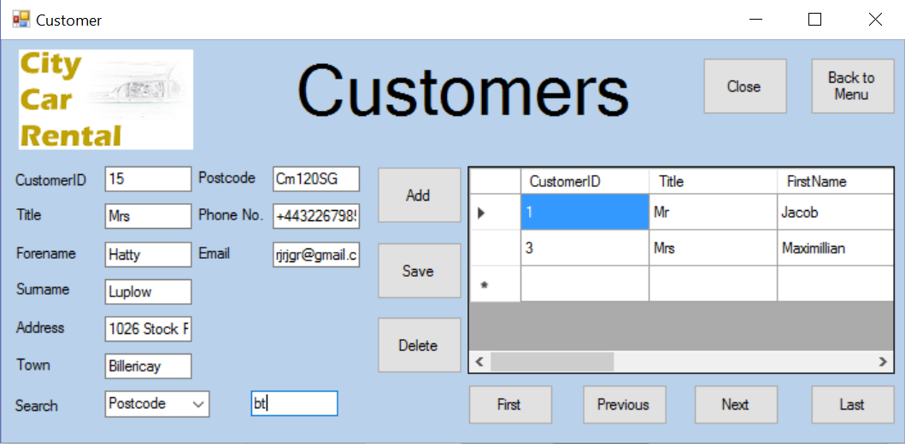

As shown above, the search function operates successfully for all indexed fields.

Staff form

|  |  |  |
| --- | --- | --- |
| Test | Expected Result | Evidence |
| Close button | Application should close | 4.0 |
| Data-grid-view | Data-grid-view should display all records from the staff table | 4.1 |
| Add button | The data entered into the textboxes should be added to the database | 4.2 |
| Save button | This should save the edited details from the textboxes into the database | 4.3 |
| Delete button | This should delete the selected record from the database  A message box should appear alerting the user that a field has been deleted | 4.4.a  4.4.b |
| First button | Moves the selected record to the first in the database table | 4.5 |
| Next button | Moves the selected record to the next in the database table | 4.6 |
| Previous button | Moves the selected record to the previous in the database table | 4.7 |
| Last button | Moves the selected record to the last in the database table | 4.8 |
| Menu button | Closes the current form and opens the menu form | 4.9 |
| Text-boxes | User should be able to enter data into the textboxes | 4.10 |
| Search combo-box | Should display all indexed fields | 4.11 |
| Search textbox | Should allow the user to enter search data  Should automatically search the table when data is entered | 4.12.a  4.12.b |

4.0

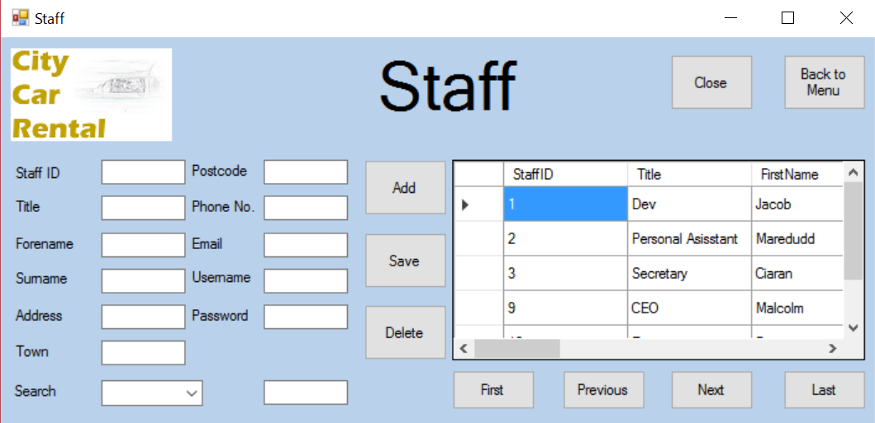

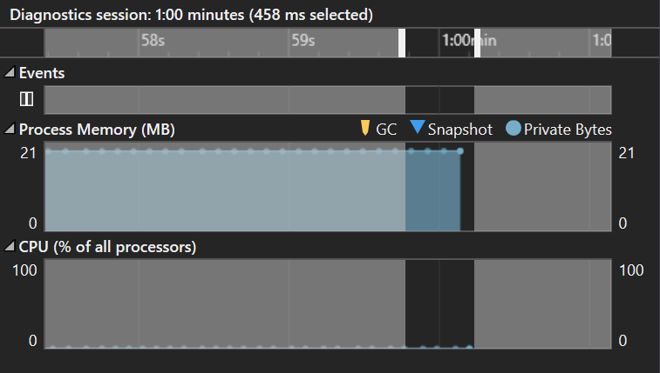

As shown above, the staff form will close very quickly

5.1



As shown above, the data-grid-view is filled by the Staffs table in the SQL database

5.2/5.10

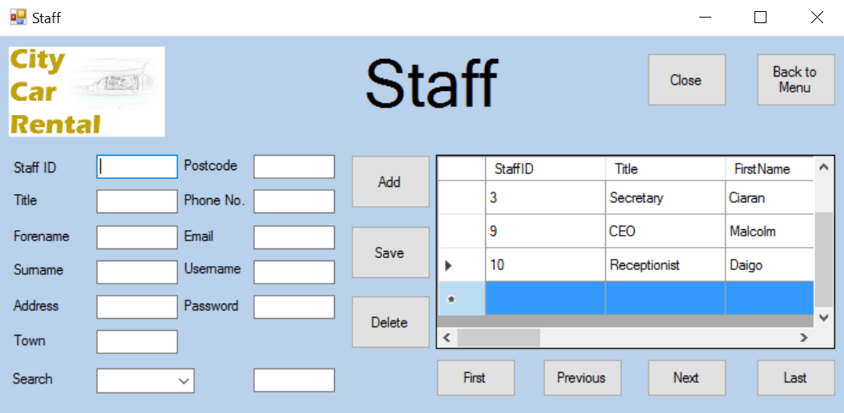

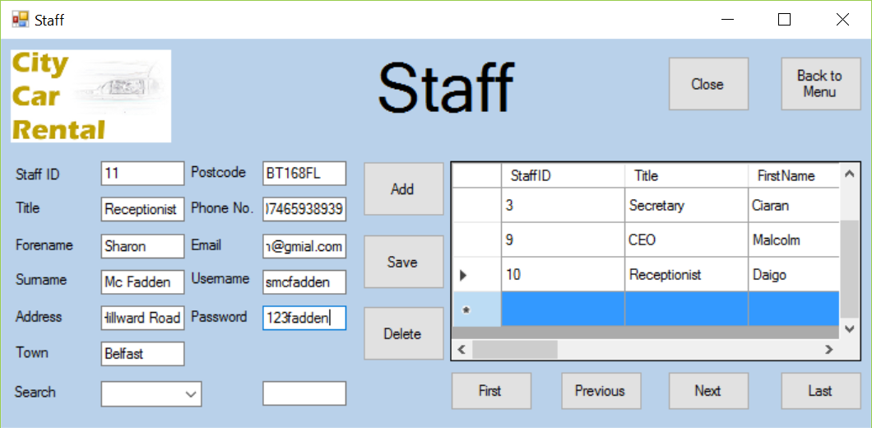

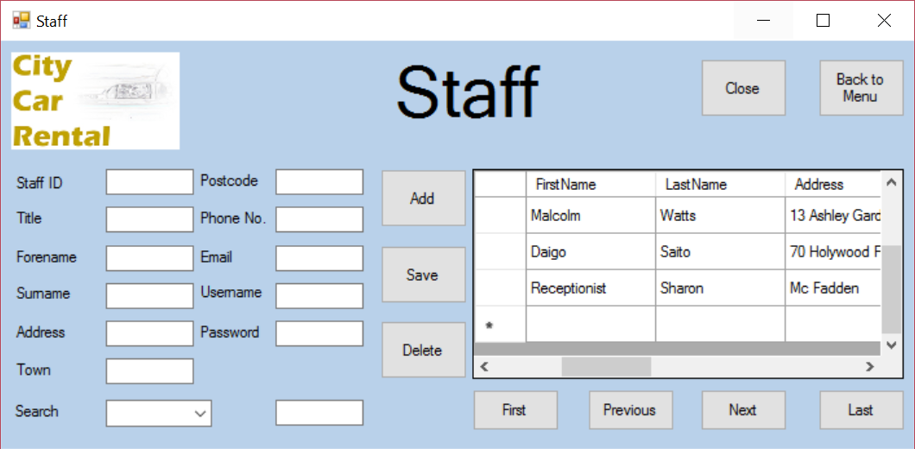

As shown above, you are able to enter details into the textboxes and add in a new staff.

5.3

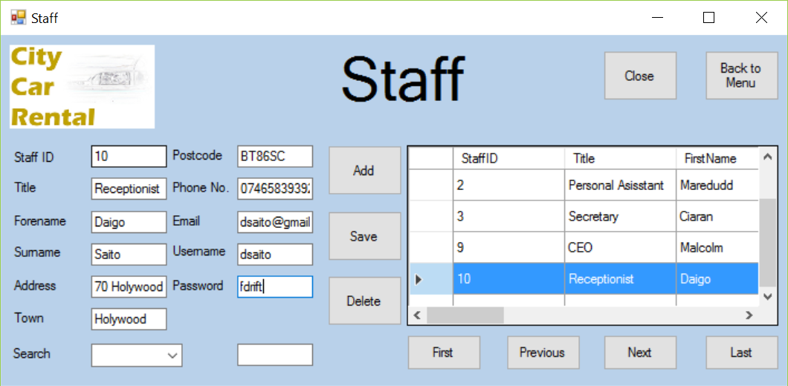

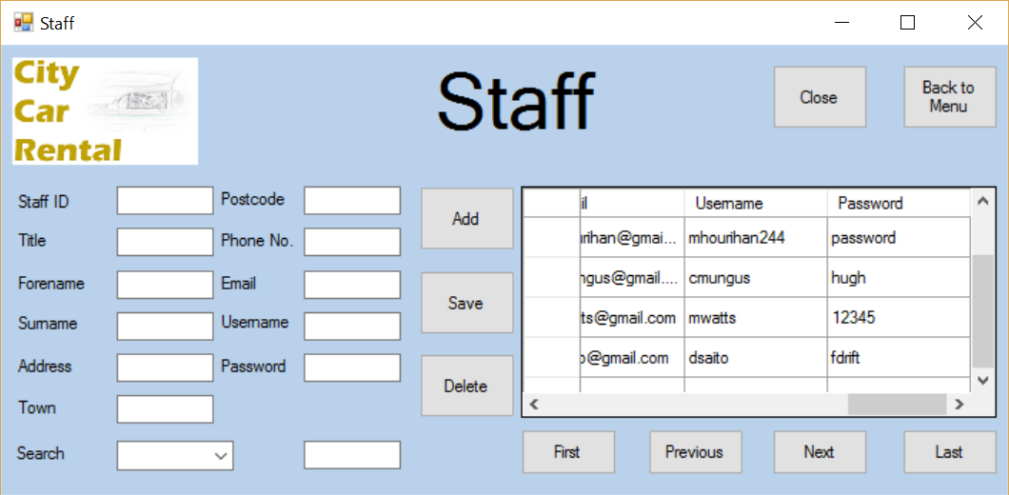

As shown above, you are successfully able to change the details in the staff form

5.4.a



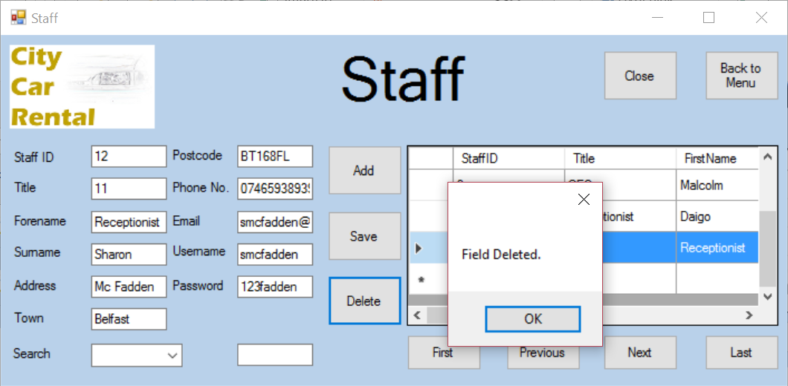

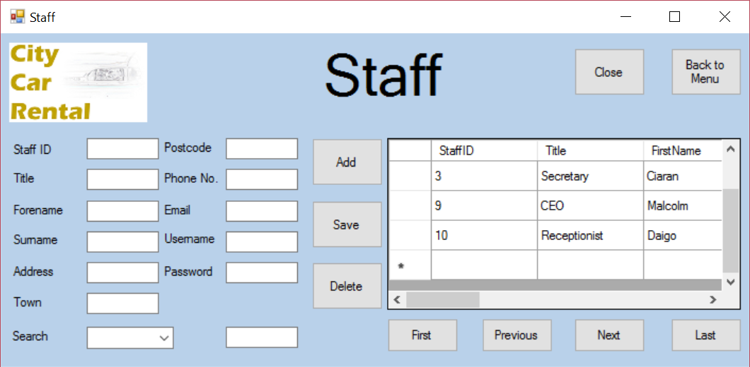

As shown above, you are successfully able to delete a staff record.

5.4.b

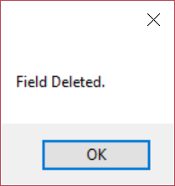

As shown above, the message box shows when a file has been deleted

5.5

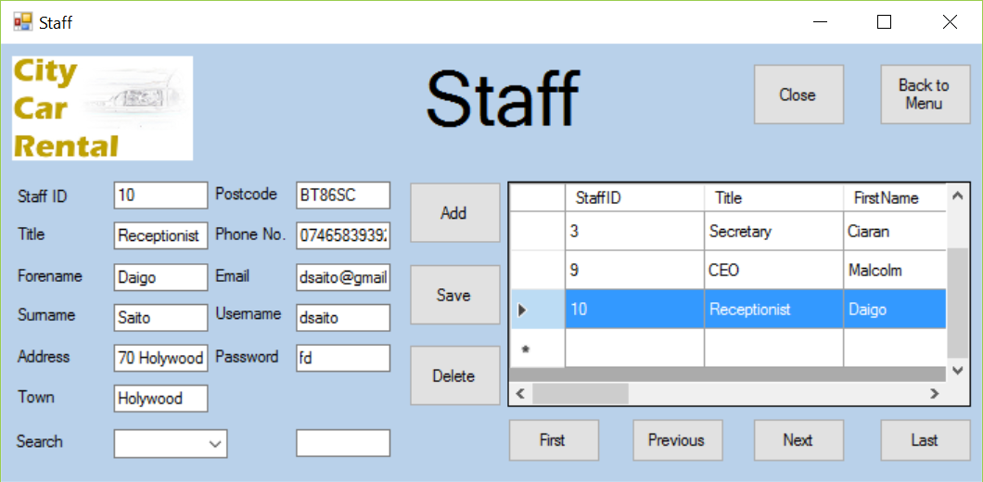

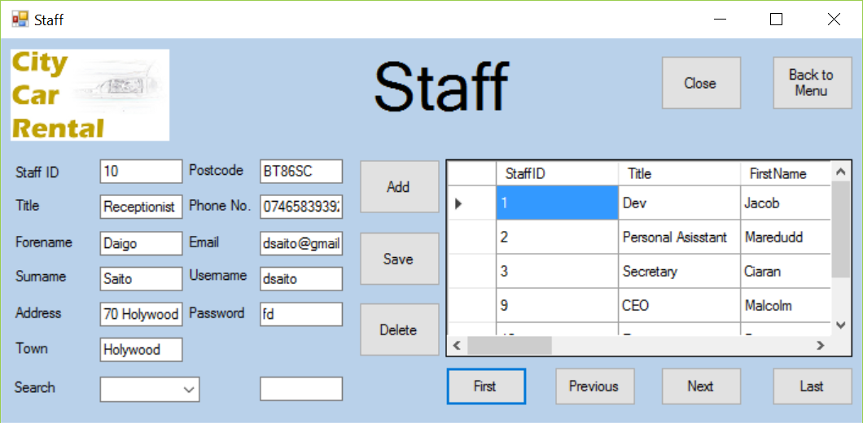

As shown above, the first button successfully moves the users position in the data grid view

5.6



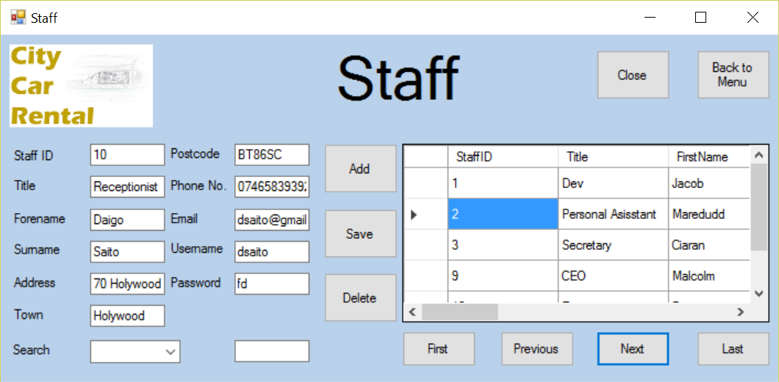

As shown above, the next button successfully moves the users position in the data grid view

5.7



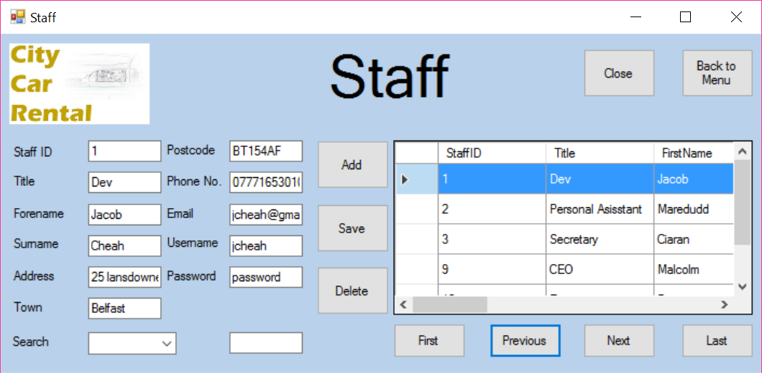

As shown above, the previous button successfully moves the users position in the data grid view

5.8



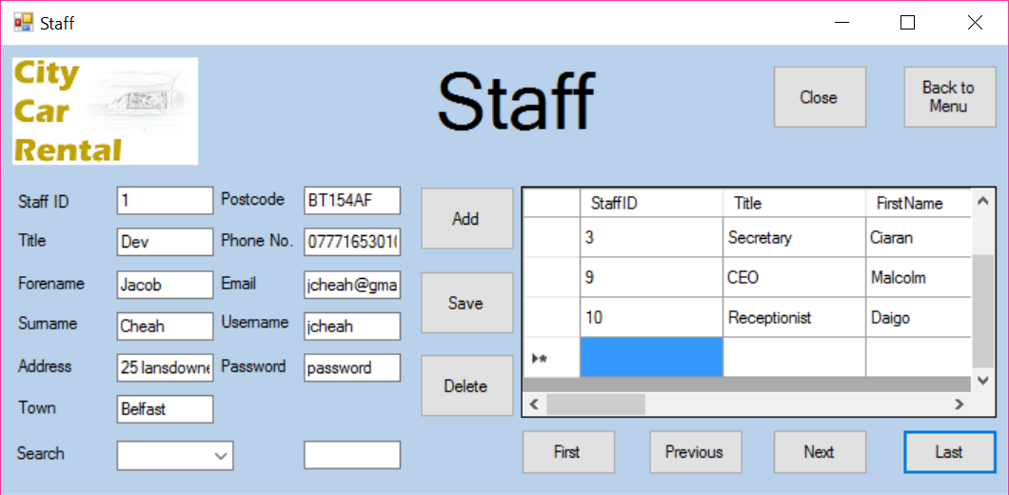

As shown above, the first button successfully moves the users position in the data grid view

5.9



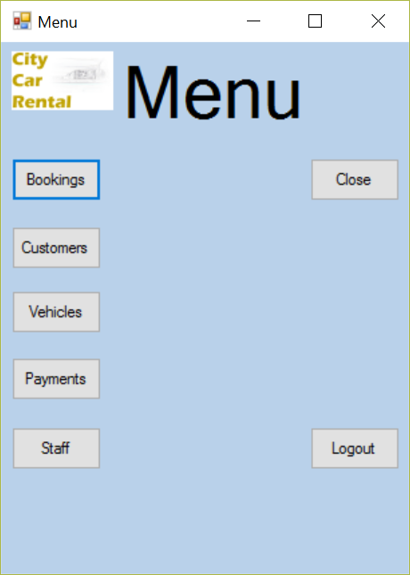

As shown above, the menu button successfully closes the staff form and opens the menu form

5.11

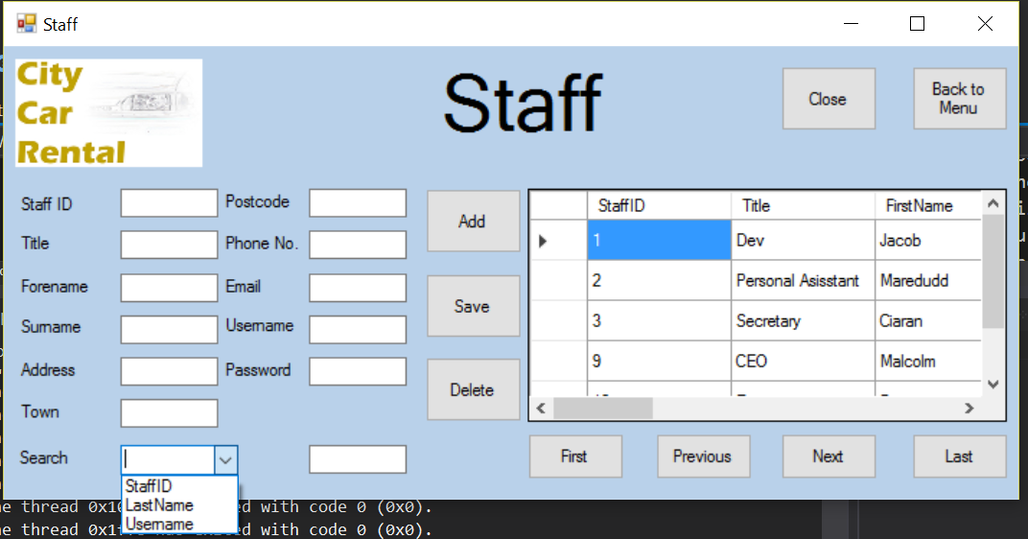

As shown above, the combobox successfully loads the the indexed fields

5.12.a

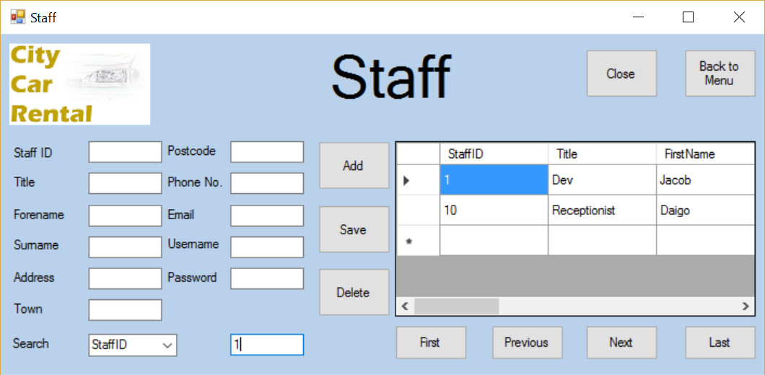

5.12.b



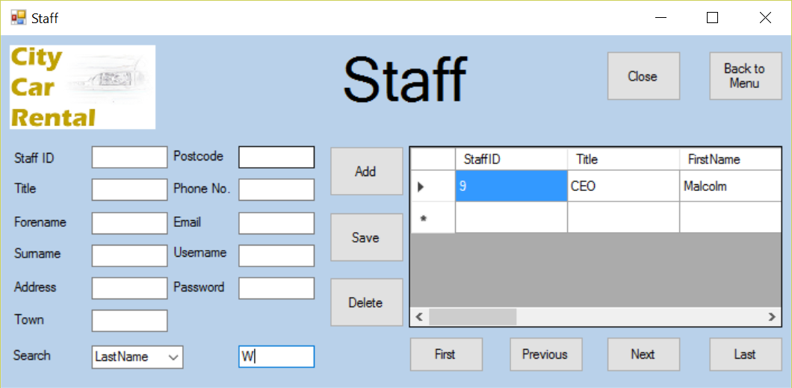

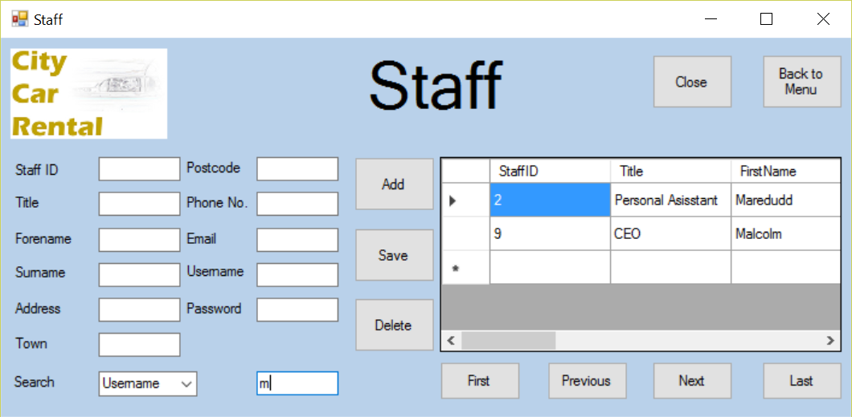

As shown above, the search function operates successfully for all indexed fields.

Vehicles form

|  |  |  |
| --- | --- | --- |
| Test | Expected Result | Evidence |
| Close button | Application should close | 5.0 |
| Data-grid-view | Data-grid-view should display all records from the vehicle table | 5.1 |
| Add button | The data entered into the textboxes should be added to the database | 5.2 |
| Save button | This should save the edited details from the textboxes into the database | 5.3 |
| Delete button | This should delete the selected record from the database  A message box should appear alerting the user that a field has been deleted | 5.4.a  5.4.b |
| First button | Moves the selected record to the first in the database table | 5.5 |
| Next button | Moves the selected record to the next in the database table | 5.6 |
| Previous button | Moves the selected record to the previous in the database table | 5.7 |
| Last button | Moves the selected record to the last in the database table | 5.8 |
| Menu button | Closes the current form and opens the menu form | 5.9 |
| Text-boxes | User should be able to enter data into the textboxes | 5.10 |
| Search combo-box | Should display all indexed fields | 5.11 |
| Search textbox | Should allow the user to enter search data  Should automatically search the table when data is entered | 5.12.a  5.12.b |

5.0

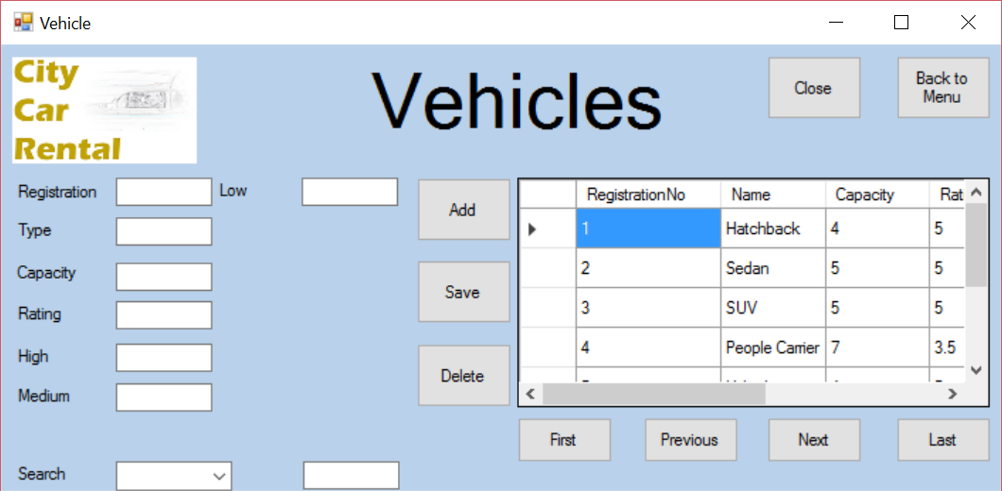



As shown above, the vehicle form will close very quickly

5.1



As shown above, the data-grid-view is filled by the Vehicles table in the SQL database

5.2/5.10



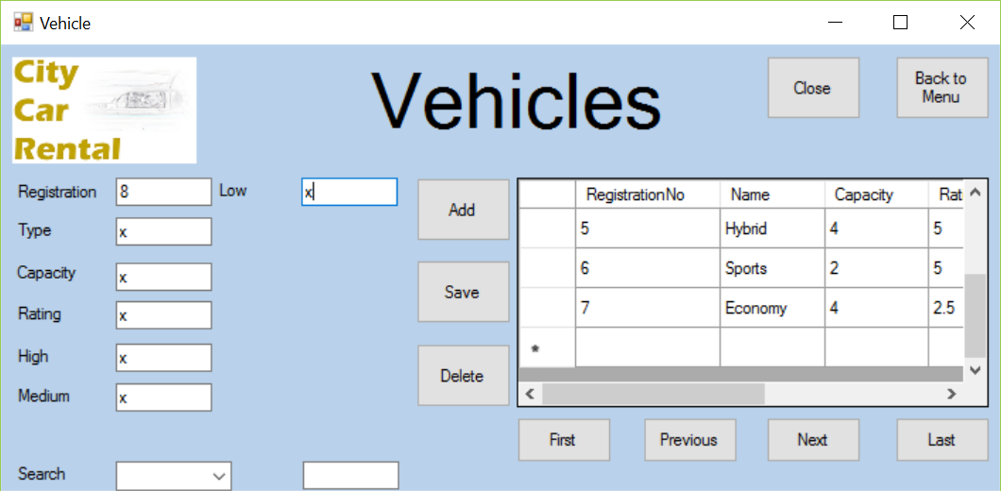

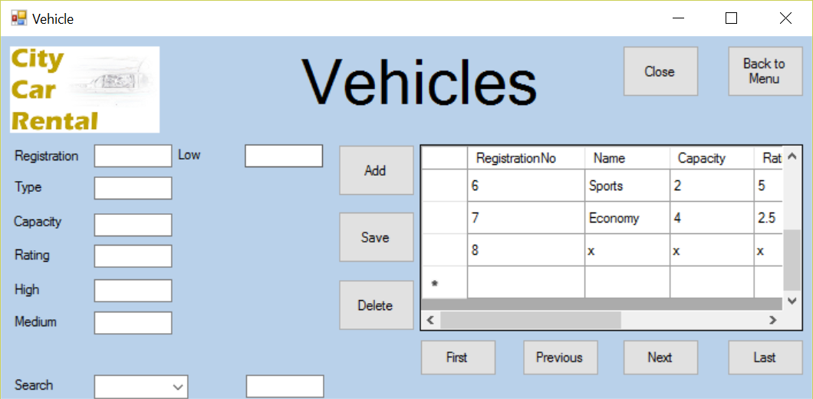

As shown above, you are able to enter details into the textboxes and add in a new vehicle.

5.3

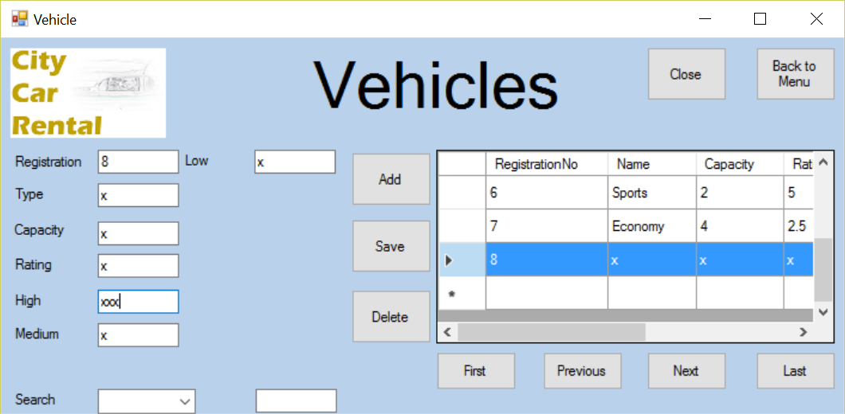

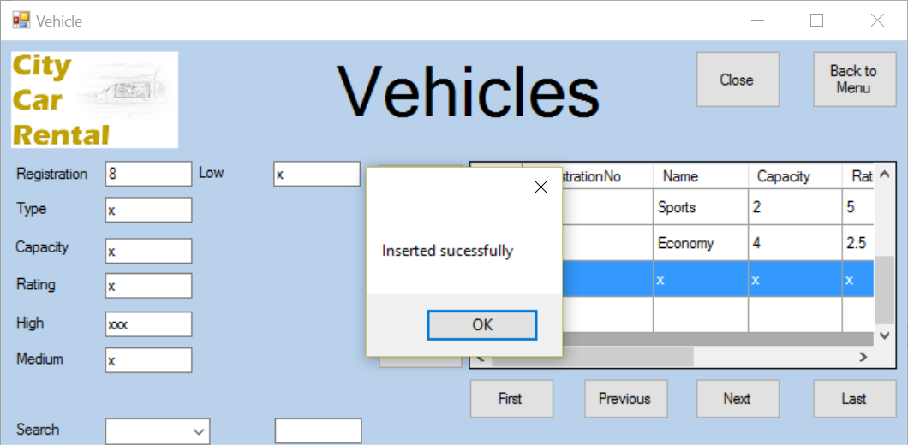

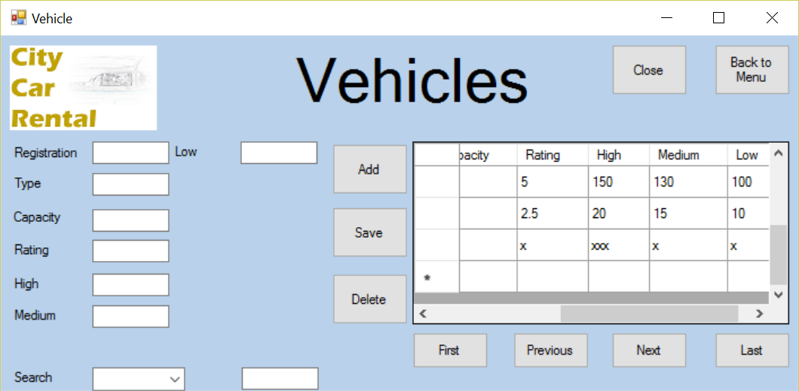

As shown above, you are successfully able to change the details in the vehicle form

5.4.a

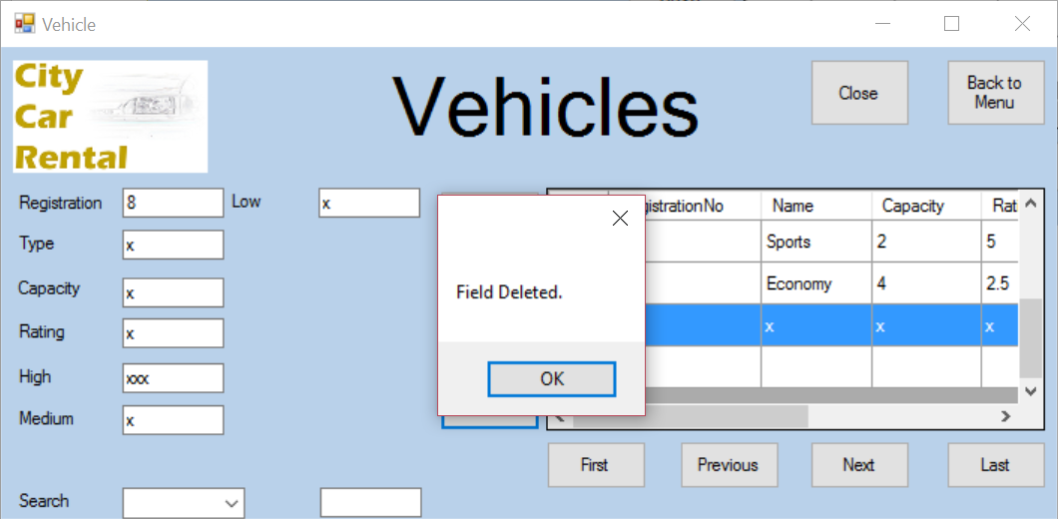

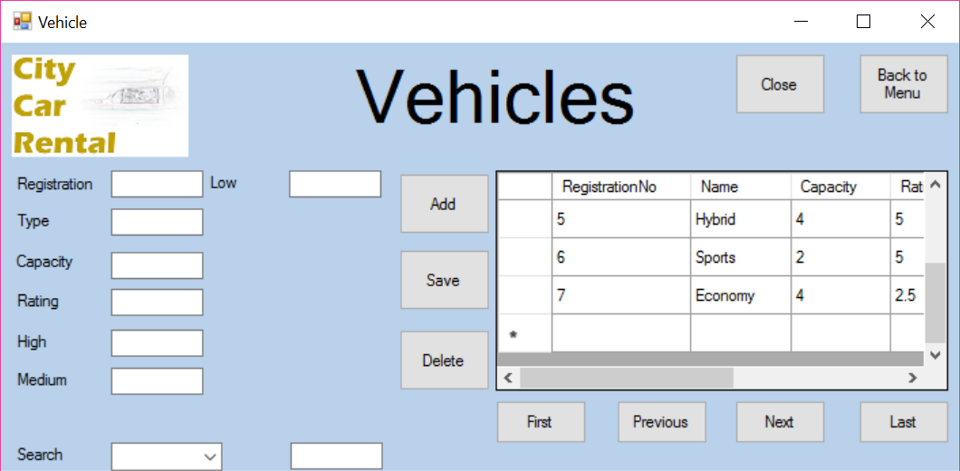

As shown above, you are successfully able to delete a vehicle record.

5.4.b



As shown above, the message box shows when a file has been deleted

5.5



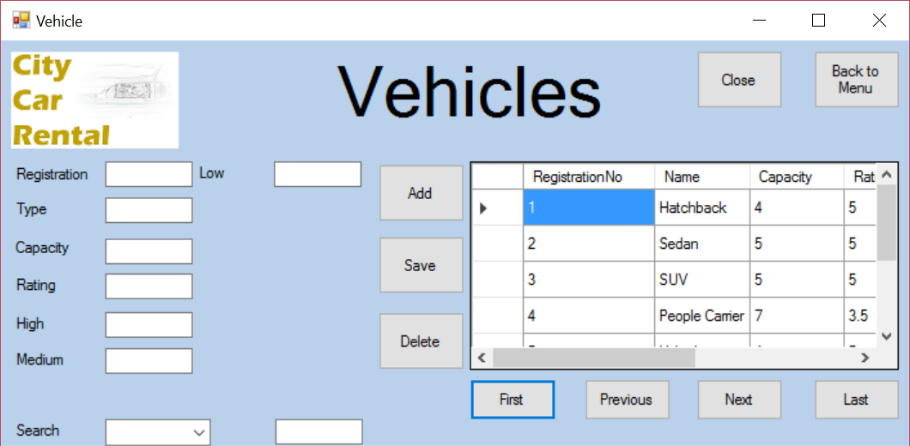

As shown above, the first button successfully moves the users position in the data grid view

5.6



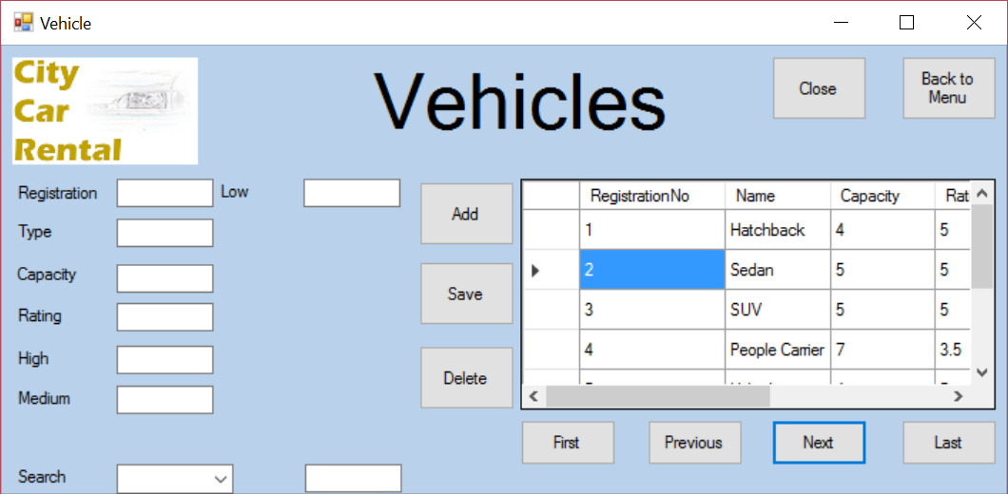

As shown above, the next button successfully moves the users position in the data grid view

5.7



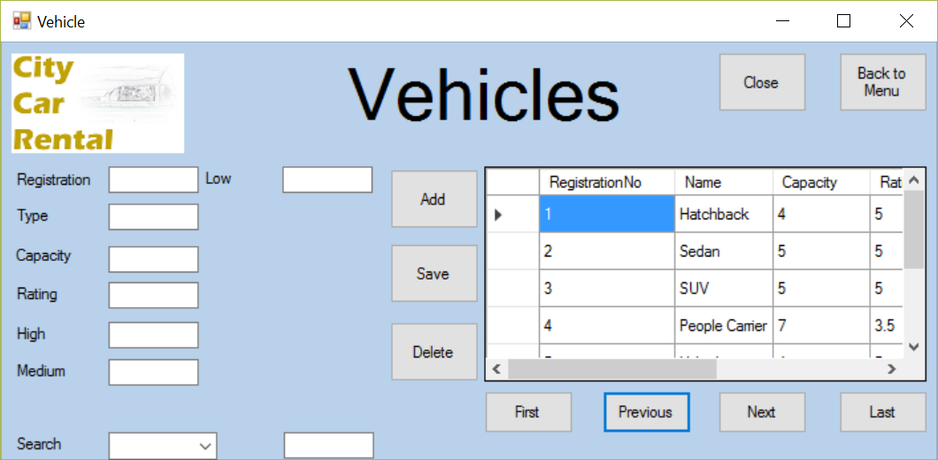

As shown above, the previous button successfully moves the users position in the data grid view

5.8



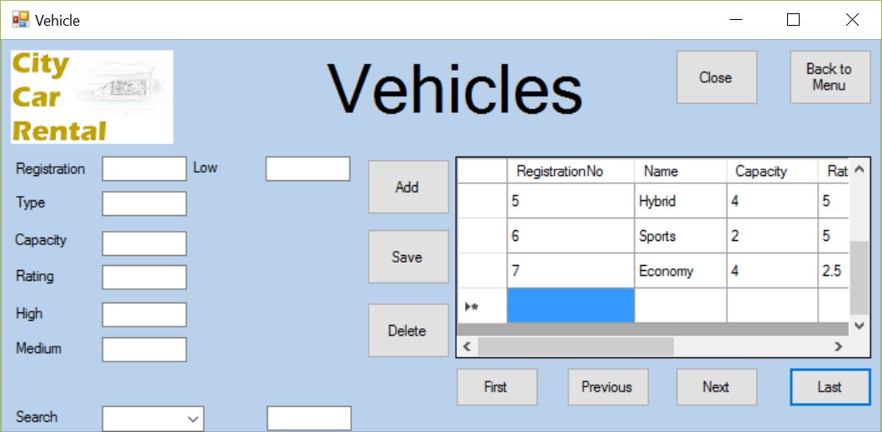

As shown above, the first button successfully moves the users position in the data grid view

5.9



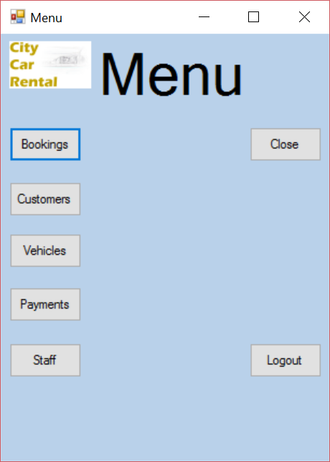

As shown above, the menu button successfully closes the vehicle form and opens the menu form

5.11

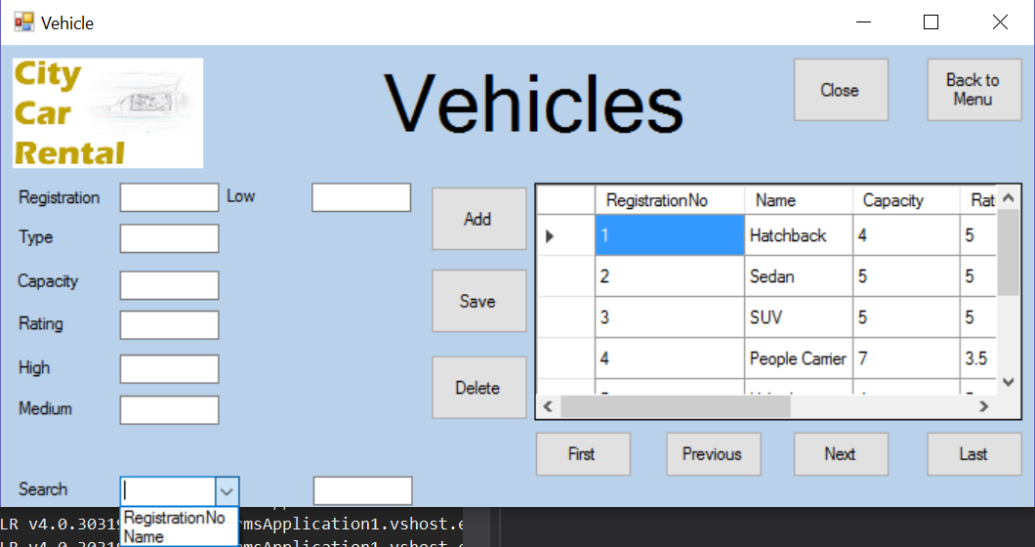

As shown above, the combobox successfully loads the the indexed fields

5.12.a

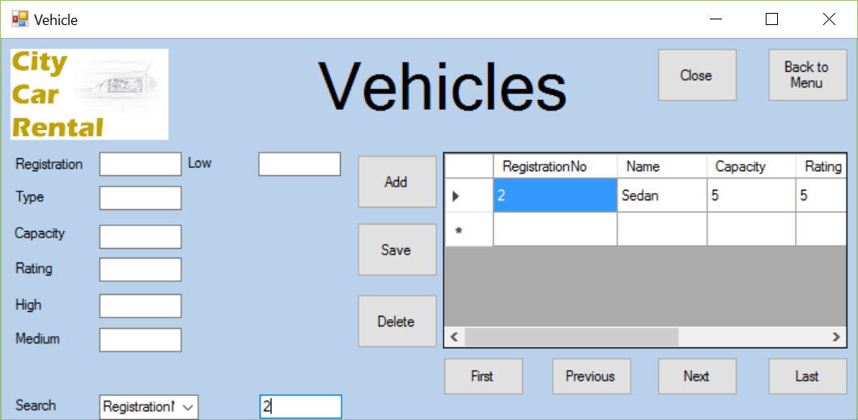

5.12.b



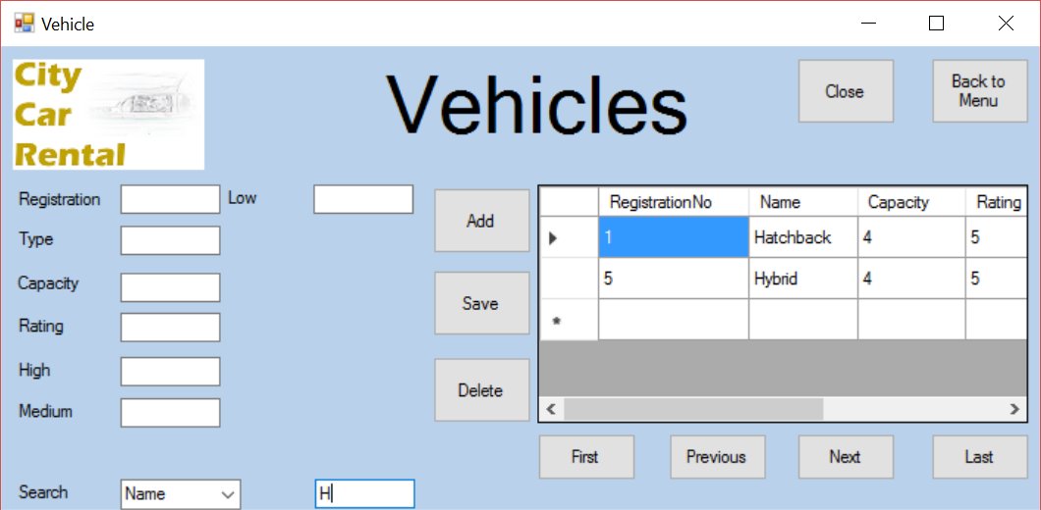

As shown above, the search function operates successfully for all indexed fields.

Payments form

|  |  |  |
| --- | --- | --- |
| Test | Expected Result | Evidence |
| Close button | Application should close | 6.0 |
| Data-grid-view | Data-grid-view should display all records from the payments table | 6.1 |
| Add button | The data entered into the textboxes should be added to the database | 6.2 |
| Save button | This should save the edited details from the textboxes into the database | 6.3 |
| Delete button | This should delete the selected record from the database  A message box should appear alerting the user that a field has been deleted | 6.4.a  6.4.b |
| First button | Moves the selected record to the first in the database table | 6.5 |
| Next button | Moves the selected record to the next in the database table | 6.6 |
| Previous button | Moves the selected record to the previous in the database table | 6.7 |
| Last button | Moves the selected record to the last in the database table | 6.8 |
| Menu button | Closes the current form and opens the menu form | 6.9 |
| Text-boxes | User should be able to enter data into the textboxes | 6.10 |
| Search combo-box | Should display all indexed fields | 6.11 |
| Search textbox | Should allow the user to enter search data  Should automatically search the table when data is entered | 6.12.a  6.12.b |

6.0

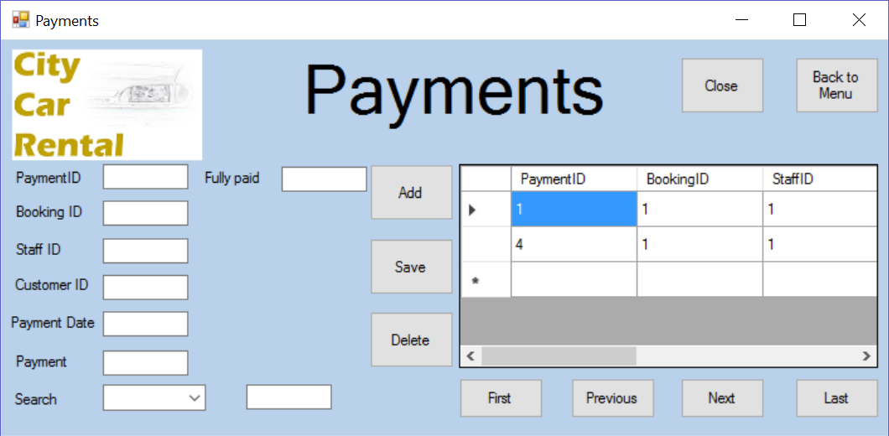



As shown above, the payment form will close very quickly

6.1



As shown above, the data-grid-view is filled by the Payments table in the SQL database

6.2/6.10



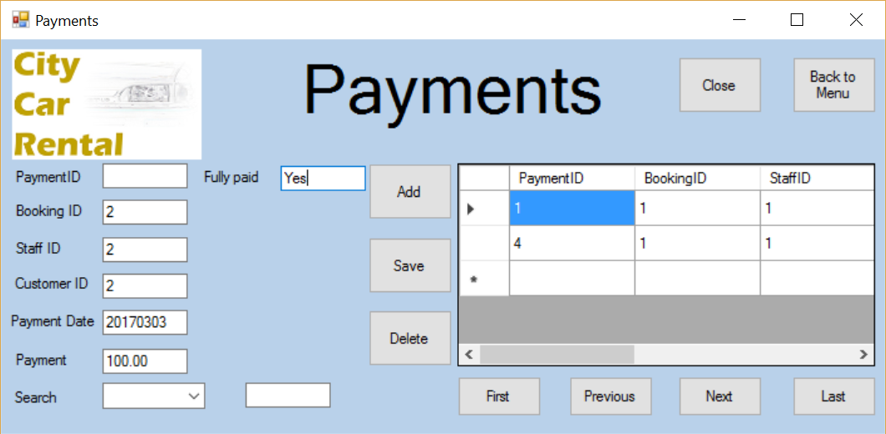

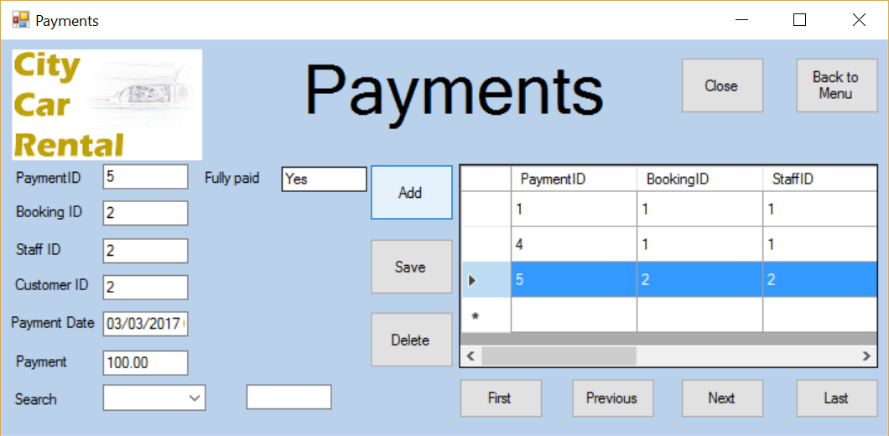

As shown above, you are able to enter details into the textboxes and add in a new payment.

6.3



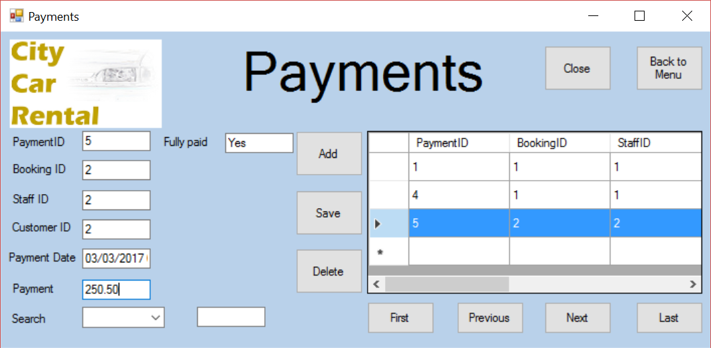

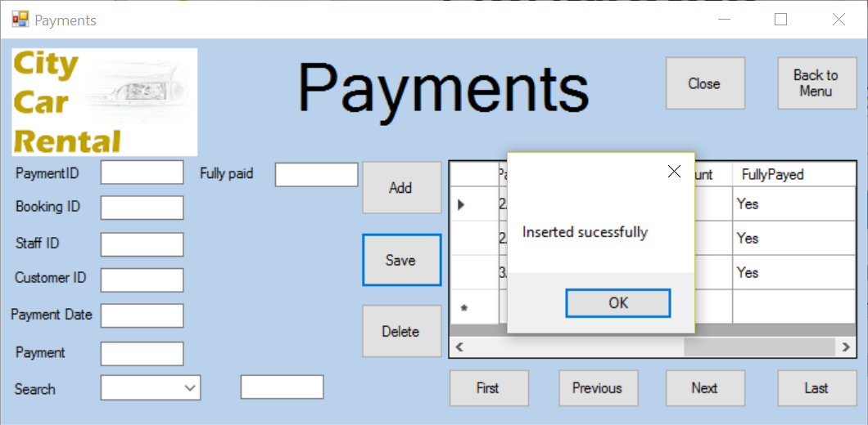

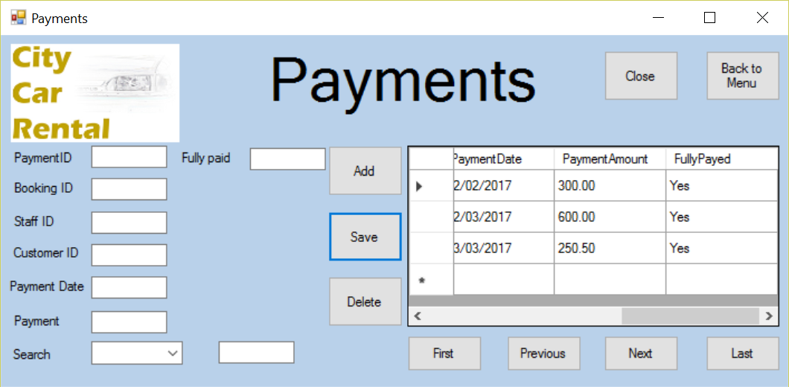

As shown above, you are successfully able to change the details in the payment form

6.4.a



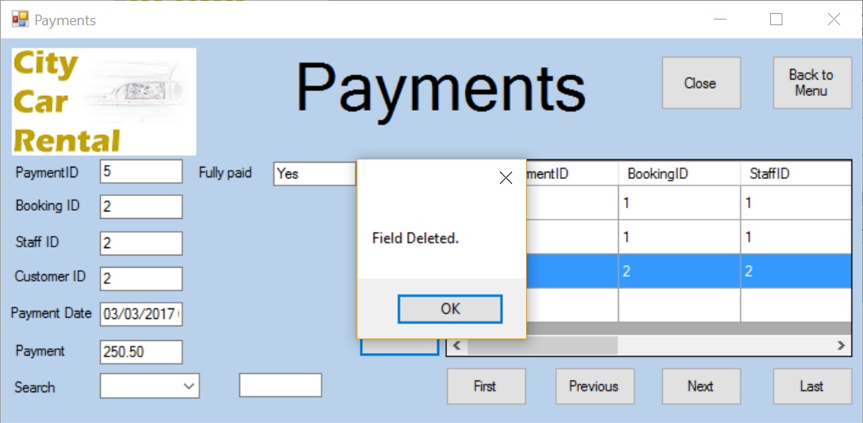

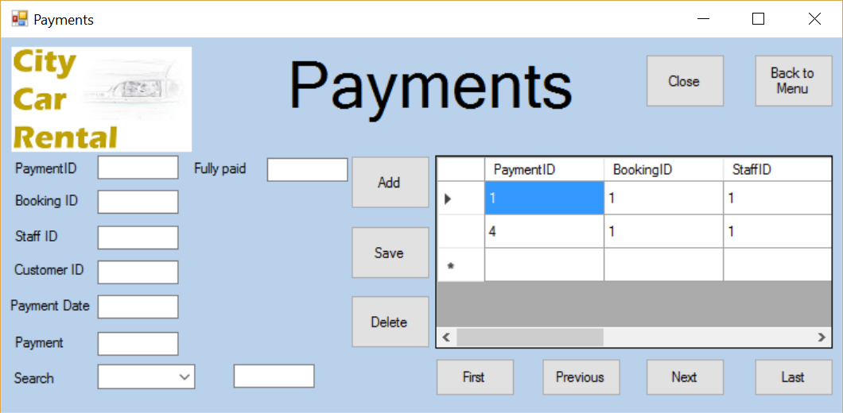

As shown above, you are successfully able to delete a payment record.

6.4.b



As shown above, the message box shows when a file has been deleted

6.5

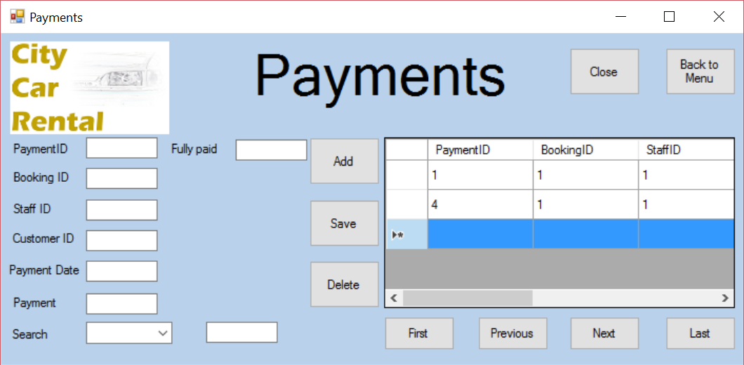

As shown above, the first button successfully moves the users position in the data grid view

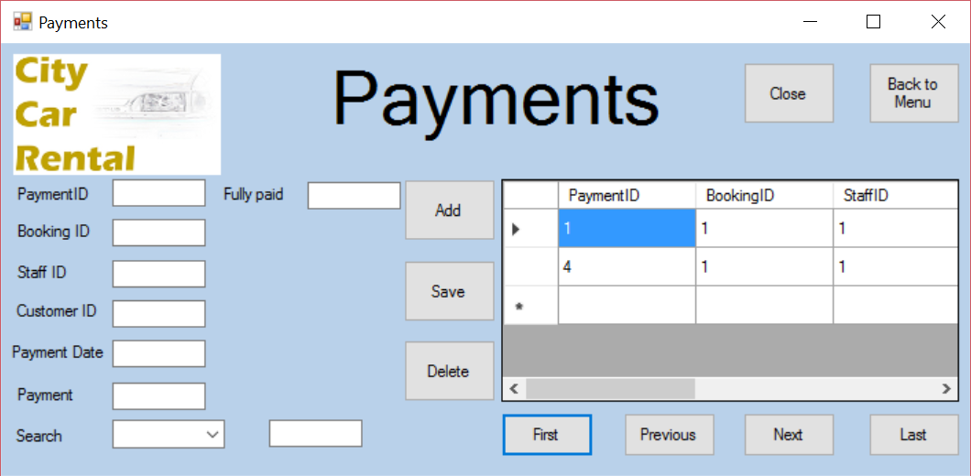

6.6



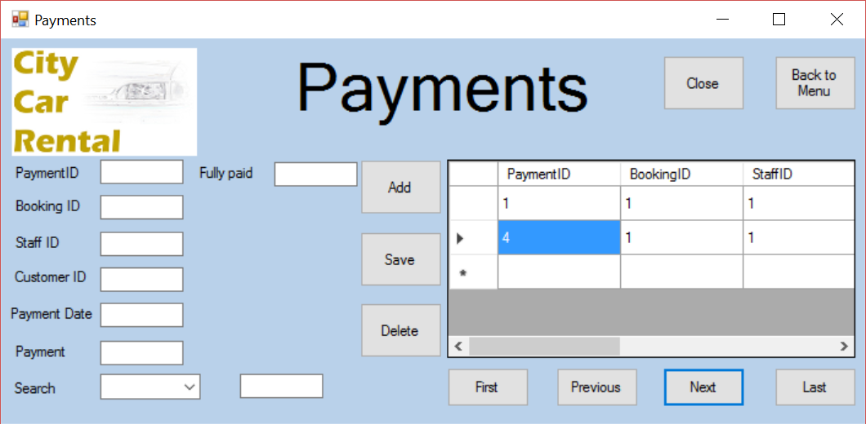

As shown above, the next button successfully moves the users position in the data grid view

6.7



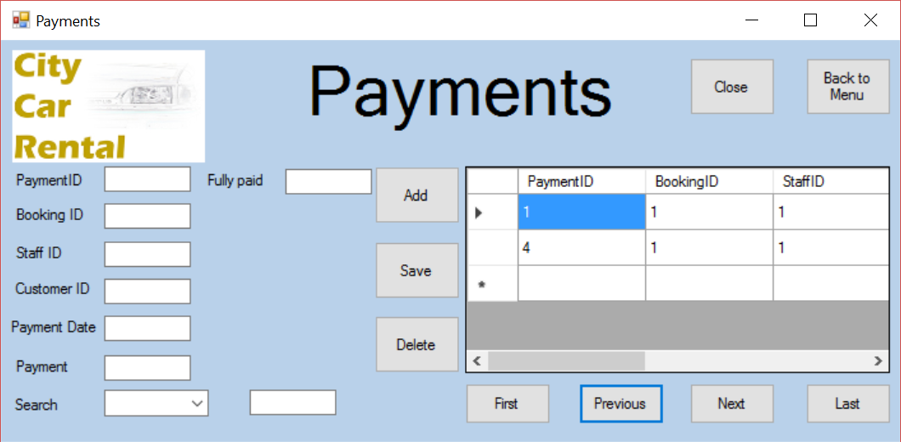

As shown above, the previous button successfully moves the users position in the data grid view

6.8



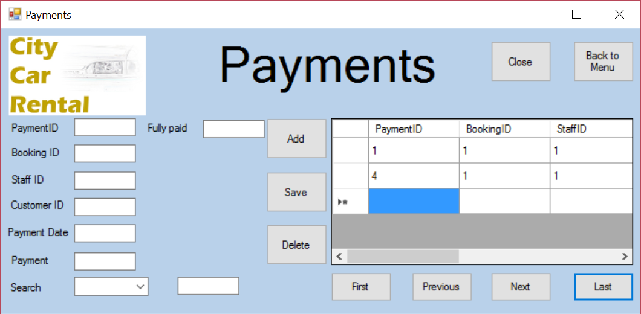

As shown above, the first button successfully moves the users position in the data grid view

6.9



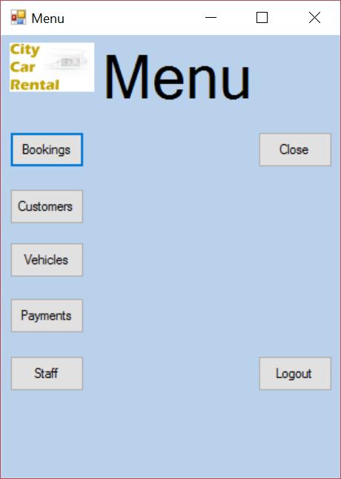

As shown above, the menu button successfully closes the payment form and opens the menu form

6.11

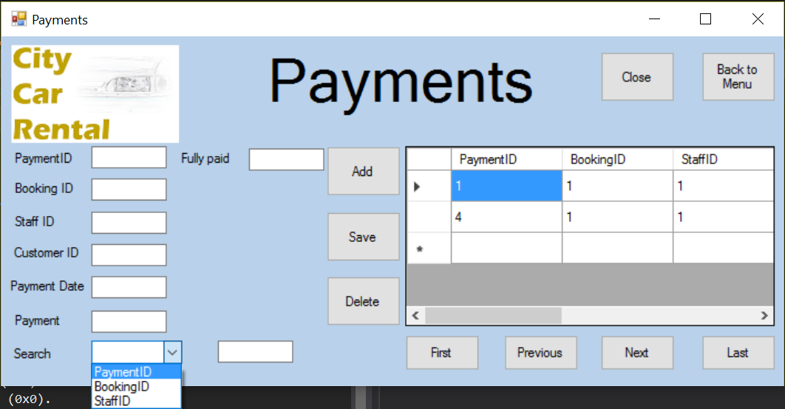

As shown above, the combobox successfully loads the the indexed fields

6.12.a

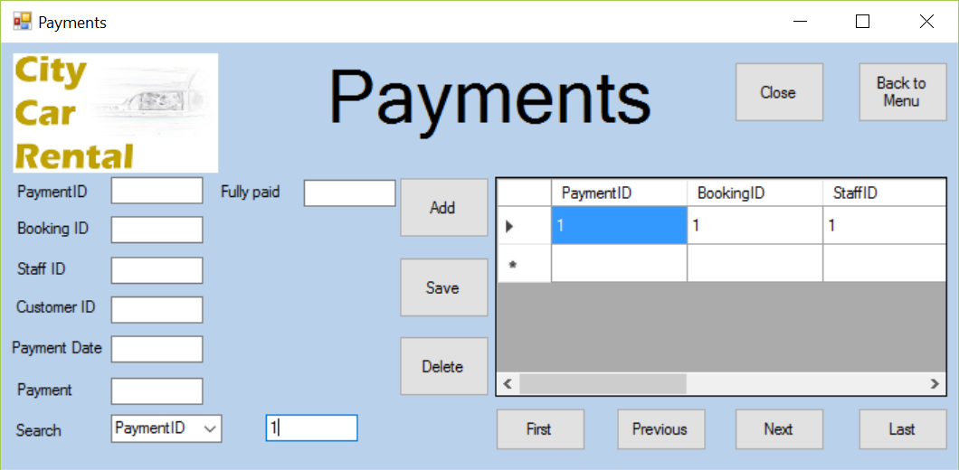

6.12.b



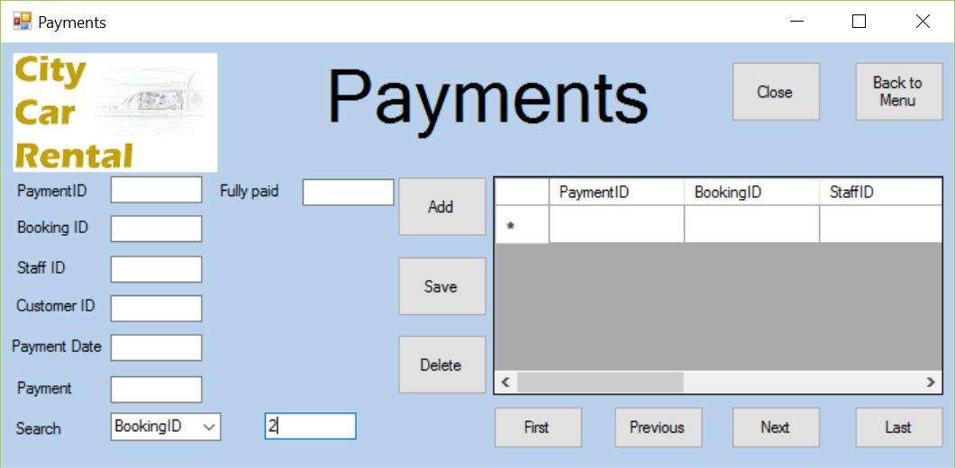

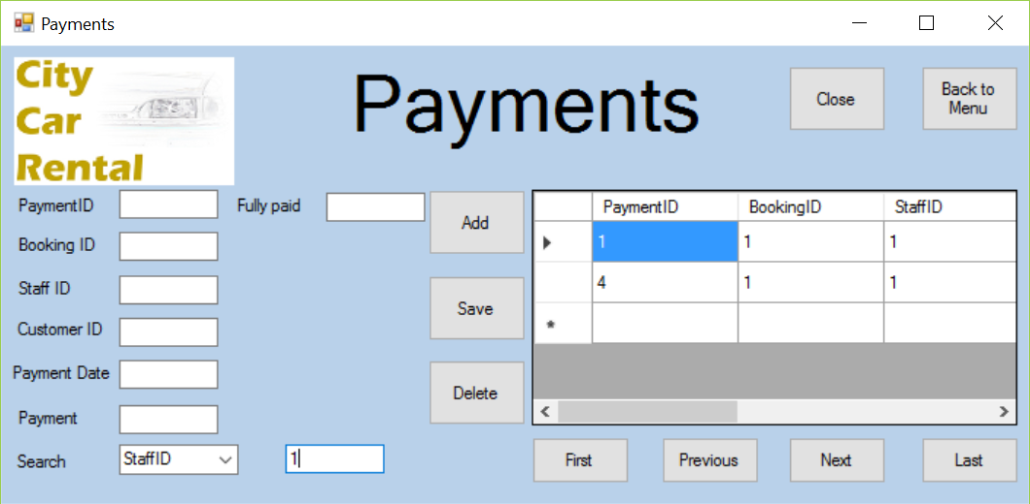

As shown above, the search function operates successfully for all indexed fields.

Booking form

|  |  |  |
| --- | --- | --- |
| Test | Expected Result | Evidence |
| Close button | Application should close | 7.0 |
| Data-grid-view - booking | Data-grid-view should display all records from the booking table | 7.1.a |
| Data-grid-view - customer | Data-grid-view should display all records from the customer table | 7.1.b |
| Data-grid-view - vehicle | Data-grid-view should display all records from the vehicle table | 7.1.c |
| Add button | The data entered into the textboxes should be added to the database | 7.2 |
| Save button | This should save the edited details from the textboxes into the database | 7.3 |
| Delete button | This should delete the selected record from the database  A message box should appear alerting the user that a field has been deleted | 7.4.a  7.4.b |
| First button | Moves the selected record to the first in the database table | 7.5 |
| Next button | Moves the selected record to the next in the database table | 7.6 |
| Previous button | Moves the selected record to the previous in the database table | 7.7 |
| Last button | Moves the selected record to the last in the database table | 7.8 |
| Menu button | Closes the current form and opens the menu form | 7.9 |
| Text-boxes | User should be able to enter data into the textboxes | 7.10 |
| Search combo-box | Should display all indexed fields | 7.11 |
| Search textbox | Should allow the user to enter search data.  Should automatically search the table when data is entered. | 7.12.a  7.12.b |
| Data-grid-view - availability | Should show the available vehicles when the check availability button is pressed. | 7.13.a |
| Check availability button | Should change the number of available cars based on the dates in the date-time pickers. | 7.13.b |
| Start date, date-time picker | Should allow the user to pick the start date of the rental.  Should be used as the start date for checking availability.  Used for calculating final price.  Should be entered into the start date textbox. | 7.14.a  7.14.b  7.14.c |
| End date, date-time picker | Should allow the user to pick the end date of the rental.  Should be used as the end date for checking availability.  Used for calculating final price.  Should be entered into the end date textbox. | 7.15.a  7.15.b  7.15.c |
| Final Price calculation | The final price should be automatically calculated and entered into the textbox. | 7.16 |

7.0

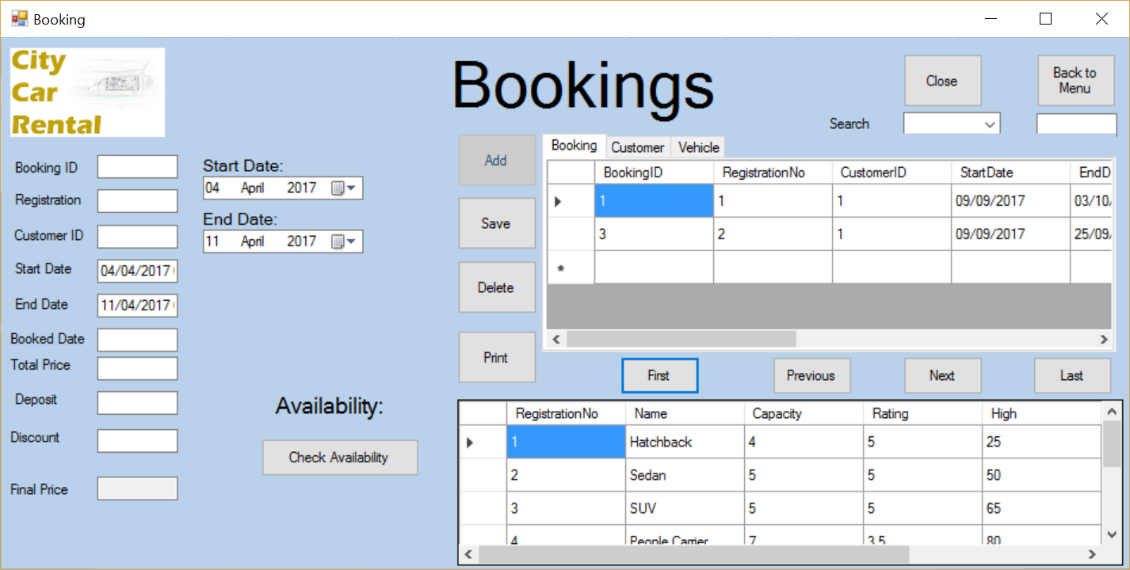



As shown above, the booking form will close very quickly

7.1.a



7.1.b

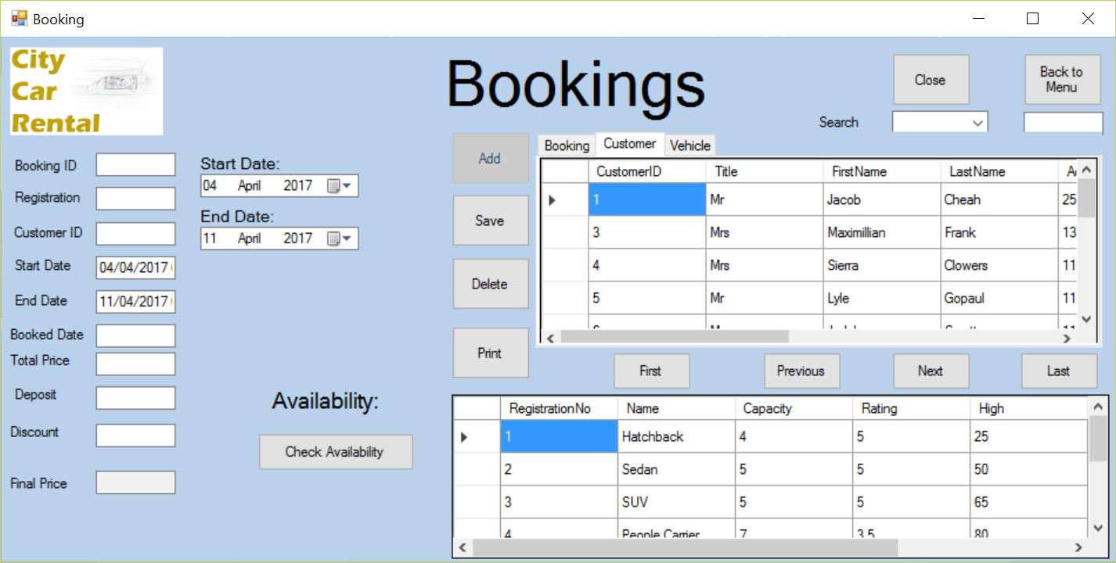

7.1.c

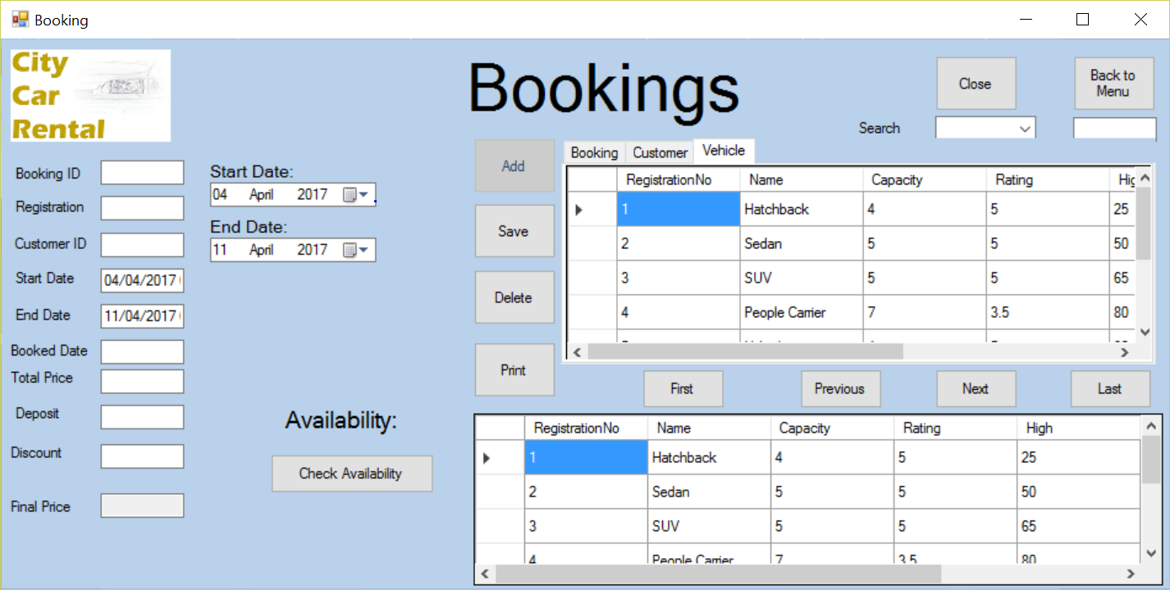

As shown above, the data-grid-views are filled by the database tables in the SQL database

7.2/7.10/7.14/7.15/7.16



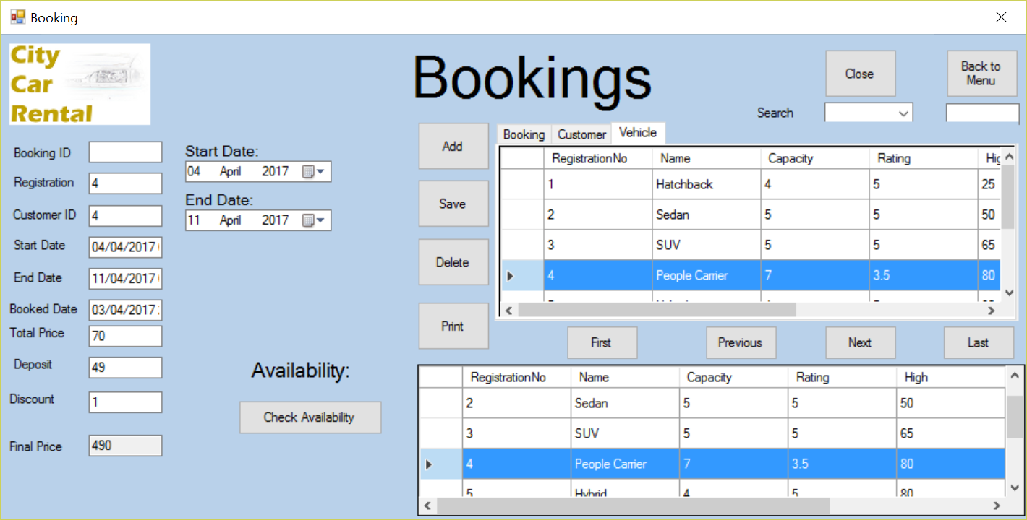

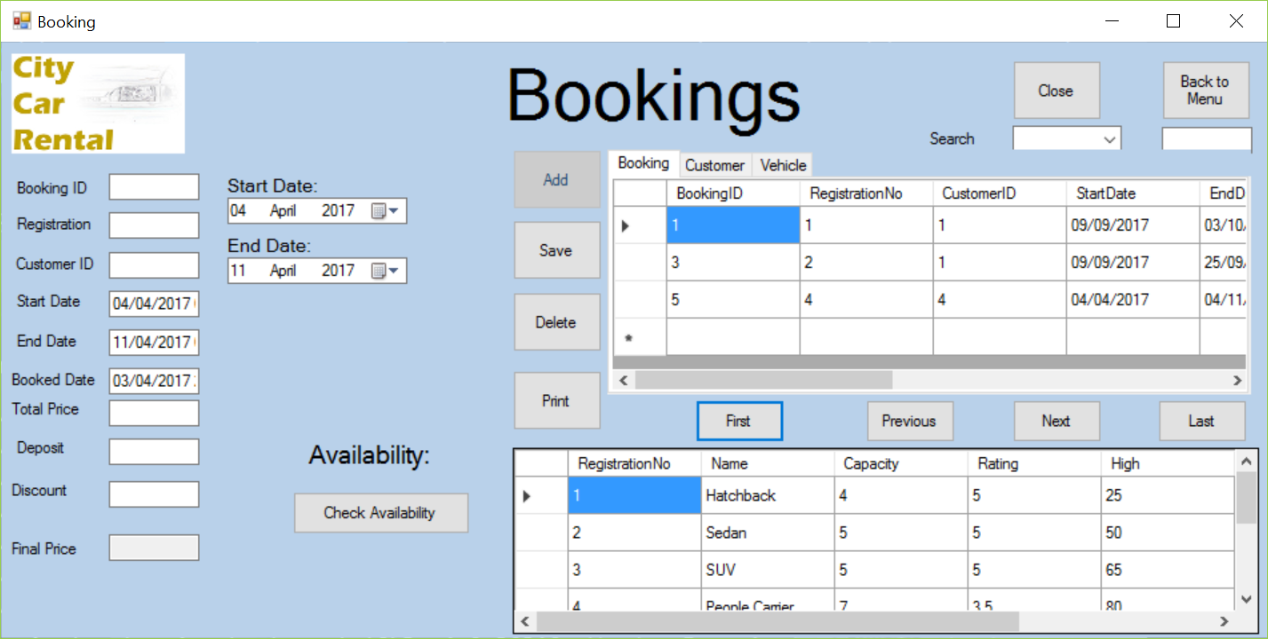

As shown above, you are able to enter details into the textboxes and add in a new booking. Also you are able to choose a date from the date-time picker and it will be entered into the textboxes. The final price, deposit, total price and discount are all successfully automatically calculated in the system

7.3

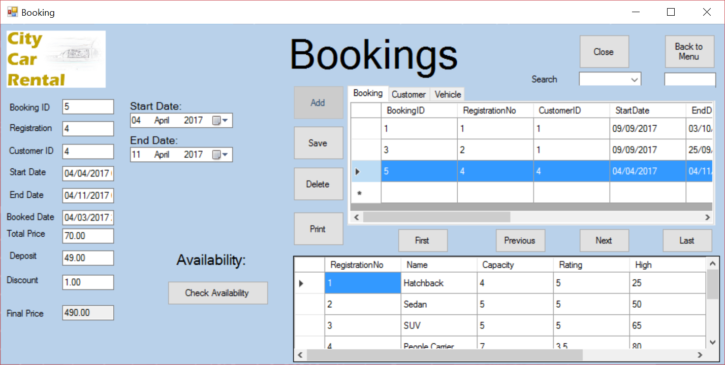

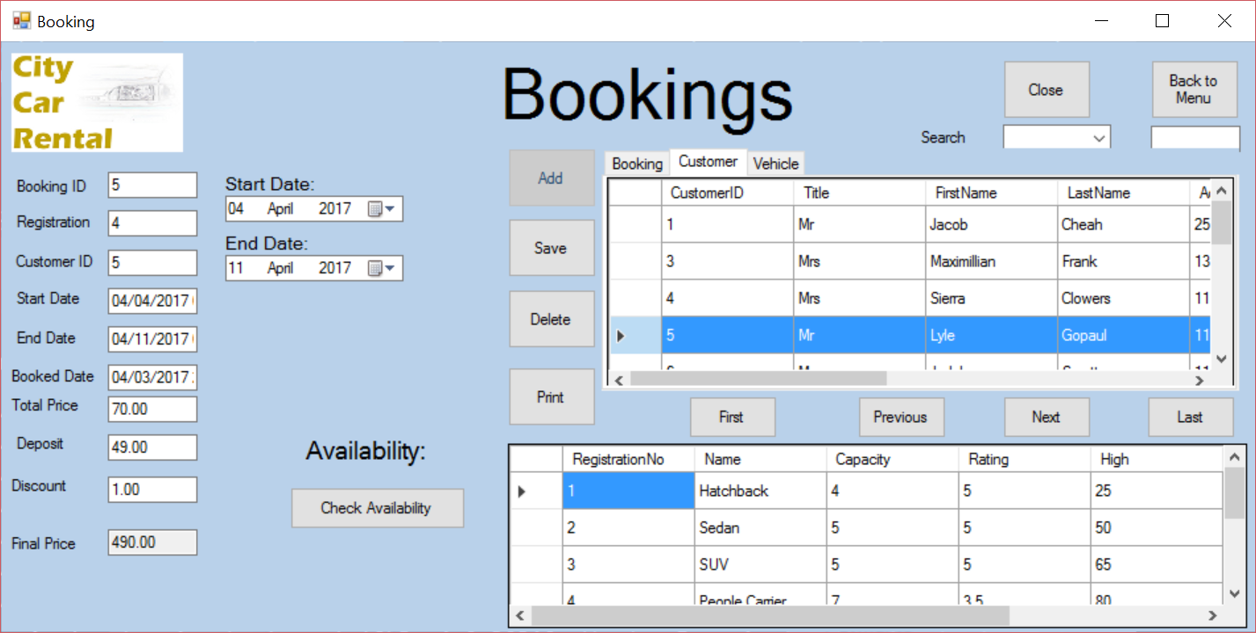

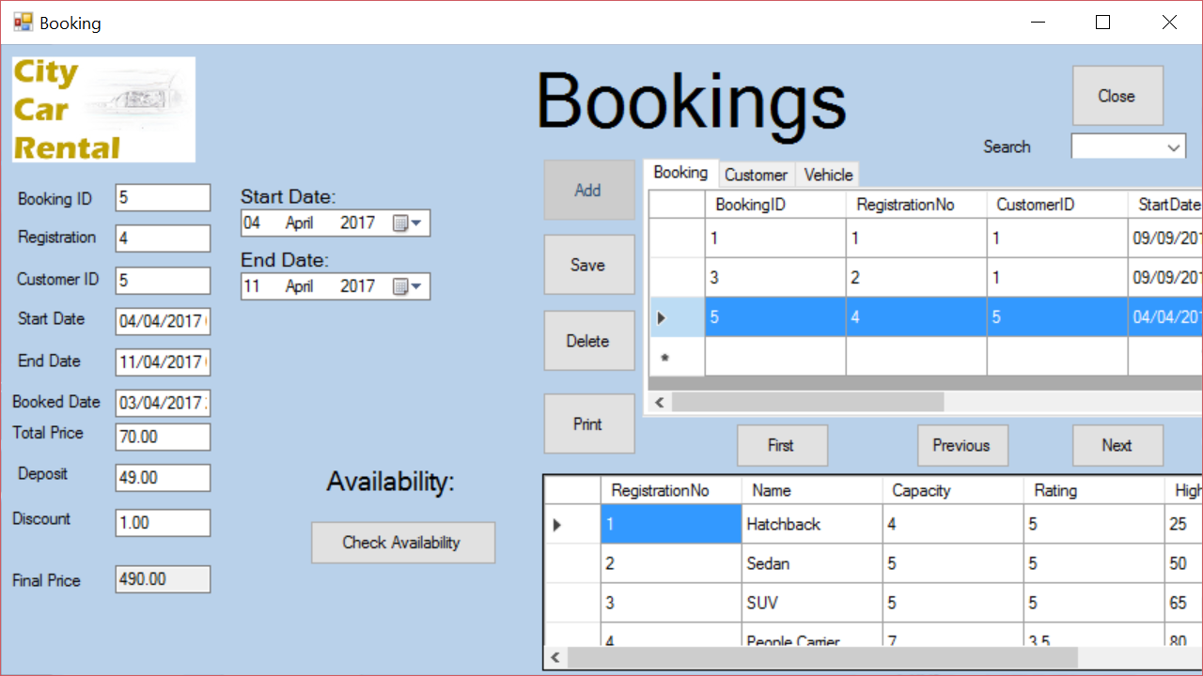

As shown above, you are successfully able to change the details in the booking form

7.4.a



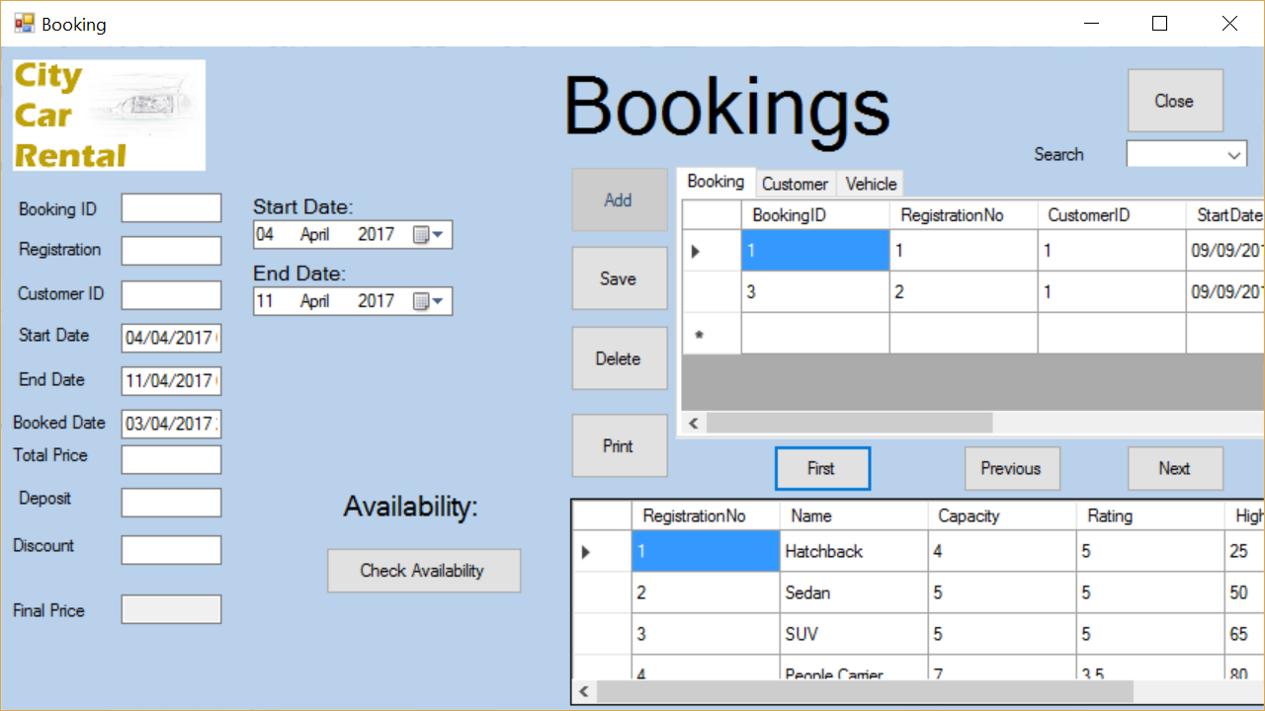

As shown above, you are successfully able to delete a booking record.

7.4.b

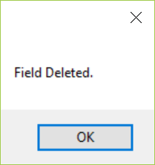

As shown above, the message box shows when a file has been deleted

7.5

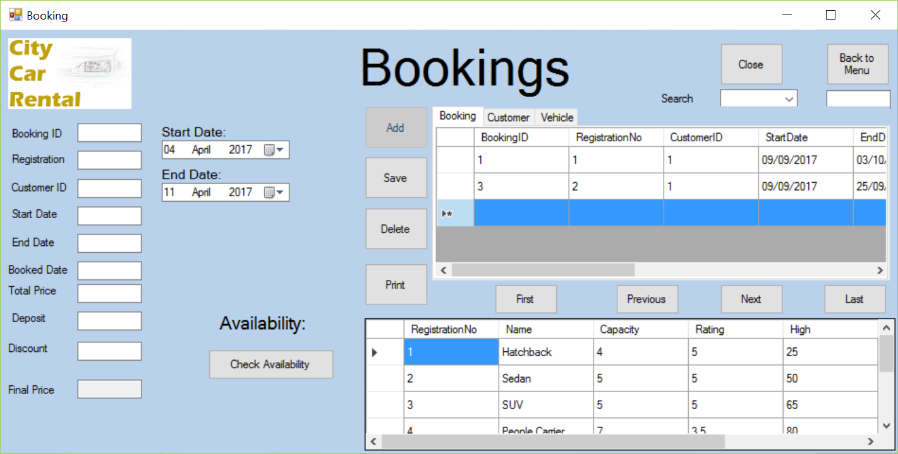

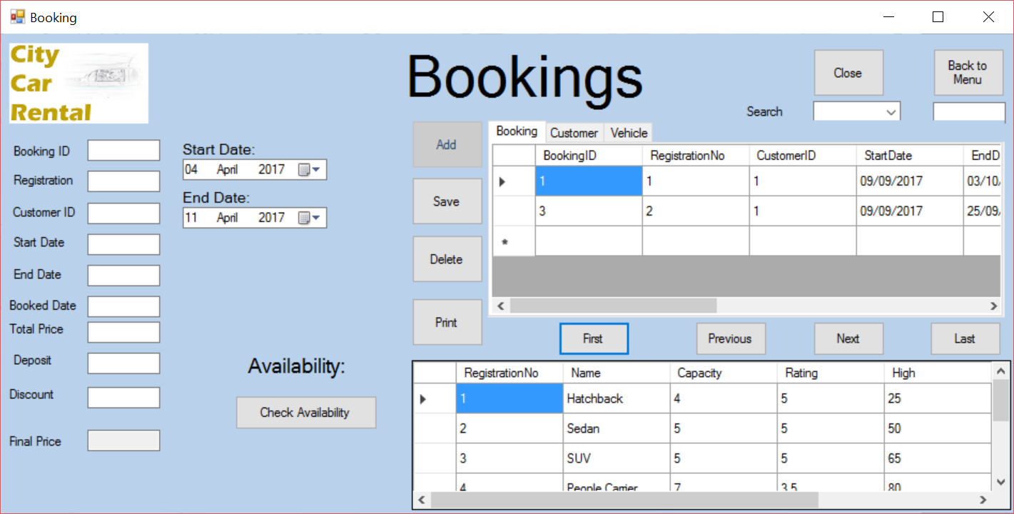

As shown above, the first button successfully moves the users position in the data grid view

7.6



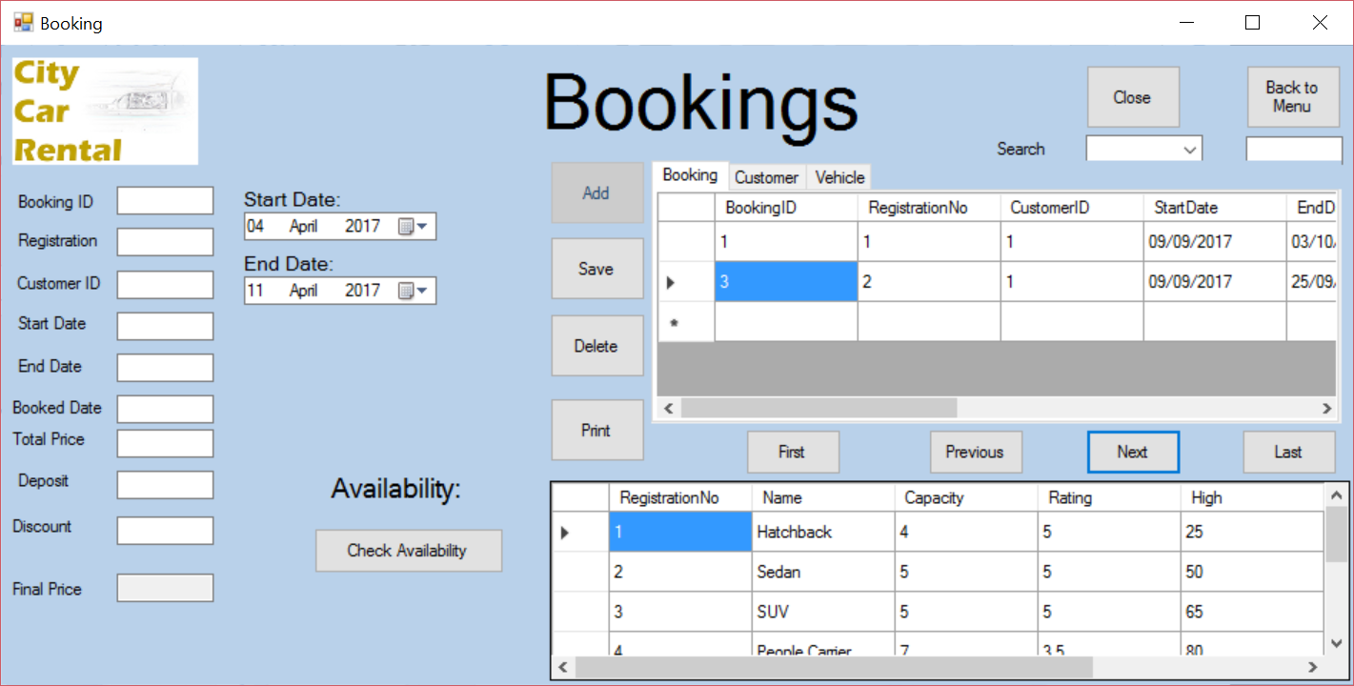

As shown above, the next button successfully moves the users position in the data grid view

7.7



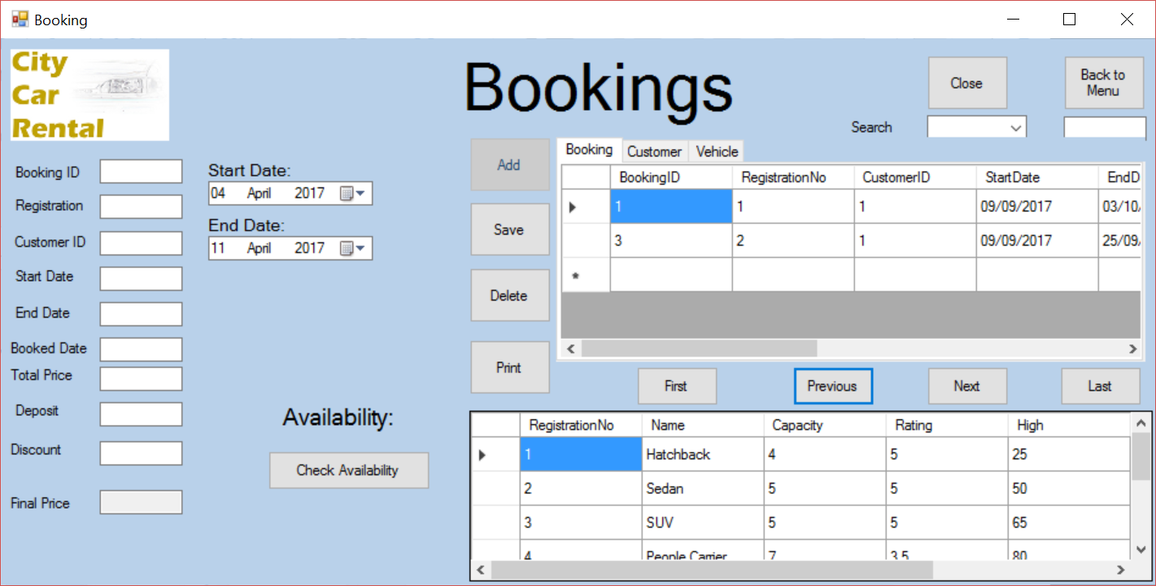

As shown above, the previous button successfully moves the users position in the data grid view

7.8



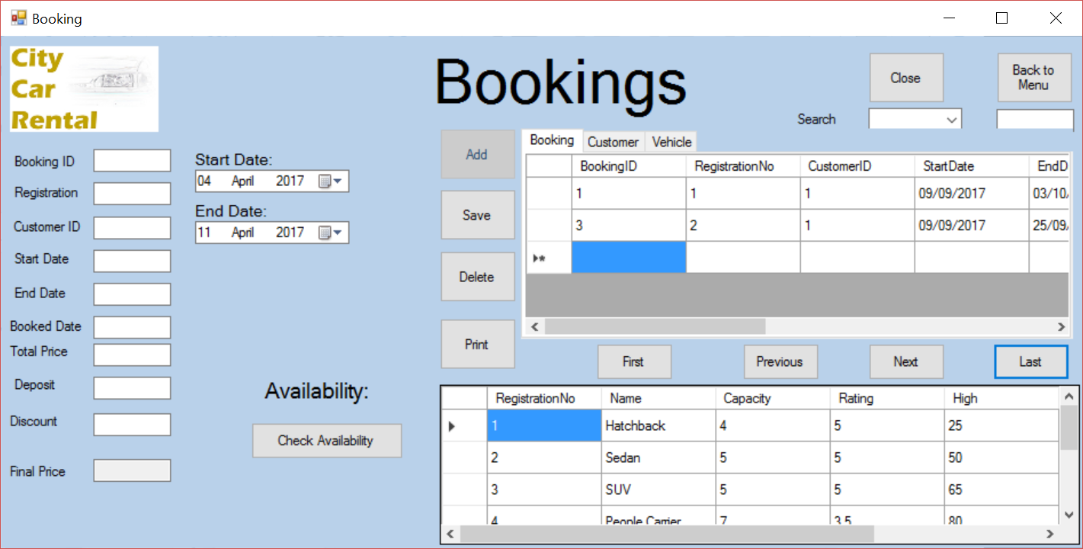

As shown above, the first button successfully moves the users position in the data grid view

7.9



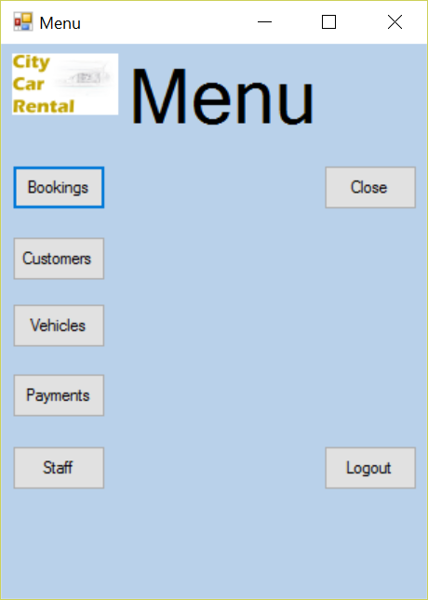

As shown above, the menu button successfully closes the booking form and opens the menu form

7.11

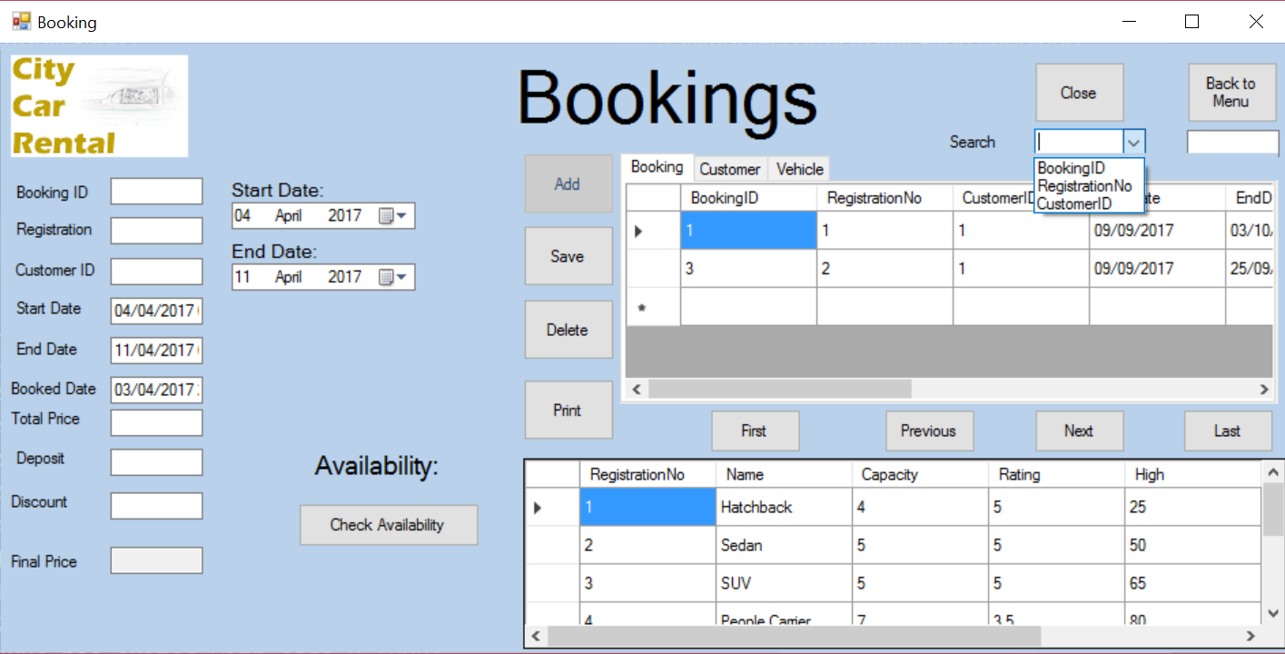

As shown above, the combobox successfully loads the the indexed fields

7.12.a

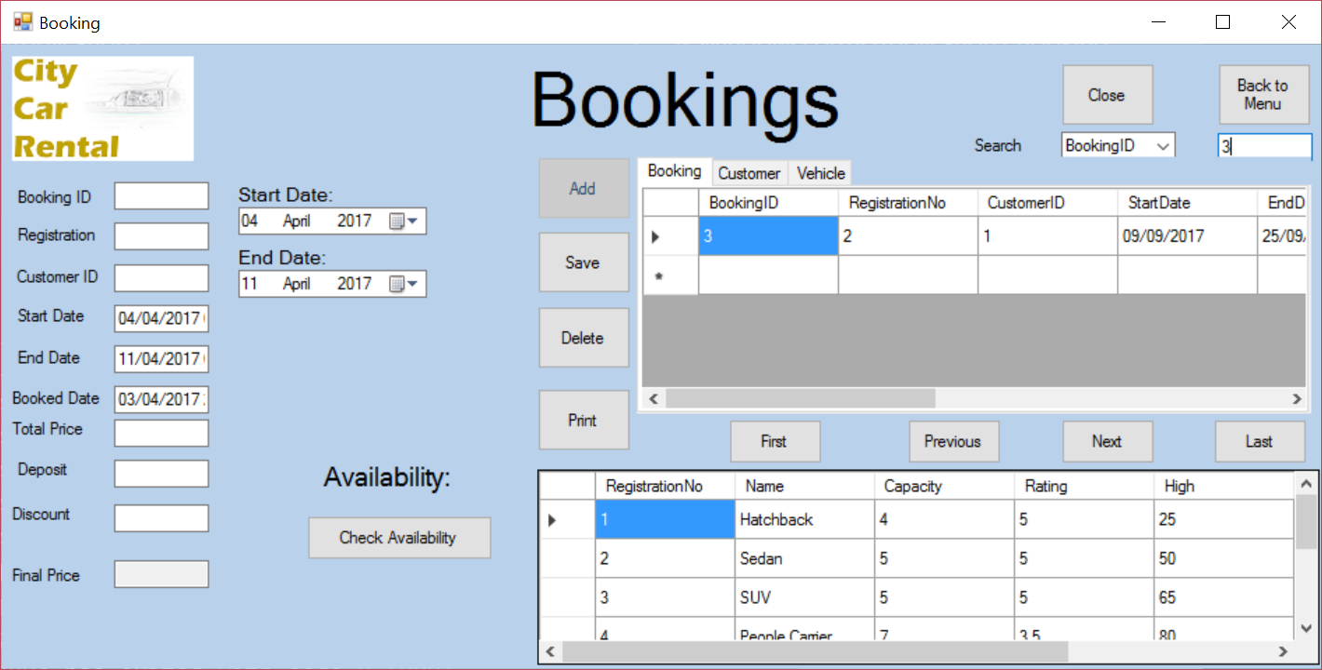

7.12.b



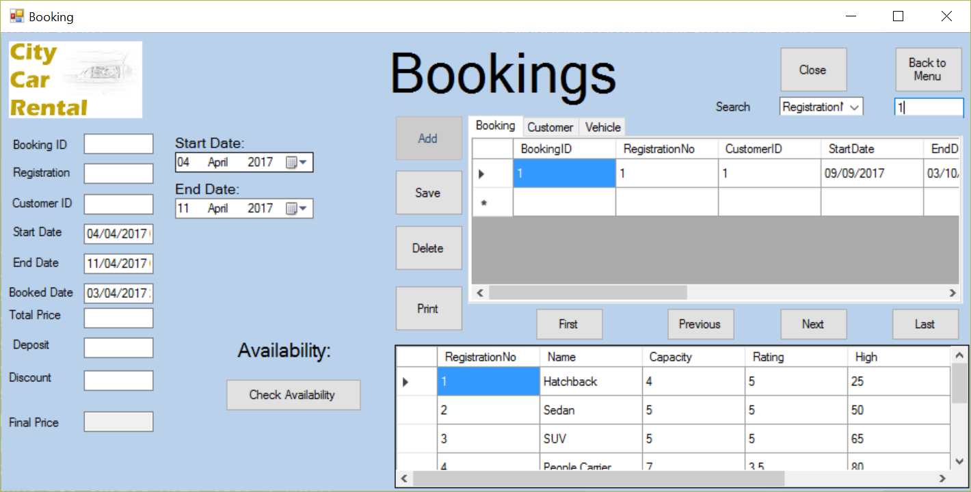

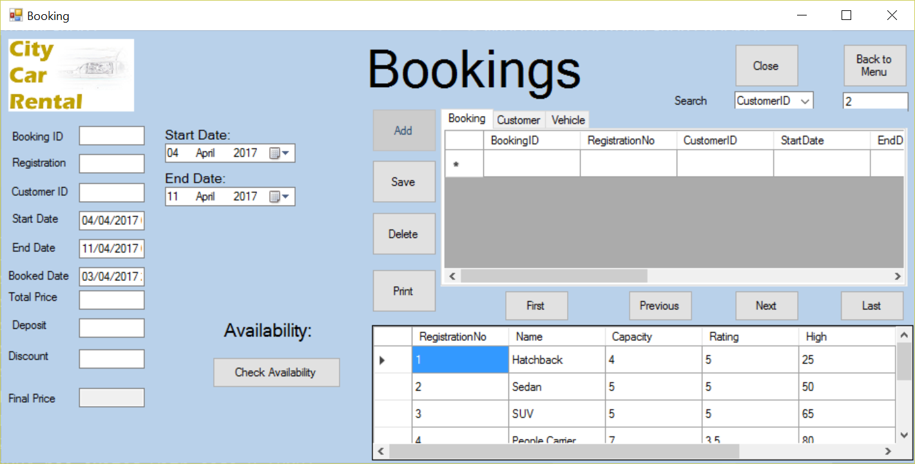

As shown above, the search function operates successfully for all indexed fields.

7.13

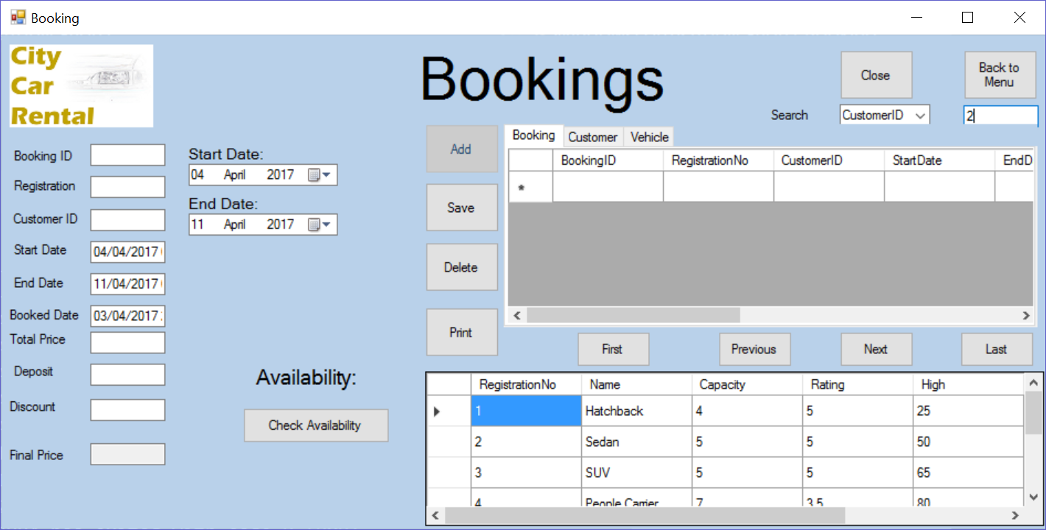

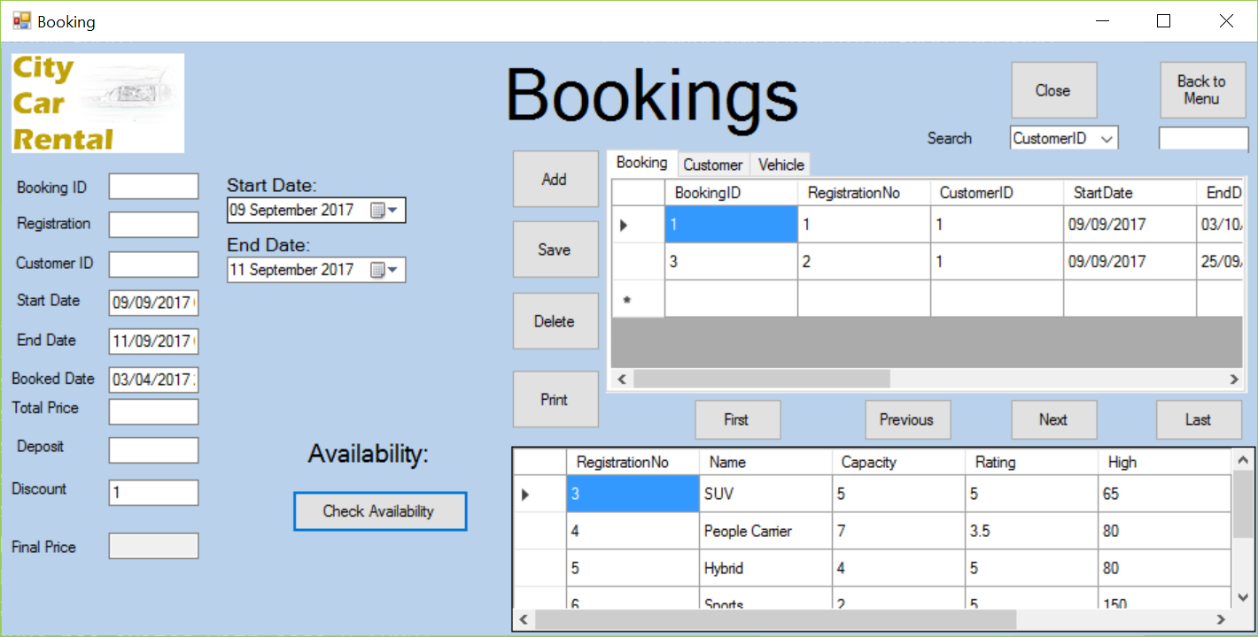

Successfully checks what vehicles are available between the start dates and end dates

Invoice form

|  |  |  |
| --- | --- | --- |
| Test | Expected result | Evidence |
| Customer listbox | Customer listbox is filled by the selected customer record detais | 8.1 |
| Booking listbox | Booking listbox is filled by the selected customer record detais | 8.2 |

8.1/8.2

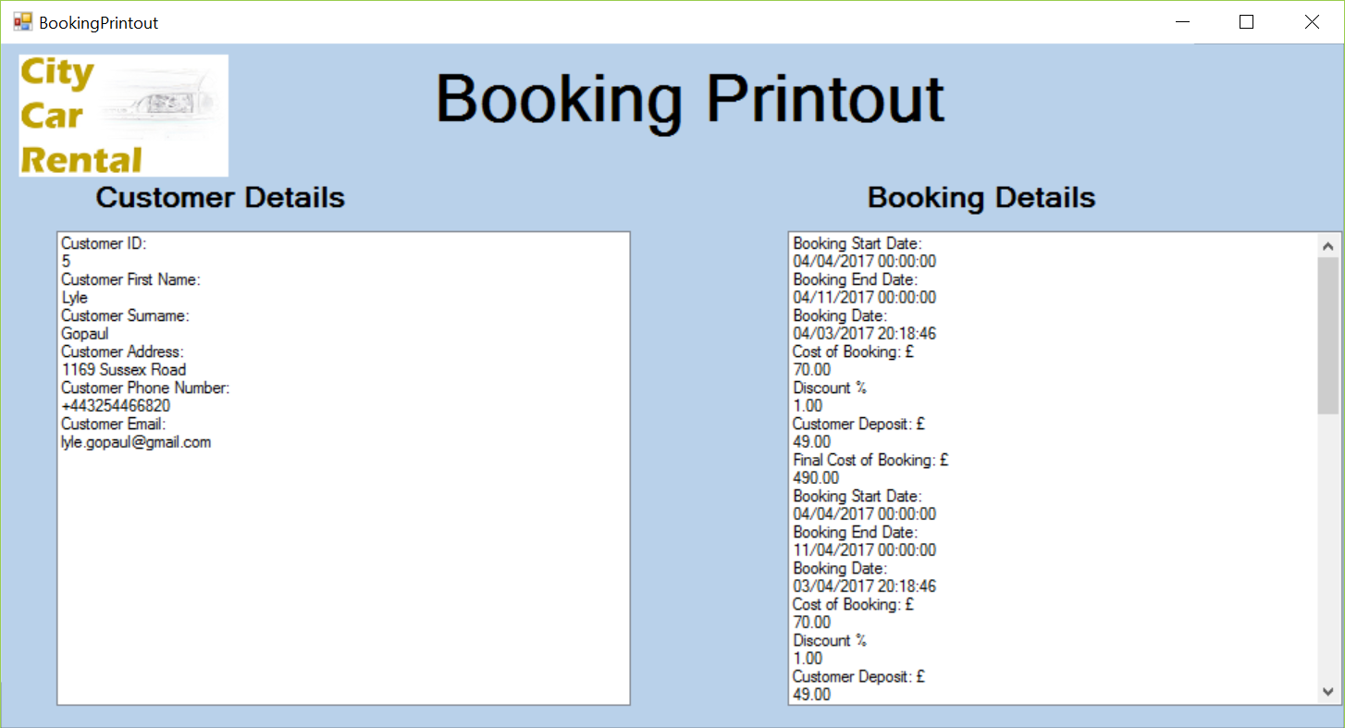

All successfully displayed

Evaluation

Section 9



Evaluation

Effectiveness of the programming language

Since creating this new programmed system, I have gained a much deeper understanding in operating and programming in the C# language and I believe that in comparison with other programming languages that I have researched and worked with. C# is a very powerful and useful language to use especially for the intended purpose.

As it is so deeply integrated with windows and other Microsoft products; for example, SQL server can be easily integrated into the code of the windows forms. This was essential for the creation of the program as the database used to hold all the data provided from City Car Rental was SQL.

The data in the database tables created in SQL are easily displayed in the visual studio data-grid-views. Also SQL commands can be executed from the code in the forms with ease, this was necessary adding, deleting, saving and searching records, the check availability would also be much more difficult to create without this available.

However, as I am not an expert in the C# programming language there are most likely some inefficiencies with my code which could be refined farther. Also other languages may have been able to deal with some of the tasks required better than C# is able to and do so more efficiently. However, other languages would most likely be insufficient to complete all tasks needed for the new programmed solution.

In conclusion I believe that C# was the most suitable language for creating this new system based on the requirements of the new system, my skills, and time restrictions.

Justification of tools and techniques used

Tools used within C#/Visual Studio

Arraylists:

Two arraylists were used for the printing of bookings to an invoice, these were needed to store both the customer details based on the customer ID from the selected booking details, the other arraylist was used to store the booking details from the selected booking. These were then displayed on the listboxes in the invoice form. This was a very easy way to hold the data needed for the invoice form as it is easy to add and retrieve data from the arraylists.

Classes:

I used two global classes to help with printing the invoices as it made the arraylists available to be filled by the bookings form and the data to be then taken and displayed by the invoice form. This was used as it was the only way I was able to use to bring the data from the arraylist from the bookings form and implement it into the invoice form.

Data-grid-views:

I used multiple data-grid-views in the system to show all the records from the required tables in a simple and sleek manner. This meant that the user would not have to reference the database when making new records or editing current ones as all the information was there. It also allowed for easier selection of records into the database.

Visual Designer:

I took great advantage of creating the interface using the visual studio visual IDE with the toolbox to add objects to the interface. I did this instead of creating the interface through programming as it is a lot faster and can give a better product as the result can be seen as it comes together rather than when the program is compiled.

SQL Tools Used

Visual ER Diagram Creating:

I took advantage of SQL server 2016’s visual ER diagram creator, this is very easy to use especially for those that are not very familiar with using SQL and saved me a lot of time when creating my ER diagram.

SQL query facility:

The SQL query facility saved me a lot of time as it allowed me to complete large commands very quickly and easily. This also helped me when encountering problems

Usage of keys:

I took advantage of the SQL built in keying function, this meant I could establish which fields must remain unique and not null. This also aided me in establishing relationships between different tables with the use of foreign keys.

How the objectives have been met

|  |  |  |
| --- | --- | --- |
| Objectives | Achievements | Evidence |
| Manipulate the data in all forms | The program can carry out calculations based on the defined discount, season and number of days, the user is also able to edit the data that has been entered into the database through the textboxes in the forms. | 1.0 |
| Add data in all forms | The Customer, Vehicle, Booking, Staff and Payments form all have buttons to add the details entered into the textboxes to the database. | 2.0 |
| Delete the data in all forms | The Customer, Vehicle, Booking, Staff and Payments form all have buttons to delete the selected record from the database. | 3.0 |
| View all forms | The Customer, Vehicle, Booking, Staff and Payments form all contain data-grid-views for viewing the records | 4.0 |
| Navigate all forms | The Customer, Vehicle, Booking, Staff and Payments form all have first, previous, next and last buttons to navigate the records. | 5.0 |
| Search data in the database | The Customer, Vehicle, Booking, Staff and Payments form all have search functions, to search the selected table. | 6.0 |
| Produce an invoice from a booking | The Booking form contains a button to print the selected booking, this produces an invoice containing the customer’s details and the details of the selected booking | 7.0 |
| Display a splash screen to welcome the user when the program is first launched, this should contain the City Car Rental logo and contact details. | The splash screen opens quickly and contains the company logo and contact details for the business. | 8.0 |
| The login form should validate the login password, it should compare the selected username with the entered password and the stored password. | The login form successfully ensures the correct login is entered before access is granted | 9.0 |
| The navigation menu should allow the user to navigate to all forms | The navigation menu Contains buttons to access all forms excluding the splash screen as I felt this was unnecessary, the menu form closes when any of these buttons are pressed, however, on each form there will be a button to return to the menu. | 10.0 |

1.0



As shown, data can be entered into the textboxes and the system will automatically do calculations for some of the data, meeting the previously stated objective

2.0







As shown above, the user is able to add in new records into the database. This meets the previously stated objective.

3.0





As shown above, you are successfully able to delete a record from the database. This meets the previously stated objective.

4.0

Splash screen



Login Form



Menu Form



Customer Form



Staff Form



Payments Form



Vehicles Form



Bookings Form



Invoice Form



All forms are shown as required in the objectives.

5.0





As shown above, the first button successfully moves the users position in the data grid view; Meeting the objective

5.1





As shown above, the next button successfully moves the users position in the data grid view; Meeting the objective

5.2





As shown above, the previous button successfully moves the users position in the data grid view; Meeting the objective

5.3





As shown above, the last button successfully moves the users position in the data grid view; Meeting the objective

5.4





As shown above, the first button successfully moves the users position in the data grid view; Meeting the objective

6.0



6.1



6.2





As shown above, the search function operates successfully for all indexed fields. Meeting the objective

7.0





As shown, an invoice can be produced from the booking form meeting the previously stated objectives.

8.0



Splash screen automatically shown when the program is launched; meeting the objective.

9.0







As shown above, when the correct username and password are entered, access is granted to the system and the login form closes. Meeting the objective

10.0





As shown above, the navigation menu will close and the login form will open with both fields empty, keeping the system secure. Meeting the objective.

10.1





As shown above, the customer form will open normally and the navigation menu will close. Meeting the objective.

10.2





As shown above, the Vehicles form will open normally and the navigation menu will close. Meeting the objective.

10.3





As shown above, the staff form will open normally and the navigation menu will close. Meeting the objective.

10.4





As shown above, the payments form will open normally and the navigation menu will close. Meeting the objective.

10.5





As shown above, the bookings form will open normally and the navigation menu will close. Meeting the objective.

Completed system in comparison with commercially available systems

Design

One thing I noticed when I was researching into other car rental systems was that the design of the buttons and textboxes was clear and easy to enter details into or to use, I feel that I have achieved this to the best of my abilities in the programmed solution.

Another repeated feature of commercial systems is the feature of the date-time picker which has been successfully implemented into the bookings form, this makes the form much easier to use and the chance of errors being made is much reduced and makes the form seem much more commercial and professional.

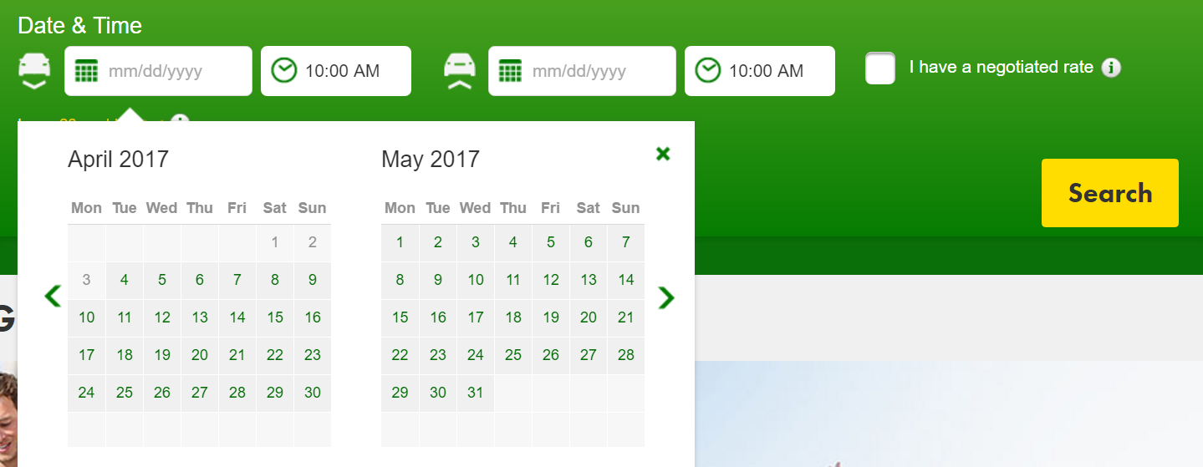

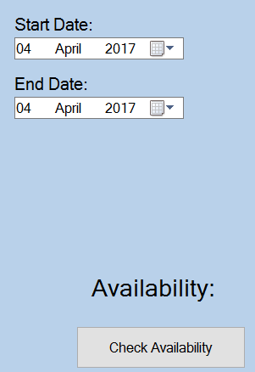

The first picture is a screenshot of ‘europcar’s’ method of checking what rental cars are available at a certain time, they use 2 date-time pickers for the pick-up and drop-off date and a search button to show the cars available.

This is similar to my bookings form as I use a start date and an end date date-time pickers and a check availability button to show the cars available.

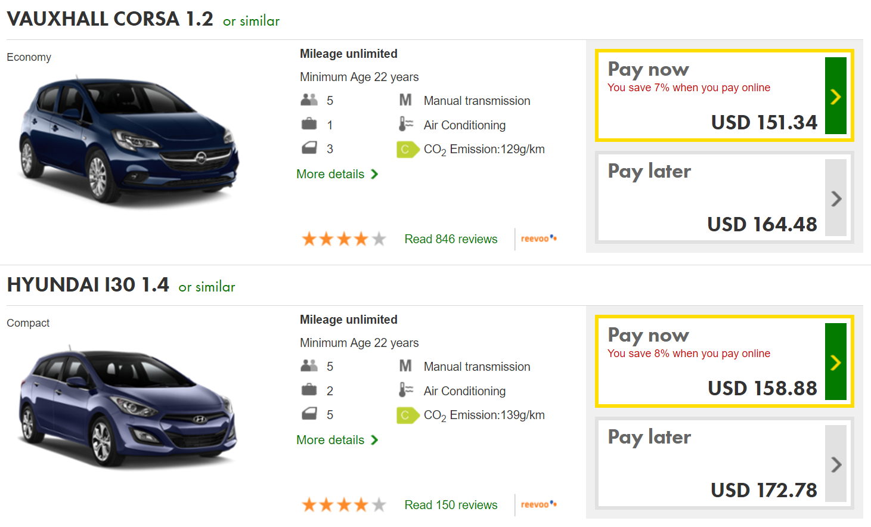

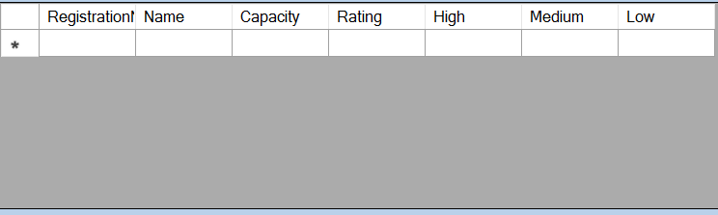

The biggest difference between the commercial way of displaying the available vehicles and the way of displaying the available vehicles is that the commercial way is much more visual with more details of the cars available. The information listed in my database is like the information in the europcar display. If I had more time to work on the project, I would like to include pictures and more information about the cars.

However, the staff will be the ones handling the new system so if the customer wishes to see more information about the vehicle, they could make a printout of the vehicle with pictures and details of the vehicle to compensate for this.

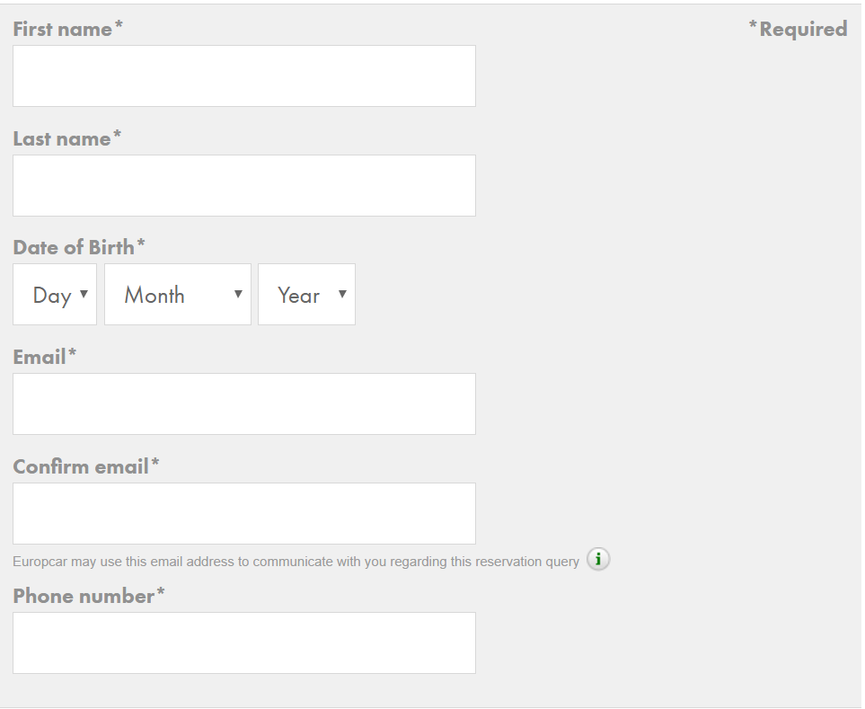

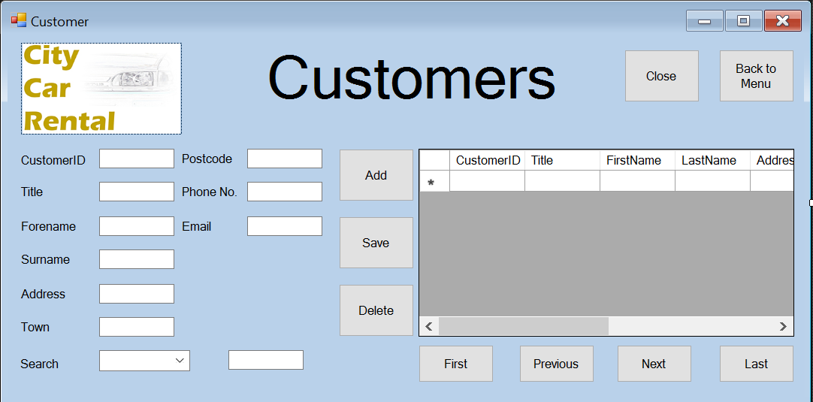

As shown in the commercial screenshot and in my program, the way in which to enter details for new customers is very simple, however, mine is more complex as this is for use by staff, not customers, therefore, the other customer records need to be able to be viewed and navigated and edited.

Functionality

Unfortunately, I was unable to see the side of any commercial programs from an employee’s point of view so I have no knowledge of the underpinnings of how the system operates, however, I have gained knowledge into the system from the point of view of the customer. This can be compared to my system to an extent, however, as the staff are the only people handling the system, it has a different purpose to be fit for the audience using it.

The main benefit of the commercial systems over the system I have created is that they are not local to one location and are available over the internet, however, this is not as necessary for my system as there is only one City car Rental branch and therefore does not require the same kind of interconnectivity, therefore my system should be fit for purpose.

Good features of the completed system

Design

The design of the forms is very clean and simple with there being a certain amount of consistency between forms that are related for example the customer/staff/vehicle/payments/booking forms all have a very similar design, this makes the overall complexity of the system low and will help the staff learn how to use the system very quickly as the forms are very similar.

The aesthetic of the program is also very pleasing to the eye with a custom-made logo by me, the pale blue background is also very pleasing to view for extended periods of time and is somewhat symbolic to the sky, in keeping with the theme from the logo with the plane as City Car Rental is Situated next to an airport.

All data-grid-views display data from the relevant table clearly with scrollbars to see data that wasn’t immediately visible.

Functionality

The functionality of all forms is complete and working as intended, with no errors.

All buttons are functional and crashes are only happening if the program has been launched incorrectly.

Most textboxes allow the user to enter data, however, some are simply there to display data for example, the final price textbox in the booking form.

The program loads and runs with good efficiency, with all forms loading in under a second and loading with it already connected to the database.

All data-grid-views have a search function and first, next, previous and last to help the user navigate the data-grid-view to enable them to find the correct record.

The bookings form is almost completely automated with all details being entered upon selection of data-grid-views and date-time pickers and all discount/deposit/final price calculations are all done automatically.

Shortcomings of the completed system

Design

Given more time and a greater budget, there are significant improvements I would like to make to the design of the new system. I would like to have a more seamless design, the arrangement of all buttons and textboxes could be better planned and laid out, this would result in a more aesthetically pleasing design for the staff to use

Functionality

The greatest problem with the functionality of the program is that each booking can only be for a single car, for example if one person is renting multiple cars for multiple people, these must be in separate booking records as one record cannot contain two vehicles. However, this should not be a major problem as most people would rent a single car for themselves and not for other people as well so this should be a rare but still present inconvenience for staff.

Another shortcoming of the solution is that the invoice is only available in digital format for the customer to view and a hard copy cannot be printed. This could cause inconvenience for customers that wish to keep track of such expenses and wish to receive a hard copy of their booking information, they could also wish to obtain a hard copy as a reference for when their booking is up and the rental must be returned

Another limitation is that no statistics can be automatically calculated and returned to the owner of the business, these statistics can still be manually calculated but an added feature could have been to automatically calculate profit, average prices etc.

Potential improvements to improve solutions effectiveness

1. Visual additions to the vehicles form
   1. Due to budget and time restrictions, I was unable to create a visual display of each of the vehicles in the vehicles forms and booking forms for the available vehicles. This would cut down on time for customers to select which vehicle they wish to rent and help them to choose which they wish to select and increase customer satisfaction
2. Automatic statistical calculations
   1. I was unable to include automatic statistical calculations that could be produced for the owner of the business to use to give them a visual aid into how profit margins, vehicle status, customer loyalty and frequency are all doing. This could enable them to know what changes to make to help them expand their business further than before. It would also aid in organising the business and reduce errors and in the long run increase profit and save time and effort.
3. Online web based customer interface
   1. Given much more time and a larger budget, I would have liked to create an online website that customers could make bookings from and create accounts, in time this would allow City Car Rental to downsize their physical branch as most rentals could be made digitally. This would save on costs for premises and staff and help the company grow as customers could make rentals before they arrive.
4. Use of encryption in staff records
   1. To increase security in the system, I would have liked to include encryption for the staff passwords, this would aid in preventing unauthorised users from entering the system. This would be essential if a web-based system would be implemented as the chances of an attack would be greatly increased.
5. Greater use of validation
   1. There was some validation used in my program, however, this could be more heavily integrated to reduce possible human error as much as possible. Unfortunately, due to time restrictions, I will not be able to include as much validation as I would have liked.
6. Error reports for users and automatic error sending
   1. The majority of errors given in exceptional circumstances are the standard errors given by SQL or Visual Studio. However, given more time I would like to include errors that would be more easily interpreted by someone who is less skilled in ICT.
   2. I would also have liked to have an option for the staff to send the error reports back to me whenever they appear so I can give them assistance with whatever the error was

Reflection on my performance in the design and development of the system

Weaknesses

There was no foundation from which to build this program upon, therefore there was a greater risk of errors in the base of the program, these would not show up until the system was complete, this wasted large amounts of time as some fundamental parts of the development needed to be changed long into the development process. This was expected as I had built this system from scratch and I am not a very experienced developer in C#.

Time management was a big weakness of mine during the developmental process, this came about as I was unaware of the detail and depth required for both the writeup and development of the program, this resulted in some additional features of the program being left out as the deadline for the systems development was fast approaching.

Significant changes were made to the function and design of the vehicles form toward the end of development, this came about due to unexpected errors with the vehicles form, with the time restrictions I was forced to abandon some features and fields of the vehicles form.

Commenting of my code was another performance weakness while developing the new system, I had not commented the code while I was developing it, this meant for understanding any problems or helping others understand my code would be more difficult.

Strengths

While developing the new system I made use of programming forums to help me with problems I had with my development, without this, some of the problems I experienced during development would have halted development and caused time management to be even more effected

I underwent extensive investigation into the problems with the current system, this helped me in understanding what the new system had to rectify and what features of the new system needed to be kept from the old system. I feel this helped me in creating an appropriate system for the specified purpose.

Specific changes of approach that could be adopted in future

Time management

Due to the large nature of the program and the time restrictions; it would have been very beneficial to the development of the new system if time was managed better.

This could be achieved using a development schedule with key dates and goals for the completion of milestones, this would have aided me in keeping track of how much I have left to complete vs how much time there is left to complete the system.

Use of project management software

There are various project management software’s available that I could have made use of. However, I was unaware of these at the beginning of my project, this would have helped me to ensure my project was on time and all sections would have been completed in a timely manner and would have enabled me to manage my time even better.